Victory Newsletter for October, 2016

Principal's Message
When I think of the month of October I think of beautifully coloured leaves and a time to give thanks. I’d like to thank all the families that came to the school to attend our Open House. It was lovely seeing so many children excitedly showing their families their classrooms and school. I hope everyone had a chance to admire the self-portraits in the front foyer. Every child in the school created a portrait and added their thumb-print to the large Victory canvas. We want our students to see themselves reflected on the walls of our school. I was also thankful to see so many families taking advantage of the opportunity to get a library card at the Public Library booth.
Our annual Terry Fox Walk was another time for our school to come together and celebrate a Canadian hero. A representative from the Terry Fox foundation presented to the whole school and then our Grade 6 leaders lead the school outside and on our walk. I’m thankful that so many families joined us for this event.
I’m incredibly thankful that funds from School Council and a donation from a former Victory student has made it possible for all of our students to take part in a week of Hip Hop dance lessons. During the week of Oct. 3 – 7th each class will be participating in a lesson a day given by instructors from DancEd. This celebration of dance will culminate in an evening performance for parents on Friday, Oct. 7th between 6:00 – 7:00 p.m.. The show will take place at GCVI which is located at 155 Paisley Rd.. Our Gymnasium is not big enough to hold all of our families and this is an event that we are hoping everyone attends! Please have your child at GCVI for 5:50 p.m.. Come out to watch your ‘star’ perform on stage!
During this month of ‘thanks’ we want to welcome all of our new families, many of whom are new to our country. We are thankful you are part of our Victory community. I also want to thank our Street and Bus Patrols for taking on these positions of responsibility.

Thinking of Others at Thanksgiving
Victory families have traditionally looked for ways of supporting families within and beyond our community throughout the year. This fall, as we look forward to celebrations of Thanksgiving, we encourage our students to think of people in our city who are in need of practical supports. We are very happy to once again support the Guelph Food Bank by collecting donations of non-perishable food

items and toiletries. Our Thanksgiving Food Drive will run from Thursday October 3rd, to Thursday, October 7th.
We thank you for your generosity as we work together to support all people in our city.


Terry Fox Run
On Thursday, September 29th our Victory community celebrated our 22nd year of participation in the Terry Fox Run. Children learned about this Canadian hero during a presentation by a representative from the Terry Fox Foundation and walked/ran at Exhibition Park. We collected “Toonies For Terry” at school. Donations may still be made on-line at: http://www.terryfox.ca/VictoryPSGuelph.

Safety Patrols
Our street patrols have recently been trained (or re-trained) by Officer Robin, our City of Guelph Police Safety Officer. Patrollers have been doing an excellent job of arriving on time at their posts and crossing families safely as they walk to school. We remind parents that our patrollers are on duty before and after school but not during nutrition breaks. If you are walking your child to school please cross with the patrols. Please also be conscious of signs indicating where you can and can’t park. It is very difficult for patrols to see if the road is clear if cars are parked in the no parking areas. Please also be aware that cars are not to park in the bus zone on either side of the street on the Powell side of the school.
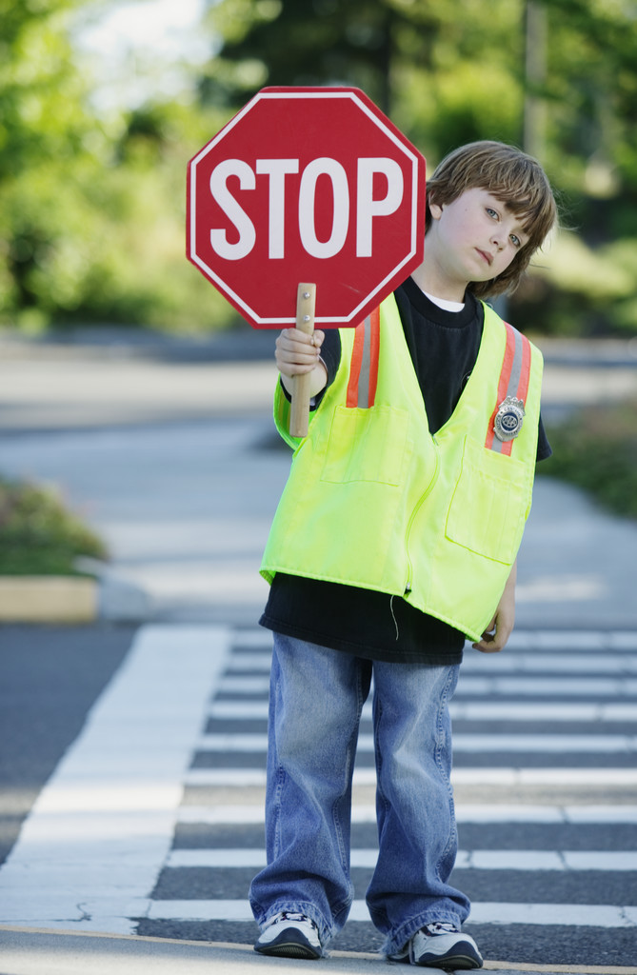

Hallowe'en Parade

Students will be participating in special activities on Monday, October 31, 2016 including our annual costume parades. Kindergarten students are asked to wear their costumes to school and will have their parade at the beginning of the day. The parade will take place right after the morning announcements and they will be going from room to room. Once back in the classroom the children will be taking off their costumes before 1st lunch. It would be helpful if students brought labeled bags that they could then place their costumes into them. All other students are asked to bring their costumes to school. Their parade will take place at approximately 1:45 p.m. This second parade will take place outdoors if the weather permits, or in the school Gym. In the spirit of keeping this event fun for all ages, we ask that children do not bring toy weapons or artificial blood as part of their costume. As always, parents are welcome to join us!

Santa Claus Parade
This year our School Council is participating in the Guelph Santa Claus Parade. The parade takes place on Sunday, Nov. 20th. There will not be school staff supervising at this event as it is a School Council run event. More information will be coming home from School Council in the next few weeks.

Student Accident Insurance
This is a reminder that the student accident insurance forms were sent home during the second week of school. The acknowledgement form should be returned to the school but application forms go directly to the insurance company. If you require an additional form please contact Reliable Life at 1-800-463-5437, or www.insuremykids.com.

Visiting the School
Please feel welcome to visit with us before school, during our breaks from instruction, or after school. When you enter the building, please go first to the main office on the second floor, sign our guest book and check in with Mrs. Hambly. If you would like an interview with a specific staff member, please make arrangements ahead of time. Remember to use the Exhibition Street doors!

Student Agendas
Thank you to our School Council for contributing to the cost of student agendas. We believe that they are a valuable communication tool between home and school, and also teach our children habits of organization and responsibility. We thank the families who have already made a voluntary donation of $5 per agenda to help offset the cost. It’s not too late! If you wish to make a $5.00 voluntary donation, please go to ugdsb.SchoolCashOnline.com. Thank-you in advance.

Community Connections
Victory Kids Club
Victory Kids Club will be offering care on non-instructional days (March break, summer break and Christmas break) to Victory Kids Club children as well as families attending Victory Public School and surrounding areas. The program must be considered viable in order to operate on non-instructional days.
ENROLLMENT IN VICTORY KIDS CLUB EXTENDED DAY PROGRAM ON NON-INSTRUCTIONAL DAYS DOES NOT ENTITLE YOUR CHILD/REN A SPOT IN VICTORY KIDS CLUB DURING REGULAR INSTRUCTIONAL DAYS.
Criteria for Enrollment
• Victory Kids Club families – Priority # 1
• Victory Public School – Priority # 2
• Guelph and Surrounding area families – Priority # 3
Hours of operation on non-instructional days – 8:00 a.m. – 5:00 p.m. 5 days/week
Fees - $200.00 per week or $40.00 per day, per child (subject to review and approval by the Board of Directors)
Payment – non-refundable and/or non-transferable
Food - Families must supply all lunches, snacks, and drinks for the day.

Extra-Curricular Sports & Clubs
There have been many opportunities for students to participate in Clubs and Sports outside of the classroom this past month.

Mme Cauley and Ms. Kelly have been running Soccer try-outs most days over the past several weeks. Their team was selected and participated in a School Board Soccer Tournament on Wednesday, Sept. 28th. They represented our school proudly!

Mme Vaughan is running Dodgeball intramurals every Day 4 in the Gym. She is beginning with the junior grades and will include primary students in the new year.

Mme. Labelle is running our Primary Me to We Club. This club is open to all Gr. 3 & 4 students and runs on Tuesdays.

Mrs. Ferris is starting our Green Team Club in Oct. for Gr. 3 & up.

We are very excited to welcome back Mrs. Becker who will work with our Kindergarten and Primary/Junior Choirs on Wednesdays this year. She will be assisted by Ms Pfeil.

Mme. de Rijcke is working with a group of junior students who are running primary Soccer Intramural. Games are currently on Mondays and are open to grade 1 – 3 students.
Thank you to teacher coaches for these sport teams and clubs.
Please ensure that your child has running shoes at school for PhysEd.

U.N.I.C.E.F.

October is traditionally a month in which we raise money to send to UNICEF. This worldwide charity upholds the Convention on the Rights of the Child, advocating for equality in children's access to education, health and peace. This month there will be four spirit days which we encourage children to bring coins to school to raise funds. Please see October Spirit Days for U.N.I.C.E.F. below for more details.

Report a Bully - On-Line Reporting Tool
As part of our Safe Schools policy, the Upper Grand District School Board has launched an on-line tool that can be used to report incidents of bullying. Reports that are made through the web-site are forwarded to the Principal of the school for follow-up. The web address is: www.ugdsb.on.ca/stop-a-bully
Please also take a moment to review our updated Bully Prevention Plan that is located on our school website.

Parking
When you visit the school or pick up children, please park on Clarke Street (not on the school side) or across the road at Exhibition Park. During school hours, vehicles should never drive onto the playground area.

Asthma Friendly Schools Policy

Asthma is a very common chronic lung disease that can make it hard to breathe. The Upper Grand District School Board adopted a new policy in June 2016 to provide support for students with Asthma. If your child has asthma, the policy requires an Asthma Management Plan (AMP) to be completed by parents, a child’s doctor and the principal of the school. A copy of this plan is available on the Board’s website under Policy 516. Parents are requested to complete the AMP and return it to the school as soon as possible at the beginning of the school year. Authorization for the collection of this information is in the Education Act. The purpose is to collect and share medical information and to administer proper medical care in the event of an emergency or life-threatening situation. Users of this information may be principals, teachers, support staff, volunteers, bus operators and drivers. This form will be kept for a minimum period of one calendar year. Contact person concerning this collection is the school principal.

Smoke–Free Environment

The Upper Grand DSB provides a smoke-free environment for its students, staff and others while on school Board property, in accordance with the Smoke-Free Ontario Act. This policy refers to all forms of tobacco, and any processed form of tobacco that may be smoked, inhaled or chewed, including e-cigarettes.

Smudging is the tradition of using sacred smoke from sacred medicines (e.g., tobacco and sage) that forms part of the indigenous culture and spirituality. Smudging is allowed in schools under the Smoke-Free Ontario Act. Parents will be informed using the school’s usual forms of communication when smudging is going to occur in our school. Participation by staff and students is optional in a smudging ceremony.

Life-Threatening Allergies

We have children in our school with potential life-threatening allergies to various foods and other materials called anaphylaxis. This is a medical condition that causes a severe reaction to food or other materials, and can cause death within minutes. In recent years, anaphylaxis has increased dramatically among students.
Although this may not affect your child’s class directly, we are letting you know so that you may refrain from sending foods to the school that contain peanuts and nuts. We aim to create an allergy safe environment at our school.
If your child is in a classroom with an anaphylactic child, or your child has anaphylaxis, you will be contacted by the classroom teacher.
Our school has procedures in place to help manage anaphylactic reactions. If your child has health concerns of any kind, please tell your child’s teacher or the office and we will take the necessary health protection steps.
Thank you for your understanding in ensuring an allergy-safe environment for all of our students.

Pediculosis (Head Lice)
The presence of head lice continues to be a community problem. They do not cause disease and they don’t result from a lack of cleanliness, but they are certainly a nuisance. The control of head lice requires the cooperative effort of parents, school personnel and health officials. Parents are responsible for meeting their child’s personal well-being, health and safety needs. This includes treating your child’s hair (if head lice have been found), checking for nits daily for two weeks after the treatment, and notifying the school that treatment has been carried out.

Victory Newsletter on the Web
In an effort to reduce the amount of paper we use we will continue to post our school newsletter on our school website. This newsletter and calendar will be available by the last Friday of each month at: www.ugdsb.on.ca/victory.

Victory School Council
Victory School Council will hold its first meeting of this school year on Wednesday, October 5th at 6:30 p.m. in the library. All parents and guardians are welcome to attend. Please consider joining School Council and become more involved with our vibrant French and English student community. It does not need to be a lot of time, nor a long term commitment. We also welcome volunteers to assist in classrooms, the library and at home. Many of our volunteer opportunities are a one-time event while others are spread over the school year in small manageable time increments. There is something for everyone who wants to participate. Please join us in the work we do for our students!
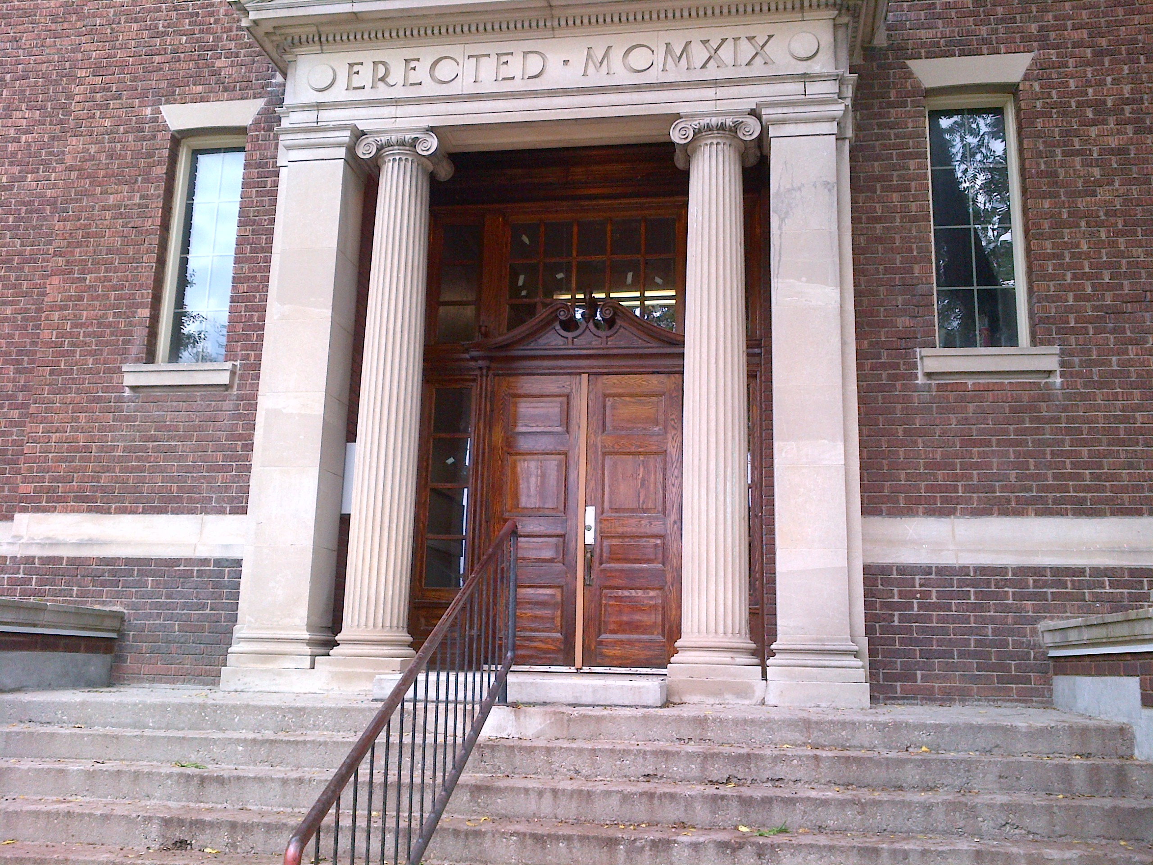

October Spirit Days for Unicef are brought to you by the Me to We Club
The Me to We Club is excited to bring you our October Spirit Days for Unicef. We have selected some really fun spirit days and ask students to bring in a loonie for Unicef when they dress up. Our spirit day themes are:
October 7 - Dress up as your favourite book/movie/tv show character
October 14 - PJ and stuffie day
October 21 - Backward day (wear your clothes backwards, carry your backpack on your front, eat your dessert first, etc.)
October 27 - Formal Day
Thank you for supporting our spirit days for Unicef.

We Scare Hunger Campaign brought to you by the Me to We Club
Hunger is a supervillain who makes life harder for many families in our community. The Me to We Club is challenging all Victory students who will be trick or treating this Halloween to ask for a canned good in lieu of candy at two houses along their route. Students are invited to bring in their two canned goods to school on Tuesday, November 1st. We ​will be sending the canned goods to our local food bank. Thank you for helping us take action to make a difference in our local Guelph community. Together, we can SCARE hunger!

Journee du Drapeau Franco-Ontarien
On Friday, September 23, Grade 1 to 4 French Immersion classes walked downtown to City Hall to join Mayor Cam Guthrie, students from Ecole Saint-Rene-Goupil and students from Ecole L'Odyssee to celebrate the French language and culture in Ontario. September 25th is Franco-Ontarian Day, a day to commemorate our community and its history. The green and white Franco-Ontarian flag was designed and first raised by a group at Laurentian University in Sudbury in 1975. Green and white are the two colours on the flag to represent the two opposite climates in Ontario. The flag also includes a white trillium, Ontario's provincial flower, and a fleur de lys, which is symbolic of French language and culture. Students watched as the flag was raised and sang the song "Mon beau drapeau."

Individual Education Plans (IEPs)
Individual Education Plans, or IEPs, are developed by schools when assessments show that a student needs special education programming and/or services. The development of the IEP should be a collaborative process that includes parents and the student (if possible). During the development phase, schools are required to seek feedback through consultation with parents. This is your opportunity to discuss and share information with the classroom teacher and/or special education teacher regarding your child’s education. If your child had an IEP last year, you will see a copy of this working document come home within the first 30 school days.

When the IEP is sent home, you will also receive a booklet titled, Parents’ Guide to the Individual Education Plan. This booklet is a resource to help parents understand how an IEP is developed, what is included in an IEP, and how an IEP supports your child. It also includes definitions and explanations to help parents understand some of the language that is part of an IEP, such as accommodations and modifications.

One more item that will accompany your child’s IEP this year is a Parent/Guardian IEP Questionnaire. We want to know your ideas about your child’s Individual Education Plan (IEP). Your ideas will be used to help us improve the IEP processes in our schools, and help us provide parents/guardians with the special education information they are looking for. Please take a few moments to share your ideas and return the questionnaire to the school office. If you need any help with completing this questionnaire, your child’s classroom or special education teacher can assist you.

Talking About Mental Health October 2016 – Promoting Mental Health
Helping kids grow up mentally healthy is an important part of parenting. Here are a few things that CHEO (http://www.cheo.on.ca/en/Promoting-Mental-Health-parents) suggests you can do to support good mental health in your children and youth.
- Put your device down.
When you are with your children and youth, show them that they are more important than your electronic device. Lead by example: put your own devices aside and spend face-to-face time with your kids.
- Listen when they’re upset.
When children and youth are upset, they just want you to listen and understand how they’re feeling. Try not to jump in with advice or reassurance. Listen is spelled with the same letters as Silent.
- Focus on their strengths.
Support your children and youth’s self-esteem by helping them to see their own strengths. Show that you see and appreciate kindness, empathy and trying hard, and not just achievements like good grades. For example, “That was kind of you to think of your brother” or “You worked so hard on that and you didn’t give up!”
Have a mentally healthy October!
Dr. Lynn Woodford is the Mental Health Lead for the Upper Grand District School Board.
Follow me on Twitter @drlynnwoodford.

Monthly Environmental Activities to help celebrate our planet

Oct 5th is InterNational Walk to School Day!

It is vital to teach our children to respect and take care of the environment.
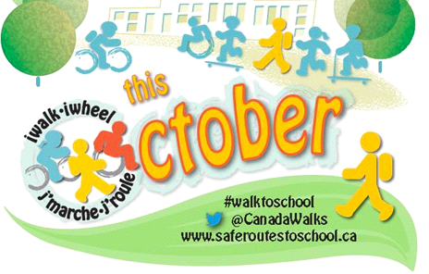
Participate in International Walk to School Day on October 5th 2016!

In October we celebrate active travel by encouraging students to walk or bike between home and school. Walking or cycling to school gets kids outside every day actively enjoying their natural environment. They arrive at school better able to concentrate and learn.

“In the 2015 ParticipACTION Active Healthy Kids Canada Report Card on Physical Activity for Children and Youth, the overall grade for Canadian children and youth remains at a D- for the third year in a row. Overall, only 9% of 5-17 year olds are getting the 60 minutes of heart-pumping activity they need each day. And sadly, the grade for Active Transportation remains a D, with only 24% of 5-17 year olds walking/wheeling to school and 62% being driven by parents or caregivers. Our tendency to constantly watch over them or keep them indoors to ensure they are safe from risk limits their opportunities for physical activity, endangering their long-term health.” http://www.saferoutestoschool.ca/

4 ways that walking or biking to school can benefit kids by Katherine Martinko

- Walking is known to improve academic performance. Children arrive brighter and more alert for their first morning class.
- Walking gives children good life experience. It’s an opportunity for them to be independent, think responsibly, and make decisions for themselves. Some children feel less anxiety about being at school when they know how to get home.
- Walking gets children outdoors – and, according to Richard Louv, who wrote Last Child in the Woods, kids certainly aren’t spending enough time outside these days. Those few minutes of walking can provide inspiration.
- Walking provides daily exercise for children. Obesity rates have skyrocketed in North America, so incorporating physical activity into a child’s daily routine is a good place to start fighting it.

Urban affairs journalist Christopher Hume says, “Walking is a reflection of how we feel about the environment in which we live.” Children will learn to love their town even more if they get to know it on foot. Why not gather a group of friends and participate in Walk to School Day?

Changing Our Beliefs and Attitudes About Math
Myth of the Math Person
Most people believe that math is one of those subjects that you either “get” or you “don’t get.” This way of thinking cannot be further from the truth; there is no such thing as a math person. Everyone can achieve in any subject with hard work, perseverance, and someone to guide them. They key to shattering this myth is developing a growth mindset in our teachers and students, and a math classroom where students are challenged by engaging problems and supported in their learning.
The Evolving Classroom

“The reason so many people think math is the most difficult is the inaccessible way it is often taught.” When we were math students our math teachers often taught us tips, tricks, and recipes for solving math problems. In the math classes of old there was only one correct solution. We could get the answer if we memorized and followed the teacher’s procedure, but if someone asked us the “why” behind our formula, most of us wouldn’t be able to answer.
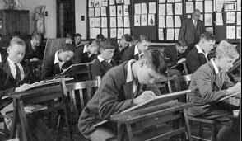
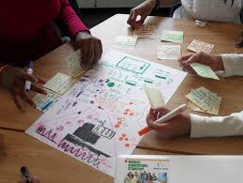
Today, teachers are striving for students to have a solid grasp of the “why” behind each solution. This often means that students are encouraged to share a variety of methods and strategies to solve a single problem. By sharing different strategies, teachers can help students see the common thread that connects each solution, thus deepening their understanding of the concept being taught. The teacher’s role is no longer to teach procedures, but to help students make connections and understand the mathematical concepts behind the solutions.

Growth Mindset Homework Help
Tips

Let your child struggle with math problems.
- See if they have the perseverance to work through their struggles. We need to break the math myth that we need fast answers to be good at math.

Never let your child hear you say: “I was never good at math.”
- Research studies have shown when parents tell their children they were not good at math, their child’s achievement is immediately affected.

Ask your child if they can solve a math problem in another way.
- This shows that your child has multiple strategies at their fingertips and they are flexible with their math thinking.

Ask your child to explain the reasoning behind their response.
- “Why did you (add/ subtract/ multiply/ divide)?”
- “What does your drawing represent?”
Online Resources
Parents’ Beliefs about Math Change Their Children’s Achievement - https://goo.gl/psL33d
“We now know that the messages we give students can change their performance dramatically, and that students need to know that the adults in their lives believe in them.”

TL Talk: The Gift of Failure – Interview with Jessica Lahey - https://goo.gl/oo7xFc
“Jessica is the author of the New York Times bestselling book, The Gift of Failure: How the Best Parents Learn to Let Go So Their Children Can Succeed.”
How to Learn Math: for Students - https://goo.gl/OCywaf
“How to Learn Math is a free self-paced class for learners of all levels of mathematics. It combines really important information on the brain and learning with new evidence on the best ways to approach and learn math effectively.”

Chromebooks
in your public ibrary!
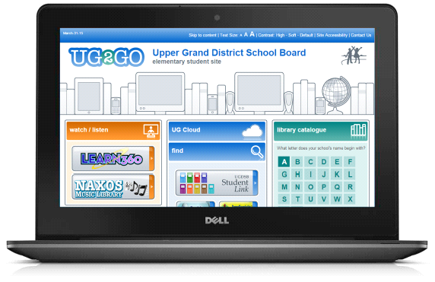
Upper Grand students can now get a Chromebook to do assignments after school, evenings and Saturdays







