Victory Newsletter for May 2017
May, 2017 mai, 2017

From the Principal's Desk ...

At Victory we are proud that our nation is celebrating 150 years of unity, diversity and inclusion. “Canada 150" is the theme of this year's Upper Grand District School Board's Education Week which runs from May 1st until May 5th. On April 19th several of our primary classes took part in, ‘La Journee du Cinema Canadien 150’. We have been working on an exciting project that we will be kicking off in the fall that focuses on Canada turning 150 and Victory approaching its 100th year! This undertaking involves a local artist and families exploring our community together. Stay tuned for more on this endeavor in September. If you know of anyone in the area that has a wealth of knowledge regarding Victory’s history we would love to hear from them!
Education week, at Victory, will be packed with special events including a book fair, choir evening performances, volunteer breakfast, bicycle safety training, our grade 4’s are going caving and our grade 5’s and 6’s are taking part in Empowerment Day! We hope to see many of you at the school throughout the week, whether you are enjoying a thank-you at the volunteer breakfast, joining one of the classes on their trip or attending our choir performance.
Music is in the air here at Victory as classes prepare to share their musical talents with our community. We look forward to having many of our students performing at the Dessert Party on May 18th. I would like to thank Mme Lewis, who has organized each of these performances.
Our staff will be ‘opening doors’ inviting our many volunteers to come in and enjoy breakfast with us on May 4th at 8:15 a.m. Victory is very fortunate to have such a dedicated group of parents and community members who volunteer their time. I especially want to thank our School Council for all they have done for us this year, and Bill Whitehead for his amazing leadership and energy!

Please feel free to contact me at any time to share ideas, suggestions or questions about your child’s education and school experiences. My door is open.

Julie Young
(519)822-6931, ext. 223
julie.young@ugdsb.on.ca

Helene Boudreau Author Visit
Helene Boudreau visited students from K-6 at Victory on April 24th. She read her book I Dare You Not to Yawn, talked about her writing process, the revision process, her illustrator’s images and her work with her editor. Students participated in spot the difference activities between the rough copy and good copy of images and shared some of their experiences of things that make them yawn and how contagious yawning can be!
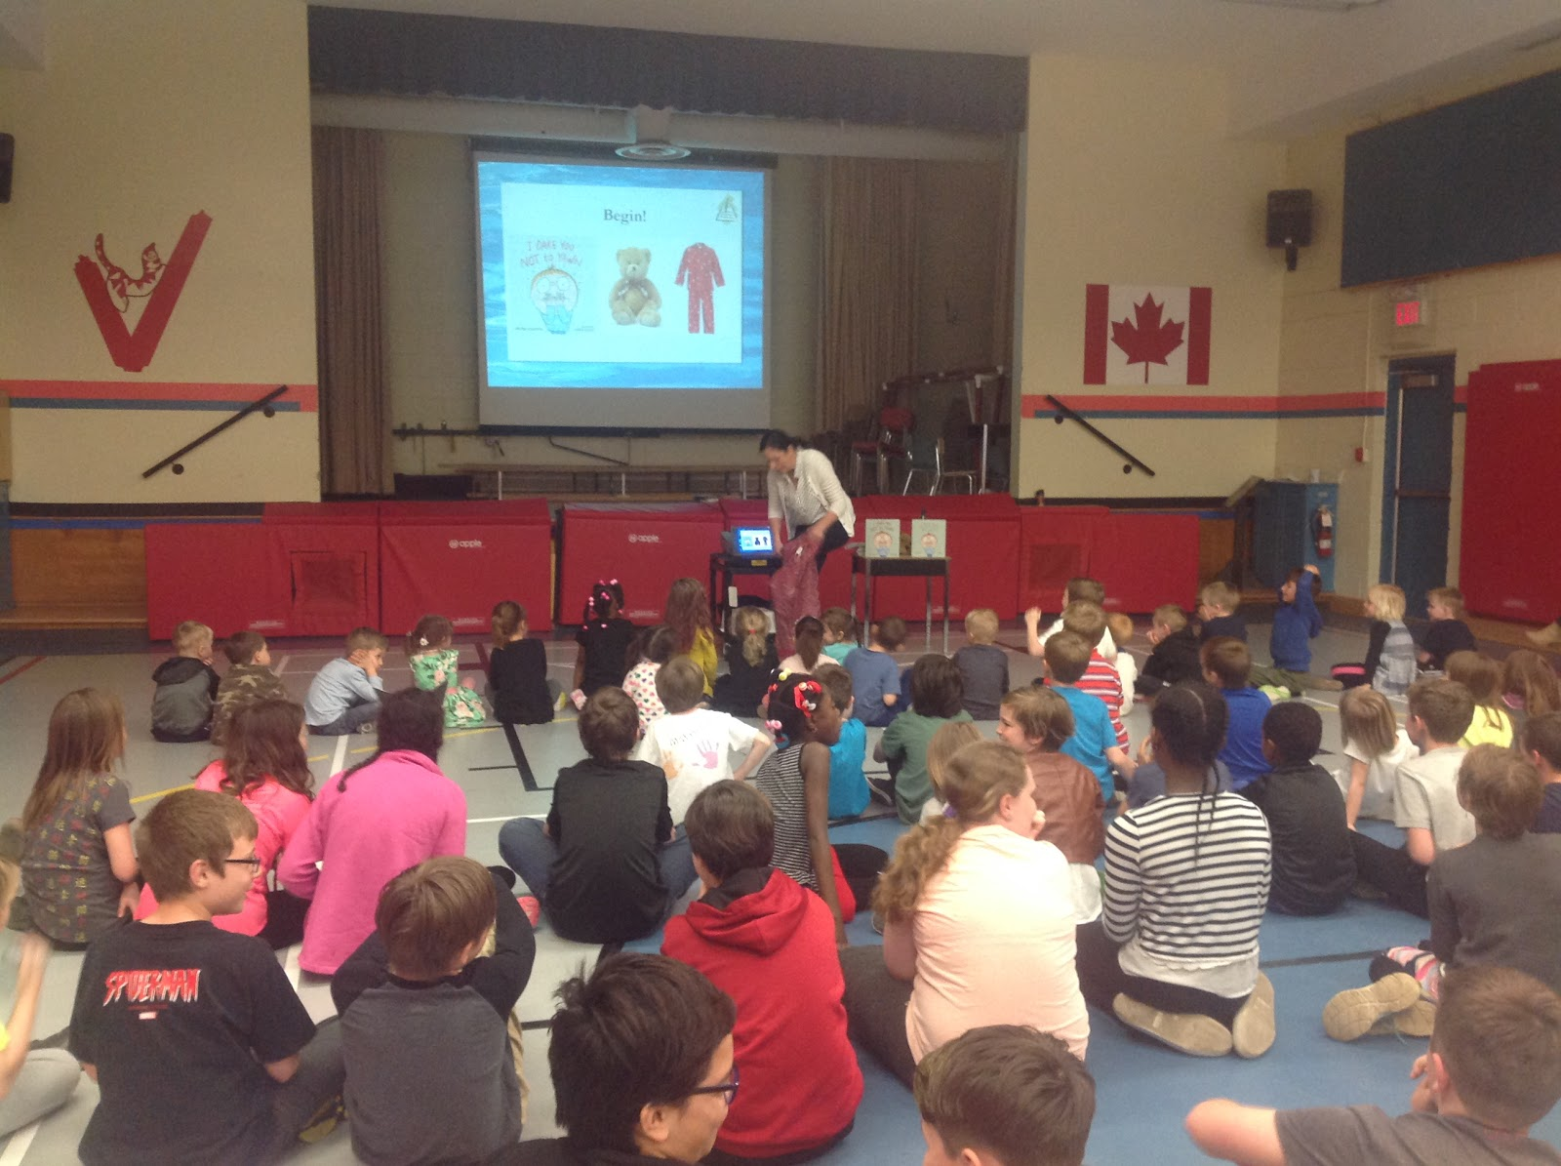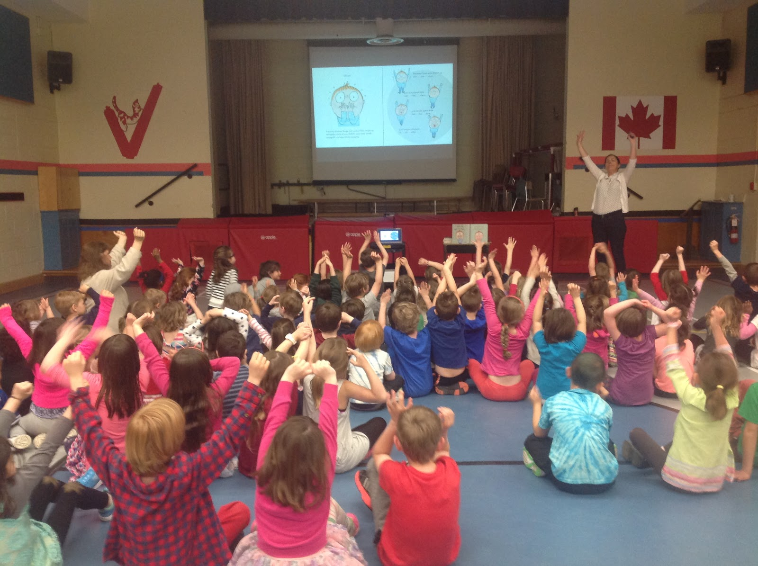
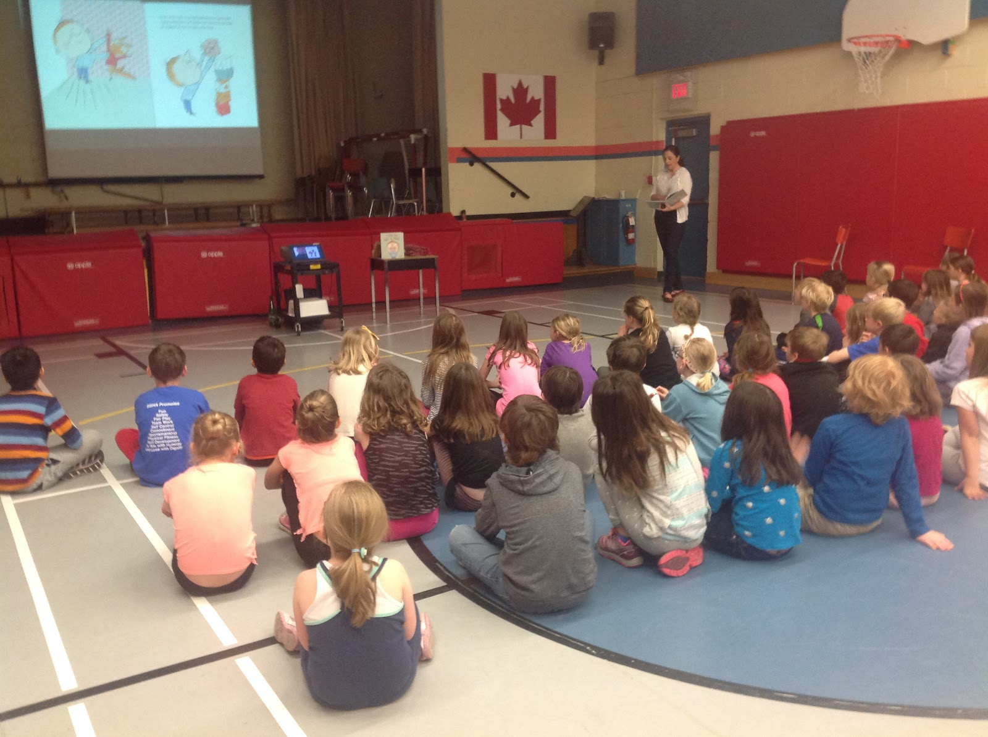
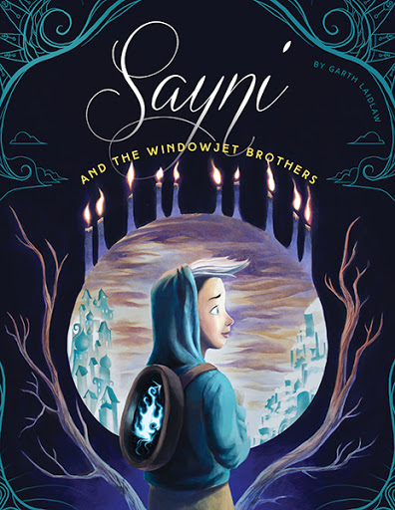

May 9th - Garth laidlaw
Author, illustrator, and Victory alumni, Garth laidlaw will be visiting Victory students on May 9th! Garth is the author of the children’s book Sayni and the Windowjet Brothers. He will be holding one session with the entire school where he will read his book and do a Q & A on writing and illustrating. He will work with individual classes on drawing and writing workshops.

Bookshelf Book fair!
The Bookshelf will be holding a book fair in the library on May 1st and 2nd! Students will have the opportunity to preview the books during the day on Monday, May 1st. After school the bookfair will be open until the Choir performance at 6:30 p.m. Students may purchase books during the day on May 2nd and families are welcome from 3:15-8:00 p.m. 20% of all sales go towards new books for the library!

Book fair hours:
Monday May 1st: 3:15-6:30 p.m.
Monday May 2nd: School day for students and 3:15-8:00 p.m. for family

Forest of Reading Update!
Students from K-6 have been engaged in reading Canadian books with the Forest of Reading program! Victory has run the Blue Spruce, Silver Birch (Fiction, Nonfiction, and Express), Prix Peuplier, and Prix Tamarac Express. Students have been reading in classes, independently and participating in book clubs. Grade 2-3 students who participated in reading the Prix Tamarac books will be visiting Harbour Front in May for the Festival of Trees. A big thank you goes out to Parent Council for making this program a possibility!

Enrichment Clusters

Once again this year our Kindergarten team are organizing a variety of community volunteers and parents to come in and run workshops with our students. All Kindergarten students will enjoy a variety of different activities on May 12th. Thank-you to all of the parents and community volunteers and our amazing Kindergarten teachers and ECE’s for all their hard work.

Primary and Junior Assessments of Reading, Writing and Mathematics
The EQAO (Education Quality Accountability Office) testing for this school year will take place on May 24, 25 and 26 our Grade 3 students and on May 29, 30 and 31 for our children in Grade 6. The Grade 3 and 6 students will do two hours per day on the above dates. Thank you to parents for avoiding interruptions on these dates and sending your children to school with healthy lunches! If you have any questions about the assessment please contact Mrs. Young.

Emergency Drills

As a reminder, each year our school must conduct drills to ensure staff and students are prepared in the event of a real emergency. While our school has been conducting fire drills, lockdown drills and tornado drills for the last several years, beginning this school year, we are also required to conduct a bomb threat drill.

The following number of drills are required each school year:

• Three (3) fire drills in the fall and three (3) fire drills in the spring

• Two (2) lockdown drills

• One (1) tornado drill

• One (1) bomb threat drill

For each of these drills, there is an education component to explain why they are necessary. All drills are conducted in a manner that is sensitive to the needs of our students.

If you have any questions, please do not hesitate to contact the school office

Head Lice
Spring often seems to be a time when we discover a higher number of cases of head lice. Thank you to parents for checking your child(ren)'s hair frequently and letting us know if and when you find these pesky creatures. For more information, please go to: http://www.caringforkids.cps.ca/handouts/head_lice

2016 - 2017 Class Placements
At this point in time we are not sure of class configurations or teacher assignments for next year. We will be setting tentative organizations early in May. Teachers work as a team to make decisions about class placements of each student. Decisions are based on many criteria, including learning styles, work habits and social groupings.
If you would like to make a request based on your child's learning needs, please send Mrs. Young a written note or e-mail message with your request and reason before May 9th. Please note that requests will be taken into consideration along with a variety of other variables.
Class placements will not be announced before the first day of school on Tuesday, September 5, 2017. Please also note that class placement in September is always tentative. Once school has begun our board takes a look at enrollment board wide and makes adjustments according to numbers of students. There is often re-organization during the first two weeks which results in changes for some students and teachers.

Grade 6 Graduation
The Grade 6 Graduation will be held here at the school on Tuesday, June 27th at 4:30 p.m. Traditionally the parents of the Grade 5 students volunteer to decorate the Gym for the graduating class. If you are able to help please contact Mrs. Kelly at andrea.kelly@ugdsb.on.ca

Moving?
If you know that you will be moving out of our school area before the year is done, or during the summer months, please call us at 519-822-6931. This information helps us with our school organization and classroom planning for September, 2017.

Warm Weather Clothing
As the warm weather arrives, many of us delight in putting away our winter jackets, hats, boots, scarves and mittens! With this change in wardrobe, we ask parents to remind students of appropriate dress for school.

This includes:
- hats and caps removed before entering the school
- for safety reason, 'flip flop' style shoes are not appropriate for school
- in gym classes, secure running shoes (not 'Croc' style shoes)

Thank you for your support in helping us maintain a school climate that is conducive to learning.

Booster Juice

A message from the folks at Booster Juice: In an effort to say thank you to all of the schools that have taken advantage of our school lunch program this year, we’ve decided to give all proceeds from one day to all the schools that have helped us provide a nutritious snack for its students. We’ve chosen April 28th to be the day.

Dessert Party
The 57th annual Victory Dessert Party takes place on Thursday, May 18th from 5:30-8:00 p.m.

Jump Rope for Heart
Our Annual Jump Rope for Heart event is on again this year! We will have our kick-off assembly on May 4th and our event on May 26th.
Please watch for a pledge envelope and join us in supporting such an important cause. Mme Lewis

Special Olympics
600 students from the Upper Grand District School Board and Wellington Catholic District School Board will be joining together to celebrate sport at the Special Olympics, May 17th. The event will be held at St. James sports fields, and includes track and field events as well as adaptive events. Athletes flock to the sports fields for the opening ceremonies at 10:00 a.m., and compete in 3 events each throughout the day. Family and friends are welcome to join in the fun and cheer on the athletes. Parking is available at the Grange plaza.

Music
Our Grade 1-6 music classes are very excited to perform for you during the Dessert Party on May 18th. Please watch your child’s agenda for a schedule. We look forward to seeing and entertaining you.
Mme Lewis

Monthly Environmental Activities to help celebrate our planet

 May 22nd is International Biodiversity Day!
It is vital to teach our children to respect and take care of the environment.

Celebrate International Day For Biological Diversity on May 22nd!
The United Nations has proclaimed May 22 The International Day for Biological Diversity to increase understanding and awareness of biodiversity issues.
Biodiversity, a simple word with some very broad reaching implications quite simply means: ‘A wide range of life’” We need to learn more about it in order to protect it.

“Biodiversity, at the level of species and ecosystems, provides an important foundation for many aspects of sustainability.” António Guterres, Secretary-General of the United Nations
https://www.cbd.int/idb/2017/

Ideas for your family to celebrate Biodiversity Day!

- Visit farmers markets in your local area to try new types of produce. Whether you incorporate heirloom tomatoes into your cooking, or try one of the rainbow of colors of carrots out there that aren’t orange, biodiversity can bring a great new experience to your table.
- View photos of endangered species on the Internet and discuss the reasons why these animals are threatened and why they should be protected.
- Join a community group and help to remove invasive plants from your local environment. These teams of volunteers will gather to remove plants that are impacting the local fauna’s biodiversity by taking over natural grow areas.
- Get out into the world and enjoy all the different types of life your local area offers. Even a local park can have an amazing variety of life you’ve never noticed, from the insects crawling through the grass, to the flowers we so clumsily lump together as ‘wildflowers’.
Adapted from: https://www.daysoftheyear.com/days/international-day-for-biological-diversity/

Celebrate the diversity of our natural world every day!

Talking about Mental Health - May 1-5 is Child and Youth Mental Health and Well-being Week!
Participate! Have Fun! Increase Awareness! Increase Well-being!
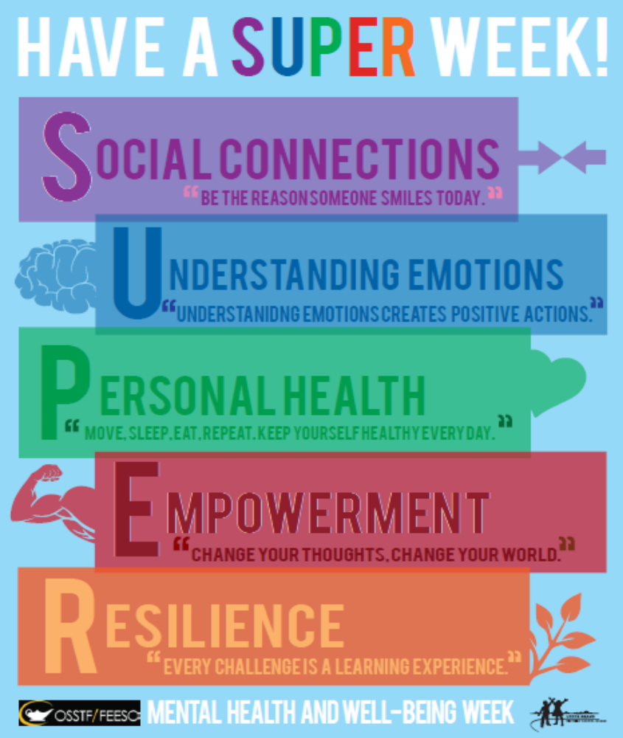
The UGDSB is participating in Mental Health and Well-being Week and so are our community partners.
Here are some of the events in the community for you and your family to participate in:
CMHAWW is presenting the following:
(see http://mailchi.mp/2d253253c223/mental-health-week-events-2017?platform=hootsuite for details)
May 1st Canadian Comedian and Mental Health Advocate Mike MacDonald - $20 - CIGI - Waterloo - 7:00 p.m.
May 1st Free film viewing of 'Resilience' - Recital Hall at the Guelph Youth Music Centre - 7:30 p.m.
May 2nd - Free SafeTALK training in Guelph - provided by our Education and Promotion - 6:00 p.m.- 9:30 p.m.
May 3rd - Clint Malarchuk - Former NHL Goalie and Mental Health Advocate speaking - $10 - Bingemans - 7:00 p.m.
May 4th - Free 'Room to Breathe' Mindfulness film viewing and panel discussion - 7:00 p.m. Kitchener Public Library
May 4th - Free - Clint Malarchuk - Former NHL Goalie and Mental Health Advocate will also be speaking at the Arthur Arena Hall – 7:00 p.m. - Admission by donation.
DCAFS is presenting : (see https://dcafs.on.ca/building-better-tomorrows-2/ for more details)
May 3rd – Sheldon Kennedy - former NHL Player and author of Why I Didn’t Say Anything will be speaking at the Caledon Ski Club. $100, all funds raised to support Dufferin Children’s Fund.
CMHA Dufferin Peel is hosting: (see https://cmhapeeldufferin.ca/events/bbqart-show/ for more details)

May 3rd - A BBQ and Art Show at Edelbrock Centre. The BBQ is from 11:30 to 1--hamburger, chips and drink for $5. Art show is from 11:00 to 4:00 p.m.

Have a SUPER Week!
Dr. Lynn Woodford is the Mental Health and Addiction Lead for Upper Grand District School Board
Follow me on twitter: @drlynnwoodford

