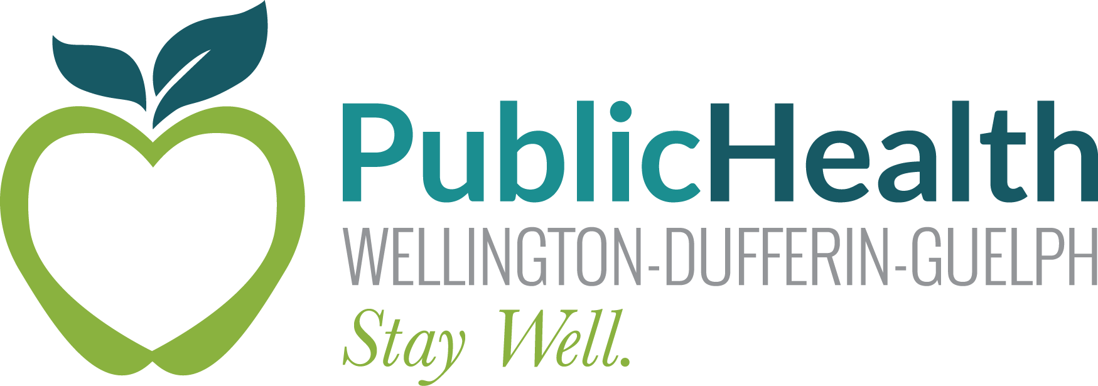 MEMO

To: Aberfoyle Public School – Bus Cohort
Subject: COVID-19 Outbreak
Date: April 12, 2021

Wellington-Dufferin-Guelph Public Health (WDGPH) has declared that there is a COVID-19 outbreak linked to Bus Route #188. An outbreak means that there are at least two individuals who tested positive for COVID-19 and at least one of the individuals was likely infected at school (including transportation and before/after school care).

WDGPH has completed contact tracing with the affected classes/cohorts of staff and students. Anyone who was determined to be a high-risk contact of the individual who tested positive have received a “high-risk letter” with further information and directions for self-isolation.

Staff or students who do not receive a letter from WDGPH are not considered a high-risk contact and can continue to complete the daily COVID-19 School and Child Care Screening tool and monitor for symptoms. If symptoms develop, please stay home and seek COVID-19 testing or follow the guidance from the screening tool.

