Your park survey results  are in!  Alma Community Recreation Association (ACRA)  Invites you to come join us for our  Family Fun Event,  Graciously supported by Township of Mapleton 50/50 funding proposal.  come join us for our family fun event, enjoy Wallace cumming park master plan update  Your opinion matters! Have a say on the future of your park! |  |  | 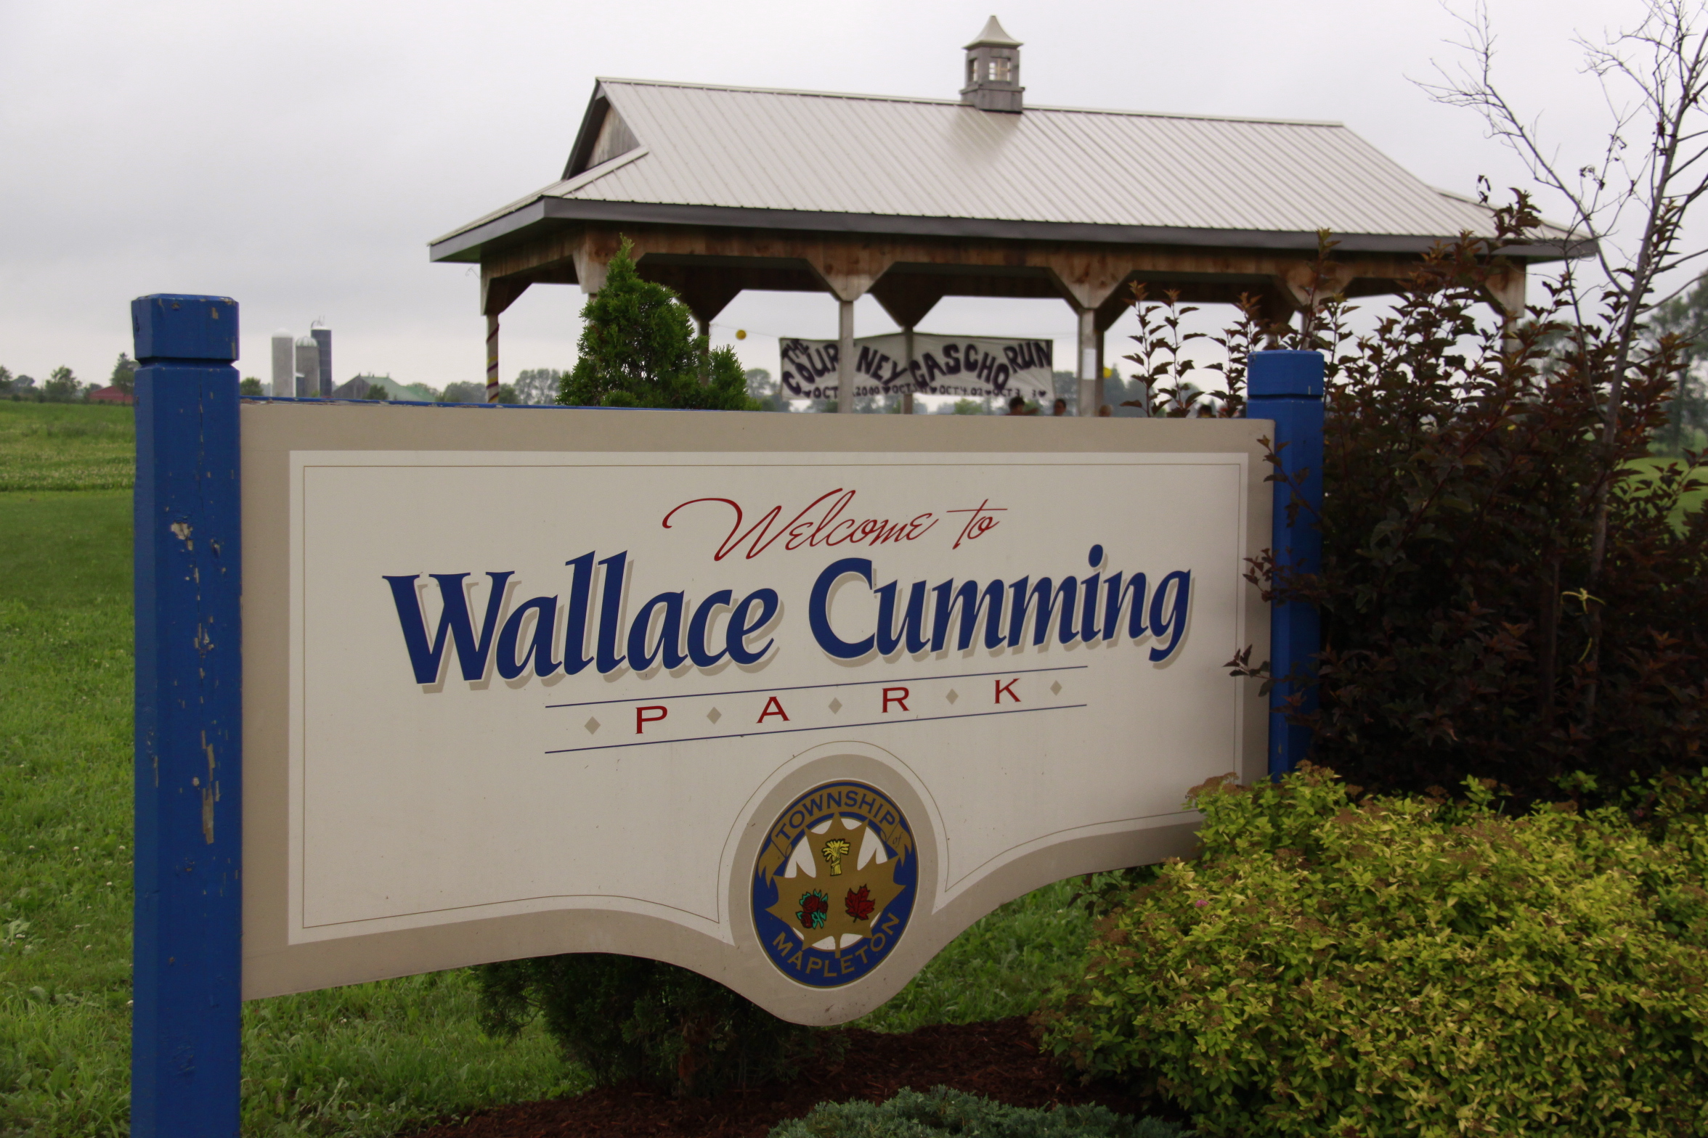  WHEn?  Friday, May 11th, 2018  5:30 p.m. to 7:30 p.m.  at Wallace Cumming Park  &  Alma Community Centre

shinny hockey, table hockey, disc golf, scavenger hunt in the park, piecing the park development puzzles

Discover with your family, the results of the recent
Wallace Cumming Park Master Plan Revisited – 2018 survey.

Hot dogs, drink & dessert (courtesy of Mapleton Township, Alma Optimist Club & ACRA)

This event is graciously supported through the Township of Mapleton 50/50 Funding Proposal for 2018.
This event is ACRA’s Interactive Annual Meeting – no sitting required! Full reports and recommendations being forwarded to the Township of Mapleton for future Wallace Cumming Park development consideration will be available at the event, as well as online after the event. Email to address below for your copy.

Email: acra.alma2018@gmail.com
Facebook: https://www.facebook.com/almacommunityrecreationassociation/

