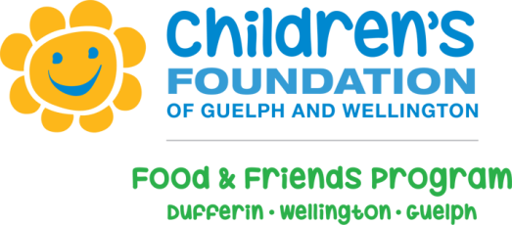
May 30, 2018
Alma Public School Snack Program

The snack program at Alma Public School has been operating since 2008. The food the students receive includes the required servings from Canada’s Food Guide with an emphasis on fresh fruits and vegetables. We know that once healthy food is provided, a child’s world changes. They become more alert, able to concentrate, and improve socially, physically and academically. We want to be able to provide our students with the best possible learning environment, therefore, we offer the snack program daily to each and every one of our students for the occasions when they have finished their lunches and are still a little bit hungry.
The program is supported through grants received from the Ministry of Children and Youth Services as well as, The Children’s Foundation of Guelph and Wellington Food and Friends. The parent council of Alma Public School makes a generous contribution to the program on a yearly basis. In the past we have received community donations as well as parent contributions. Alma Public School hosts a yearly fundraiser, the Live Free Campaign, were all funds raised go directly to our snack program.
Our snack program is facilitated daily by the generous support of our student volunteers along with the assistance of a parent volunteer. The students are responsible for the distribution of the snack bins, including preparing of the fruit, filling the snack bins and then returning them at the end of the nutrition break. Our parent volunteer also looks after all of the grocery shopping for the snack program. As it is said, “many hands make light work”, therefore we would like to provide you with the opportunity to contribute if you so choose and are able. There are a number of ways to support the snack program at Alma Public School some may include; volunteering and/or supporting our fundraising efforts.
Best regards,

Alma PS Snack Program Committee

