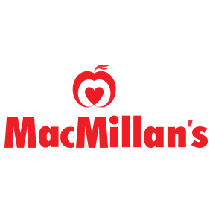

YOU DESERVE A

Cookie

I am participating in a fundraiser for

Brant Avenue Public School
____________________________________________

We have joined up with MacMillans Foods to bring you a delicious assortment of Cookie Dough, Muffin batter and other tasty treats!

Please consider showing your support.
Simply shop online at
www.macmillans.online/shopfundraising
Using the Code:
BAPS / Student Name
(School Code / Student Name)

The deadline to get your orders in is
March 23 2022
so please be sure to get your orders in on time and help make this campaign a success.
Please visit https://www.macmillans.online/faq with any questions.

We greatly appreciate all your dedication. Together we can reach our mutual goals in sustaining important school programs.
Thank you.

