Monthly environmental activities to help celebrate our planet

February 7th is National Sweater Day!

Make the Earth better by wearing a sweater

Celebrate National Sweater Day on February 7th!
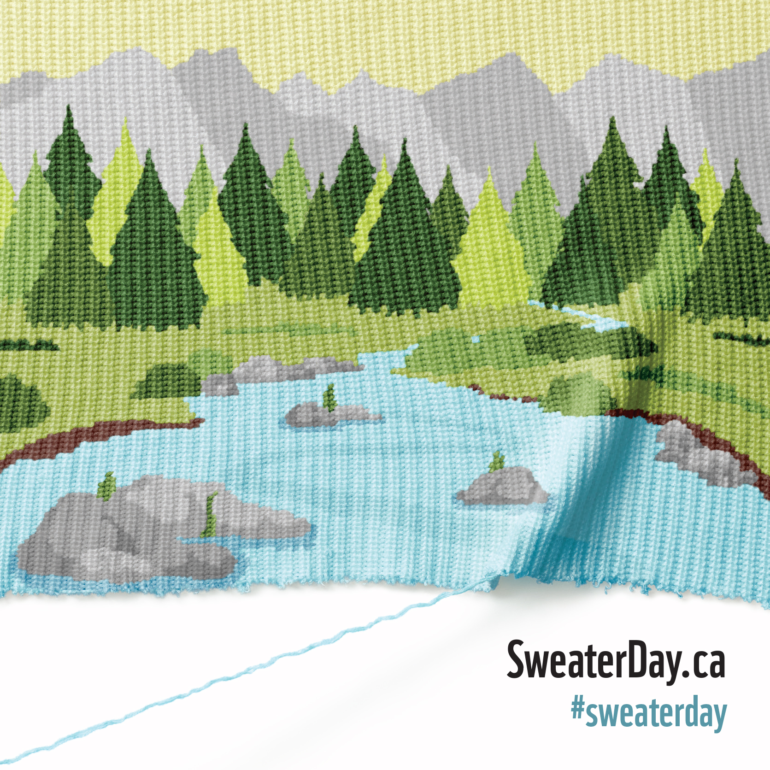
National Sweater Day is a way to learn about the importance of saving energy and to inspire you to use less energy all winter. Heating accounts for 80% of residential energy use in Canada. If all Canadians lowered their thermostats by just 2 degrees Celsius this winter, it would reduce greenhouse gas emissions by about 4 megatons – that’s equivalent to taking nearly 700,000 cars off the road! http://www.wwf.ca/events/sweater_day/

National Sweater Day is about thinking differently about how we use energy, where our energy comes from and how we can play an important role in fighting climate change by using energy wisely. It is designed to help raise awareness about renewable energy and change behaviours around energy consumption in Canada. assets.wwf.ca/downloads/nsd_2017_en_school_toolkit.pdf

Ideas for your family to celebrate Sweater Day
- Turn down your thermostat and wear a sweater on Feb 7th - and every day this winter!
- Ask your children to brainstorm with you about ways to save energy at home. Make a pledge to implement as many as you can. For extra ideas go to: https://www.ontario.ca/page/how-use-less-electricity-home
- Read a children’s book on conservation such as: Why Should I Save Energy? by Jen Green. Encourage lots of questions and find the answers together.
- Learn about Green Energy sources. What types of renewable energy are available in Ontario - Wind? Solar? Geothermal?
- Valentine’s Day is just around the corner - use recycled materials to create your cards this year! To learn more about how recycling saves energy go to Alliant Energy Kids: www.alliantenergykids.com/UsingEnergyWisely/SavingEnergyAtHome

