Monthly environmental activities to help celebrate our planet

April 22nd is Earth Day!

“Look deep into nature, and then you will understand everything better.” - Albert Einstein

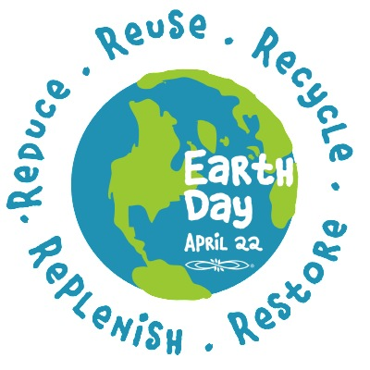
Celebrate Earth Day on April 22nd!
Founded in 1990, Earth Day Canada inspires people of all ages across the country to connect with nature and build resilient communities as well as foster an intrinsically motivated, enduring commitment to stewardship and conservation. https://earthday.ca/about/
waystogogreenblog.com

Earth Day 2018 Theme: End Plastic Pollution

From poisoning and injuring marine life to disrupting human hormones, from littering our beaches and landscapes to clogging our waste streams and landfills, the exponential growth of plastics is now threatening the survival of our planet. Earth Day 2018 is dedicated to providing the information and inspiration needed to fundamentally change human attitude and behavior about plastics. https://earthday.org

Ideas for your family to celebrate Earth Day:

- Get involved with Earth Day 2018’s Theme https://www.earthday.org/yourjourney2018/
Download your Plastic Pollution Primer to learn more about this problem and act to help End Plastic Pollution!
- Spend a day outside. In the garden with your family, plant vegetables, trees or native flowers and attract native animals and pollinators. Or join a local community event to help clean your neighbourhood or restore local plant life.
- Make commitments to cut down on your energy usage as well as waste. Turn lights off, power down electrical devices, turn down your thermostat and only do full loads of laundry and dishes. Always bring cloth bags when shopping, refuse to buy over packaged products, and lug a mug instead of using non-recyclable coffee cups.
- Learn more about the environment and the effects of global warming. Encourage awareness and promote the Reduce, Reuse and Recycle way of life.
Remember that every day is Earth Day! Don't restrict yourself to just one day a year. Make environmental actions and caring about the planet a habit - on Earth Day and every day.

