Centre Peel Public School
“Helping Hands, Caring Hearts, Learning Together”
7623 Sixth Line ● Drayton, Ontario ● N0G 1P0
● Phone: 519.638.2668 ● Fax: 519.638.5530 ● Alternate Phone Number 519-400-2807

Welcome to November 2020 …
Welcome to November! A month worthy of special recognition as it is host to Treaties Recognition Week, November 1-7, Remembrance Day November 11 and Bullying Awareness and Prevention Week November 15-21. Due to COVID and the limitations on large gatherings, Centre Peel will be adjusting how we recognize these significant events.
During Treaties Recognition Week students will hear about what Treaties are and why they exist. In daily announcements the ‘Thought of the Day” will be in the form of a “did you know. . . .”? that shares facts about Treaties.
November 11th, Remembrance Day, will be observed in individual classrooms through a virtual assembly. Because Remembrance Day is an important part of our Canadian identity, helping to shape our continuous quest for peace and understanding, each class has been asked to prepare something that can be included in the slide show presentation that teachers will commit time to viewing with their class on November 11^{th .}
Finally, Bully Prevention Week will be marked by a Day of Pink on Wednesday, November 18. Throughout the week, teachers are being asked to work with students on building relationships that foster tolerance, inclusion and friendship. Your child will be supported in learning more about bullying and its effect on learning and well-being in an effort to help promote safe schools and a positive learning environment. They will learn about the different forms of bullying that can take place and how to get help should they be victims of bullying
- Physical – hitting, shoving, stealing or damaging property
- Verbal – name calling, mocking, or making sexist, racist or homophobic comments
- Social – excluding others from a group or spreading gossip or rumours about them
- Electronic (commonly known as cyberbullying) – spreading rumours and hurtful comments through the use of cellphones, e-mail, text messaging and through social media.

Chris Kay
Principal

And now for a look at how Centre Peel is bringing ‘fun’ to learning. Can you identify what is special
about what’s happening in the pictures?

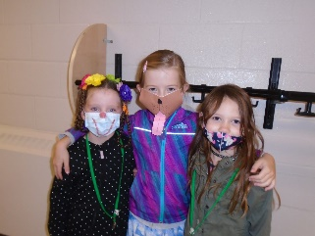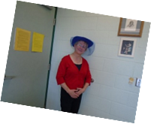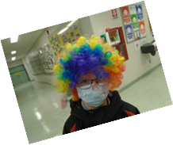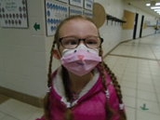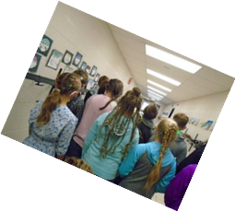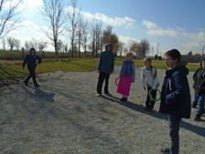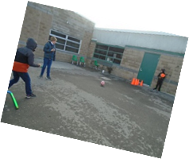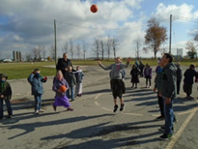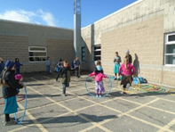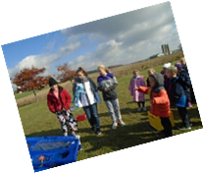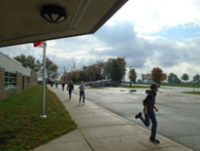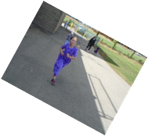

Remembrance Day
Centre Peel Public School will be holding our Remembrance Day celebration in our homerooms only on Wednesday November 11 from 9:45 am to 10:45 am. Student will be participating in creating a remembrance path out front of the school. Many thanks to Ms. Howard for all of your help in getting the supplies we needed to make this great project!

Weather Reminder
As cold wet weather has arrived, please help your children to dress appropriately for spending time outside. Many of our students are coming to school without coats and are very cold at recess. Our school is surrounded by open fields and the wind blows quite heavily across the yard. Students should wear appropriate clothing as the expectation is for them to be outside as much as possible.

Indoor Shoes
If your child would like to wear boots for outdoor play please make sure they bring a pair of indoor shoes for gym class. Accommodations will be made for storing the boots during class time so they aren’t at students’ desks.

Report Cards
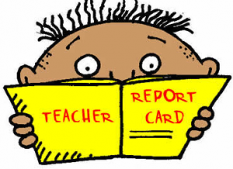
Progress Report Cards will be sent home with students on November 19th, 2020. Please sign and return the bottom portion of the report as soon as possible. Parent/ Teacher Contact will be made on the evening of November 26 and on the PA Day November 27th, 2020.

Spirit Week
Centre Peel participated in a week of fun last week. Students were able to earn points for their Spirit teams by wearing a hat, a class colour, funky hair and masks, pajama’s and by playing fun games on play day. Points awarded helped team leaders bid on an auction of surprise bags from all of the staff! Spirit week is always a great hit at Centre Peel. Thank you all for participating and for donating to our Terry Fox Run!

Upcoming Events :
Please check our website for up to date information and any changes that are taking place in the events for the month.

November 1- Daylight Savings Time Ends, turn clocks back one hour
November 1-7- Treaties Recognition Week
November 11- Remembrance Day in classrooms at 9:45 am
November 15-21 Bully Prevention week
November 18- Day of Pink-wear pink
November 19- Report Cards home
November 27-Parent teacher interviews and PA Day

School Council 2020-2021

Our school council has been unable to meet so far this year so our Parent Council will remain with Dennis Frey as chair and with Brian Gingrich as vice chair. We are looking forward to arranging a time when we can meet in person. Virtual meeting information will follow as soon as details are finalized.
Dennis Frey Dennis Diefenbacher
Brian Gingrich Darren Gingrich Gerald Martin
Melvin Martin Isaac Thiessen
Paul Weber Jacob Zacharias

