Monthly environmental activities to help celebrate our planet

JANUARY is the time to carry out your Eco Resolutions!

“There will be more waste plastic in the sea than fish by 2050” Dame Ellen MacArthur

It’s a brand new year and the perfect time for positive change. For example, let’s end plastic pollution.
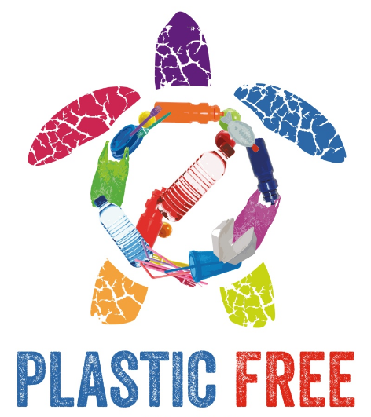
Based on the daily news, it’s never been more critical to increase your environmental efforts. The Earth Day Network is calling to end plastic pollution. Imagine a future free from harmful plastic garbage! Single-use plastics are especially wasteful and many plastics are also not properly recycled and take up precious landfill space or pollute our oceans, killing marine life and washing up on pristine beaches. Plastic garbage ‘islands’ are appearing in seas and oceans all over the world.
www.wuft.org
https://www.nationalgeographic.org/encyclopedia/great-pacific-garbage-patch/

Tips on how to reduce single-use plastics:

- Extend your use of cloth shopping bags beyond the grocery store. Use them at all other retail stores too.
- Avoid buying over-packaged food. The choice is yours. Do you need to buy the carrots that are shrink wrapped on a Styrofoam tray?
- Let the restaurants you frequent know that you would them to join the growing movement to ban the use of straws. Many have implemented a 'serve-straws-upon-request' policy.
- Tap water is best. Bottled water can deplete our precious groundwater resources and produce unnecessary green house gas emissions through the production and transport of plastic bottles. Carry a reusable water bottle instead.
- Lug a travel mug to your local coffee shop. (The plastic lining makes coffee cups unrecyclable, and they all end up in the garbage and in our overflowing landfills.)
- Write letters to the government asking them to fix a problem that you are concerned about such as: mandating the reduction of plastic packaging, banning Styrofoam, or promoting research for recyclable coffee cups or coffee pods, etc.

