Monthly environmental activities to help celebrate our planet

April 22nd is Earth Day!

“Look deep into nature, and then you will understand everything better.” - Albert Einstein

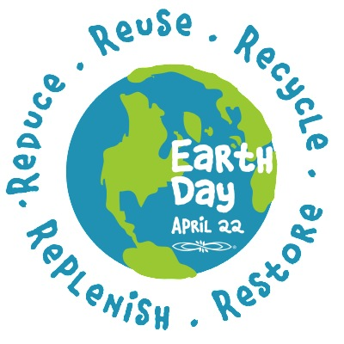
Celebrate Earth Day on April 22nd!
Founded in 1990, Earth Day Canada inspires people of all ages across the country to connect with nature and build resilient communities as well as foster an intrinsically motivated, enduring commitment to stewardship and conservation. https://earthday.ca/about/
waystogogreenblog.com

Earth Day 2021 Theme: Restore Our Earth
The theme is based on the emerging concept that rejects the idea that our only options to save the planet are to mitigate or adapt to the impacts of climate change and other environmental damage. Go to https://earthday.org for some quick facts and additional information about this problem.

Ideas for your family to celebrate Earth Day:

- Review previous Earth Day Themes. For example there is a ongoing focus on ending plastic pollution. Make a pledge to always carry a reusable shopping bag, use alternates to Ziploc bags, buy in bulk, refuse to buy-over packaged products and make litter-less lunches. Download your Plastic Pollution Primer to learn more about this problem help End Plastic Pollution!
- Spend a day outside. In the garden with your family, plant vegetables, trees or native flowers and attract native animals and pollinators. Or join a local community event to help clean your neighbourhood or restore local plant life.
- Make commitments to cut down on your energy usage as well as waste. Turn lights off, power down electrical devices, turn down your thermostat and only do full loads of laundry and dishes.
- Learn more about the environment and the effects of global warming. Encourage awareness and promote the Reduce (buy less), Reuse (repurpose it) and Recycle (sort it right!) way of life.
Remember that every day is Earth Day! Don't restrict yourself to just one day a year. Make environmental actions and caring about the planet a habit - on Earth Day and every day.

