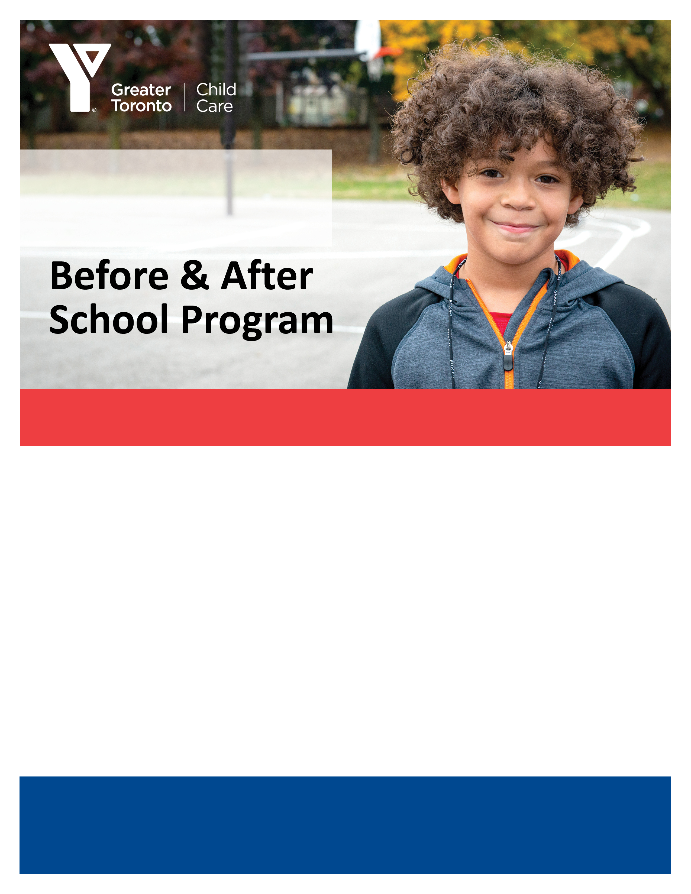

East Garafraxa

YMCA

**Now Accepting Registrations!**

**For program details contact**

519-215-0936

Kirsten.Almand@ymcagta.org

Quality care for 4-12 year olds

**Register Today!**

• Safe environment where children contribute to their daily plan.

• YMCA Playing to Learn™, our research-based curriculum, implemented in

Extended Day programs for 4-5 year olds.

• YMCA A Place to Connect™, guided by the new school age curriculum, fosters   
 fun, friendship and learning for 6-12 year olds.

• Qualified staff who provide physical activity, team building and leadership

opportunities.

• Programs from 7:00 a.m. until school bell, and after school until 6:00 p.m.

• P.A. Day, Winter Break and March Break Programs available.