Math on the Go!
Card Games to Develop Math Skills For All Ages

Are you looking to help your child to develop his or her math skills at home in a meaningful and engaging way, while spending quality family time together? Why not try some card games! Playing a card game can take as little as 5-10 minutes. Next time you find yourself trying to entertain your child while waiting at the dentist office or at a sports practice, why not bring along a deck of cards and play a couple of card games with your child. This is a great way to connect socially with your child, while practicing math skills. As author Marilyn Burns says in her book, Win-Win Math Games: "Games help to lift math off the textbook pages, and they support students' learning about numbers and operations."
(Retrieved on May 1, 2018 “Acing Math One Deck At A Time, The Positive Engagement Project” http://www.pepnonprofit.org/uploads/2/7/7/2/2772238/acing_math.pdf )

Card Sort (Grades K - 3)  Players: Individual or groups of two  Materials: Deck of cards  Skill: Number recognition and group, sort, or categorize by attribute  How to Play: As a group, or individually, have students use the full deck of cards to sort and create groups by attribute. Some sorting possibilities are by color, suit, or number. | 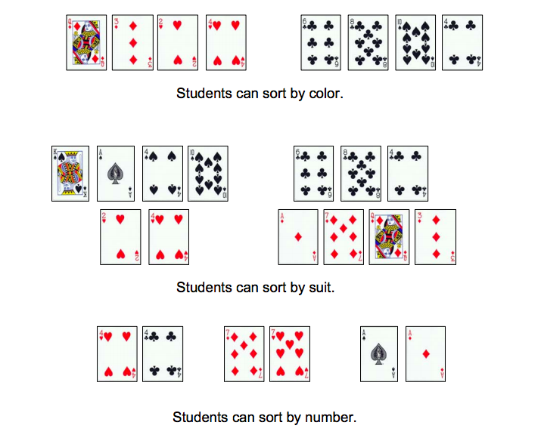
Reading Multiplication Minds  (Grades 3 - 6)  Players: Groups of three (groups of four or five for more advanced)  Materials: Deck of cards  Skill: Multiplication, product  How to Play: In this game for three players, one student is the leader and the other two are the “mind readers”. | 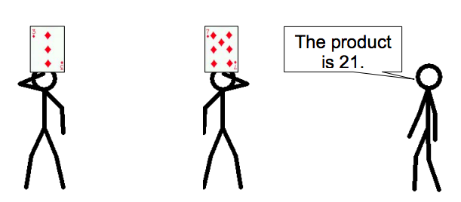  The two players each draw a card and, without looking at it, hold it up to their foreheads so that everyone else can see it, but themselves. The leader announces the products of the two cards. Each “mind reader” must figure out which card is on his or her own forehead and say it aloud. When both “mind readers” have figured out their cards, a new leader is chosen and the game continues. With Reading Multiplication Minds, all players get practice with products and factors in every round.
Integer Addition Number Battle (Grades 5 - 8)  Players: Groups of two  Materials: Deck of cards, Ace worth 11, Jack worth 12, Queen worth 13, King worth 14, scratch paper  Skill: Number recognition, positive integers, negative integers, and addition  How to Play: Black cards are positive numbers; red cards are negative numbers. Players split a deck of cards and simultaneously flip over their top two cards. Remember -2 is greater than -7. | 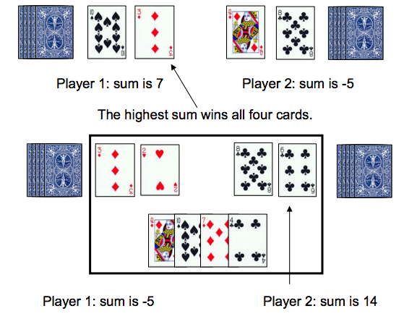  If the cards sums have the same value, the cards are placed in a center pile. The next hand is played normally and the winner of the next addition number battle takes the center pile as well.

