Monthly Environmental Activities to help celebrate our planet

September 27th is National Tree Day!

“Let nature be your teacher.” William Wordsworth
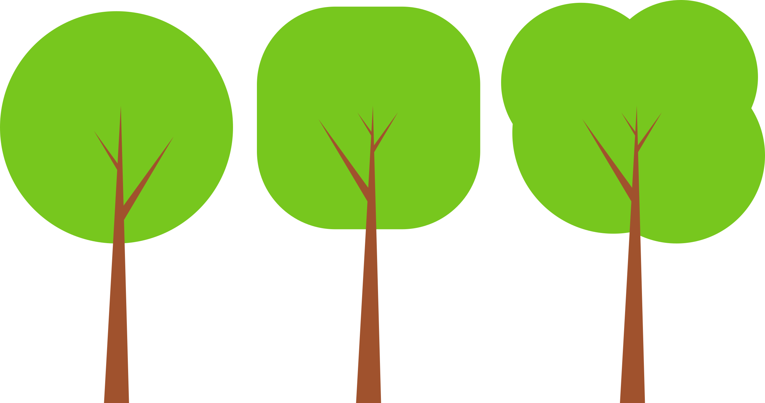
Celebrate National Tree Day on September 27st 2017!
“National Tree Day will serve as a celebration for all Canadians to appreciate the great benefits that trees provide us - clean air, wildlife habitat, reducing energy demand and connecting with nature.”
http://www.nationaltreeday.ca/

“Children today spend less time outdoors than any generation in human history.” http://getbackoutside.ca/

“For children, studies show that time outdoors, especially unstructured time in more natural settings, can increase curiosity, creativity and problem solving ability. It also improves their physical fitness and coordination.” http://30x30.davidsuzuki.org/

Some great activities for your family to do on Tree Day, or any day!

- Read a book on trees: The Lorax, by Dr. Seuss; The Giving Tree by Shel Silverstein; What Good Is a Tree by Larry Dane Brimner; The Great Kapok Tree by Lynne Cherry
- Learn the names of the trees in your backyard or neighbourhood
- Do tree art – e.g., a leaf collage, or leaf/bark pencil rubbing art, or tree photography
- Create a tree book: "adopt" a favourite tree, name it and throughout the year record and examine its characteristics and the changes that it goes through.
- Organize a Tree Walk game - Look for trees that are: the tallest, oldest, has the widest trunk, has the largest leaf, is the most prickly, etc.
- Download a bird app and start to help your child learn to identify the colours and songs of birds in your neighbourhood
- Research all the great forest hiking trails in your area and pick one to try out.
- Hold a Tree Day birthday party with your family, friends, neighbours or community! Serve tree-shaped foods! (Find lots of ideas on Pinterest.)

For more ideas:
- Join the 30x30 Nature Challenge: If you want to feel healthier, happier and more focused - add a daily dose of nature to your routine! Find out more at http://30x30.davidsuzuki.org/
- Do a Google search: “What to do on a nature walk” or “Arbour Day activities”

