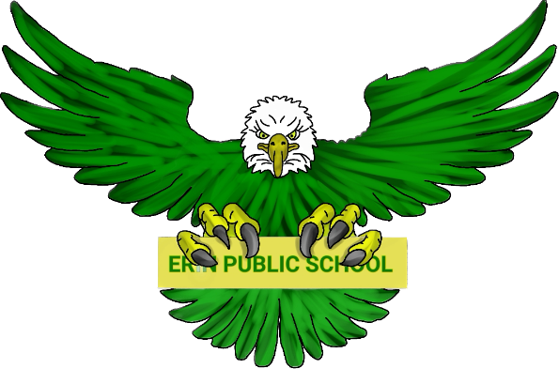
Erin Public School Parent Council | November 7, 2023 6:30pm
Meeting called by: Parent Council Executive Meeting type:  Hybrid, monthly | In-person - Erin Public School Library  Online Link
Agenda
Welcome | 6:30 – 6:40
To be approved:  - Agenda  - Minutes from October 3, 2023 | 6:40 – 7:00
Principal/Vice Principal Updates:  - Ms. Regota  - Mr. Allen  - Teacher’s requests | 7:00 – 7:20
Treasurer Report | 7:20 – 7:30
Fundraising:  - Current initiatives update  - Holiday Card  - Holtom’s  - Cheese  - Volunteers Needed – Nov. 23  - Holiday Music Night | 7:30 – 8:00
New Business:  - EQAO Results  - Freezer for Servery  - Winter Item Donations  - Bazaar Donations  - Chamber of Commerce Membership | 8:00 – 8:30
Discussion  - Open to group | 8:30 - 9:00

