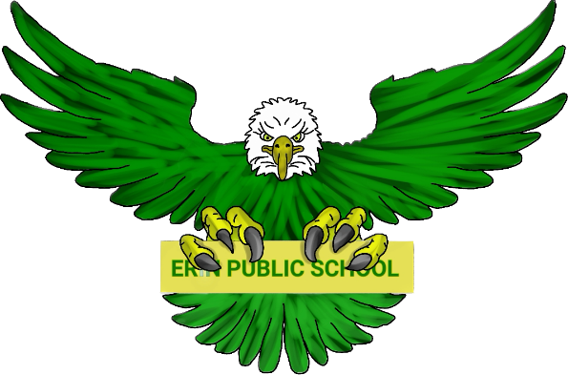
Erin Public School Parent Council | October 3, 2023 6:30pm
Meeting called by: Parent Council Executive Meeting type:  Hybrid, monthly | In-person - Erin Public School Library  Online Link
Agenda
Welcome | 6:30 – 6:40
To be approved:  - Constitution and Bylaws | 6:40 – 7:00
Principal/Vice Principal Updates:  - Ms. Coulombe  - Mr. Allen  - Teacher’s requests | 7:00 – 7:20
Treasury Report  - Update | 7:20 – 7:30
Fundraising:  - Hot Lunch Update  - Carnival Update  - Paper Shredding Event  - Other ideas | 7:30 – 8:00
Outdoor Items:  - Where does this stand? | 8:00 – 8:10
New Business:  - Best Buy Technology Grant  - Open House Debrief / Feedback | 8:10 – 8:30
Class Trips:  - Grade 6 Mansfield Trip  - Grade 8 Trip  - Others? | 8:30 – 8:45
Discussion  - Open to group | 8:45 - 9:00

