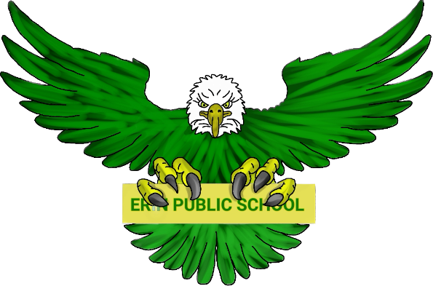
Erin Public School Parent Council | February 6, 2024 6:30pm
Meeting called by: Parent Council Executive Meeting type:  Hybrid, monthly | In-person - Erin Public School Library
Agenda
Welcome | 6:30 – 6:40
To be approved:  - Agenda  - Minutes from November 7, 2023 (no December mtg, January mtg deferred) | 6:40 – 7:00
Principal/Vice Principal Updates:  - Ms. Coulombe  - Mr. Allen  - Teacher’s requests | 7:00 – 7:20
Treasurer Report | 7:20 – 7:30
Fundraising:  - Review of November 2023 initiatives  - Holiday Card  - Holtom’s  - Cheese  - Discussion re: holiday fundraising events | 7:30 – 8:00
New Business:  - EQAO Results  - Freezer for Servery  - Diversity and Inclusion Committee – Jenna | 8:00 – 8:30
Discussion  - Open to group | 8:30 - 9:00

