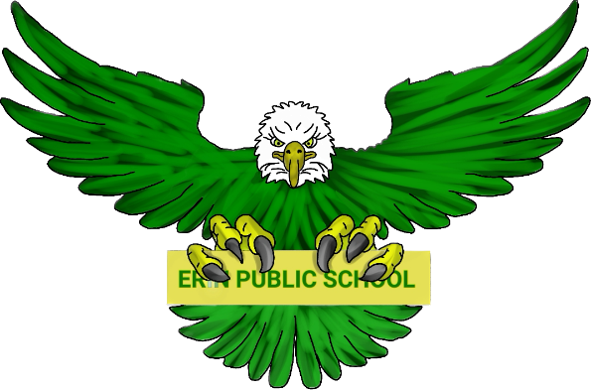
Erin Public School Parent Council | April 9, 2024 6:30pm
Meeting called by: Parent Council Executive Meeting type:  Hybrid, monthly | In-person - Erin Public School Library
Agenda
Welcome | 6:30 – 6:40
To be approved:  - Agenda  - Minutes from March 5, 2024 | 6:40 – 7:00
Principal/Vice Principal Updates:  - Ms. Coulombe  - Mr. Allen  - Teacher’s requests | 7:00 – 7:20
Treasurer Report | 7:20 – 7:30
Fundraising:  - Update  - Paper Shredding Event  - Hot Lunch / Lunch Box | 7:30 – 8:00
New Business:  - Update on guest speaker topic – Gaming / Screen time impacts on mental health  - Update on Tribal Vision – dates to be confirmed  - Annual Principals Survey | 8:00 – 8:30
Discussion  - Open to group | 8:30 - 9:00

