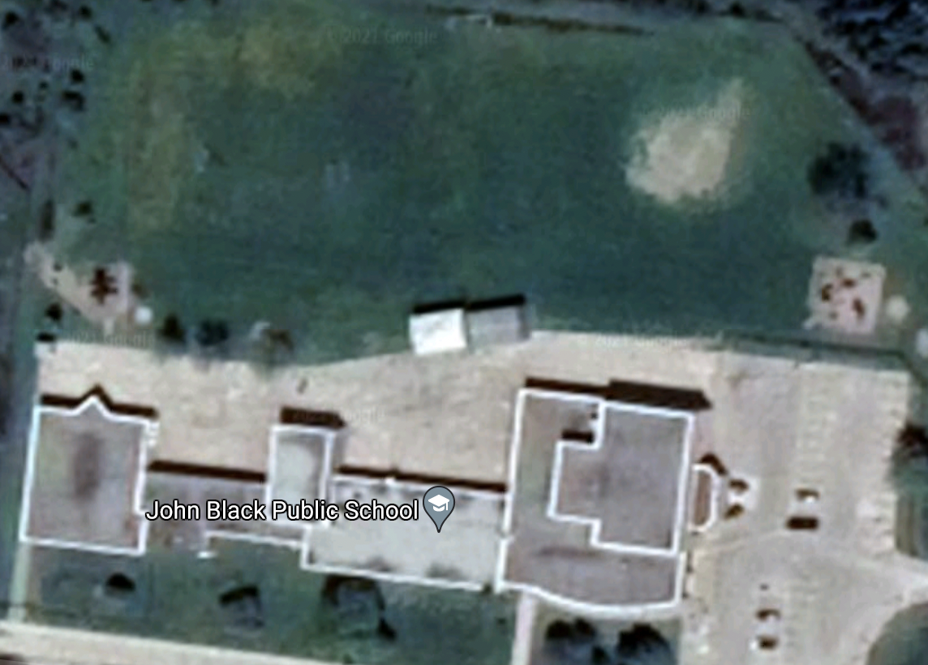
John Black Class Lines Map 2021-2022
Junior
Portables
Primary
Intermediate
Kindergarten
Ms. Matheson 5
Ms. Oszewki 6
Mr. Mooney 4
Ms. Fulcher 4/5
Mr. Lawson 5/6
Mr. Kordupel 8
Mr. Hirst 7

Mr. Cranston 7 7
Mr. Shirk 7
Mr. Shannon 8
Ms. Klaver-Croezen1/2
Ms. Lehman 1/2
Ms. Nollert 3
Ms. Weaver
Ms. Negrave

