John Black PS News 2022

June is Pride Month, National Indigenous Heritage Month, Italian Heritage and Portuguese Heritage Month
Upcoming June Dates:
May 30-June 4 - National AccessAbility Week
May 31 - Grade 8 Grad Trip to Blue Mountain
June 3 - PD Day - No School, Kindergarten Orientation 10am-11am
June 7 - Grade 8 Visit to Centre Wellington DHS
June 8 - Victoria Terrace Grade 6 students visit John Black, Grad Committee Mtg.
June 9 - Grade 6 Trip to Camp Brebeuf, Intermediate Track & Field
June 14 - James McQueen Grade 3 students visit John Black
June 15 - Grade 7 Trip to Camp Belwood
June 16 Volunteer Tea
June 22 - Grade 8 Graduation 6pm
June 23 - Report Cards Available Online
June 27 - Play Day
June 29 - Last day of School!
Kindergarten Orientation - Parents/Guardians and our newest Junior & Senior Kindergarten students are welcome to attend our Kindergarten Orientation this Friday, June 3rd from 10am to 11am. An email with an invite has already been sent to our families and more information will be coming this week! Looking forward to meeting our newest John Black Badgers!
A Message from the Learning Commons: Mr. Swan will start collecting library books the week of June 6-10. All books are due back to the Learning Commons by June 13. Please have a good look around your homes, as there are still books missing from last year that maybe have been forgotten with school closures over the past year or so. Notices for anything missing from our system will go home starting June 13. There are no overdue or replacement fines being charged for overdue/missing materials, but we would like to see as many books as possible come back!

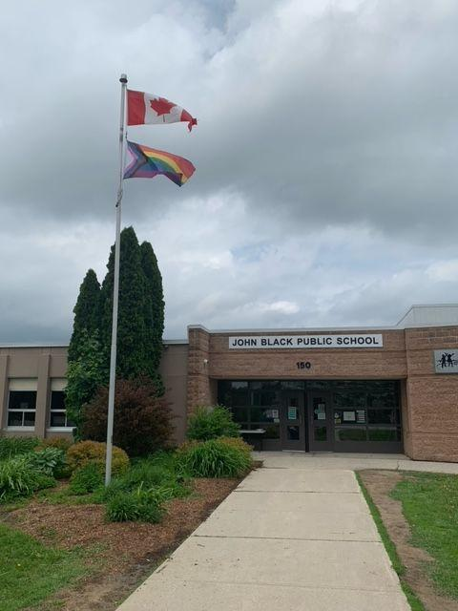
Pride Month: To honour Pride Month, John Black School will raise the revised rainbow flag, known as the Progress Pride Flag, for the month of June. The colors reflect and celebrate the diversity of the 2SLGBTQIA+ community and calls for a more inclusive society. Recently, the colors black and brown were added to the Progress Pride Flag to represent people of color. Baby blue, pink and white were also added to include the trans flag in its design.
Interested students will be given an opportunity to join with other Centre Wellington elementary school groups on June 16th for a community Pride Walk.
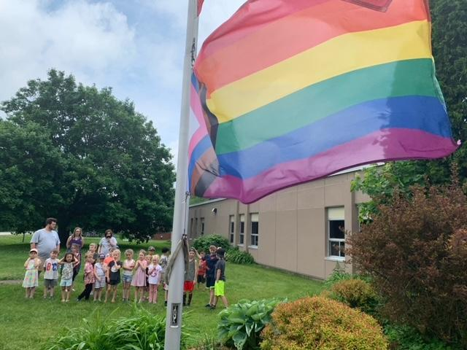
The GSA group at John Black has also been busy preparing for a launch of pronoun and people-positive buttons that will be available for students who are interested, and will be sharing Pride related information throughout the month.

School Council News:
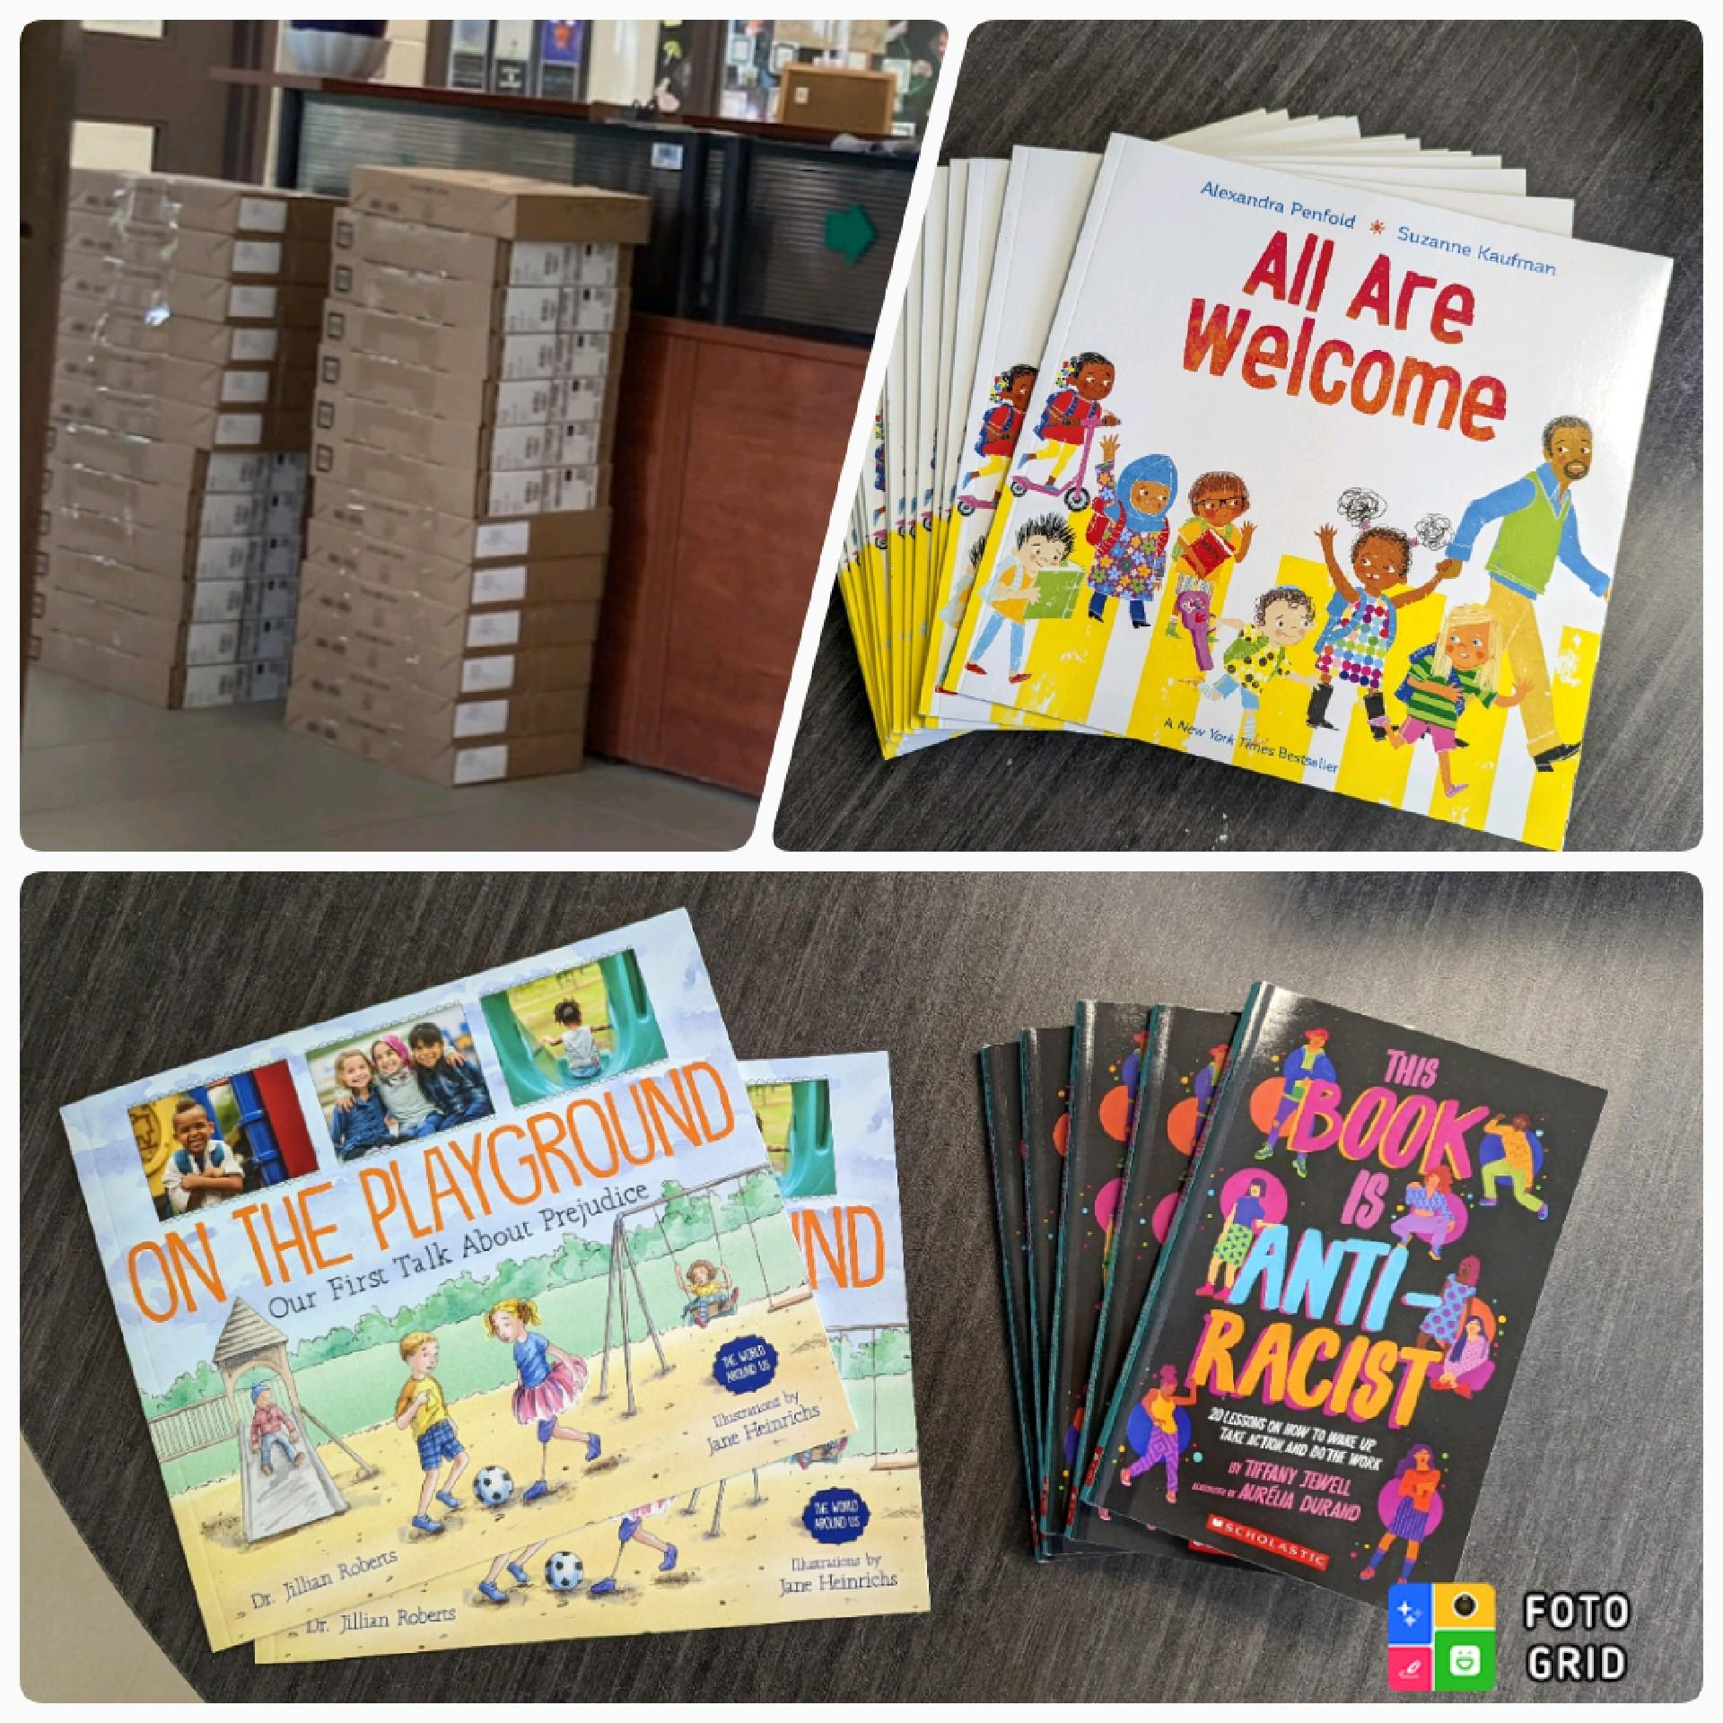
Chromebooks are in! School Council would like to thank families for your generous support of our fundraisers. We were able to purchase 16 much needed Chromebooks for the school. Council has been making efforts to address racism and to communicate inclusive attitudes and actions. Funds went to support the purchase of books to start a Parent Resource Library. Five copies of This Book is Anti-Racist and two copies of On the Playground-Our First Talk About Prejudice were purchased; these books are available for parents to sign out (more details to follow). Also, 25 copies of All Are Welcome were also purchased for our incoming kindergarten students. A Gaga Ball court purchased with Council funds is scheduled to be installed on our playground this summer and will be ready for students to use this fall. Watch for a Google online survey coming soon for feedback on options for school lunches.

Wishing everyone a safe and fun summer!

National AccessAbility Week: To help John Black students become more aware of the barriers that face those with disabilities, teachers will be engaging in discussions and learning with their students about equity of access to spaces, ableism and building a world that is disability inclusive. Considering our own school indoor and outdoor space, this week, Mrs. Schoettler would like classes to consider the aspects of our school building and playground that may be barriers for those with a disability.
Classes are to choose one aspect that they believe needs to become more disability inclusive for all students and staff and to share it through a diagram, a description of the problem and a possible solution to the problem.
Grade 8 Graduation:
Grade 8 Graduation will take place on Wednesday, June 22nd at 6pm. The graduation ceremony will take place in the gym and a student social will follow. Information regarding grad and tickets will be sent home next week.

EQAO - Our grade 3’s are almost finished with EQAO and the Grade 6’s are set to write this week. Our staff have done an excellent job preparing the students, helping them to feel calm and confident in their abilities.

