John Black PS May News 2022

May is Asian/South Asian Heritage Month, Jewish Heritage Month and Dutch Heritage Month.

Upcoming May Dates:
May 1 - Principal Appreciation Day
May 2 - Wear School Colours to Kick-off Mental Health and Education Week
May 3 - Samosa’s go on sale for families on SchoolCash Online
May 4- Badger-wear sales close today on SchoolCash Online
May 5 - Gr. 7/8 Vaccinations
May 9- School Council Meeting 6:30pm
May 12- Samosa purchases sent home and students can purchase for $2 at school
May 16- World Educational Support Worker Appreciation Day (EA’s and CYC’s)
May 23- Victoria Day Holiday- No School
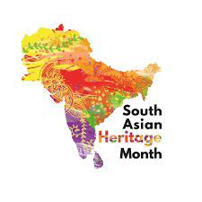
Asian/South Asian Heritage Month - Throughout this month, students will be learning about Asian/South Asian-Canadian culture, the achievements and contributions of Canadians of the diverse Asian heritage that makes up our Canadian communities, and understanding the historical journeys and anti-asian racism that people of diverse Asian communities face and how we can work together to dismantle it. Each week at John Black, students will learn about diverse Asian Canadians through our announcements and a trivia question will be shared with our students and community to participate in. A draw will be held at the end of the month for those who participated, for a chance of winning a range of Asian/South Asian inspired books.
Order Your Samosas! Thanks to The Official Orange Kitchen, we will have Samosas on sale this week on SchoolCash Online. They will be sold in bags of 4 ($8) and 6 ($12) for our families. Orders will be prepared and sent home with students on Thursday, May 12th. Students will also have the opportunity to purchase warm samosas for lunch that day between first and second break for $2 each. Ingredients will be posted on SchoolCash online.
School Council News:

Spring is here and the John Black School Council will soon be holding our last meeting of the school year! We are looking for new people that reflect the diversity of our school community to join our council. Bring your ideas and please consider joining us virtually for our next meeting on Monday, May 9 at 6:30 pm. Parents/Guardians can join us virtually or by phone:

Google Meet: :meet.google.com/yjp-qjaj-eig
Phone: (‪CA‬)‪+1 778-729-9758‬ PIN: ‪124 770 699# ‬All are welcome!

It has come to School Council's attention that there have been incidents of racial discrimination in our school community. The school council is supporting the school in its efforts to educate the school community by providing funds for a parent resource library focused on anti-racism. Five copies of This Book is Anti-Racist by Tiffany Jewell are being purchased for a new School Council Parent Resource Library and parents will have the opportunity to borrow them. In addition, $250 of school council funds are being put towards supplementing books for the classrooms on diversity and inclusion, in alignment with the school and board anti-racist and anti-oppression goals.

Furthermore we encourage families to visit the following links and use some of the resources provided such as articles, videos and podcasts to start family discussions on how we can do our part in creating a more inclusive school community.

Resources for Parents to talk about Race and Racism with their Children:
https://www.ugdsb.ca/wp-content/uploads/2020/06/Resources-for-talking-to-children-about-race.pdf
https://www.ugdsb.ca/schools/safe-equitable-and-inclusive-schools/equity-and-inclusive-education/anti-racism-and-anti-oppression-work/anti-racism-resources-for-parents-guardians/

Grade 8 Graduation:
Grade 8 graduation will take place on Wednesday, June 22nd at 6pm. The graduation ceremony will take place in the gym and a student social will follow. Due to limited space and current Covid guidelines, we ask that families plan for immediate family attending only. More details will be shared closer to the date.
John Black Badger Wear Sales Ends This Wednesday!
Purchase your school clothing on Schools Cash Online!
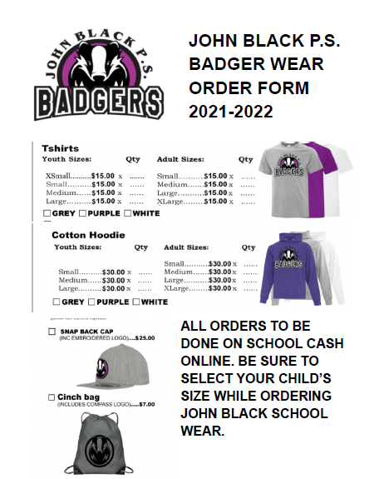Days of Significance: At John Black, our students learn about the days of significance shared on the UGDSB inclusion calendar through our morning announcements. Here are the days of significance for the Month of May:
