John Black Public School – School Council Minutes

Date: January 12, 2023
Time: 7pm
Location: Online
Co-Chairs: Melissa Mulligan & Carrie-Ann Nind
Treasurer: Catherine Shelton-Galdes
Secretary: Jessica McClennan
Principal: Sarah Schoettler
_________________________________________________________________________________
School Members Present: Sarah Schoettler, Luke Kordupel
Council Members Present: April Albano, Melissa Mulligan, Carrie-Ann Nind, Rami Kridli, Kerri Cavell, Sarah deLange, Cassidy Fair, Catherine Shelton-Galdes, Jessica McClennan
Regrets: Natalie Dorie

1. Welcome, Introductions and Regrets
Agenda approved by Catherine Shelton-Galdes, seconded by Rami Kridli.

2. Review and Approval of November 2022 Meeting Minutes
Approved by Melissa Mulligan, seconded by Catherine Shelton-Galdes.
Action Items from last meeting – No changes

3. Fund Raising Recap:
$1262.00 was raised for the winter fundraiser. Council made approximately $1100.00.
Sled a thon to be held in February weather dependent. Sled a thon will need 2 days plus one period. One of the prizes will be a dodge ball game against the teachers. Parent help will be needed on the hills, as well as making and distributing hot chocolate. Vulnerable sector check must be done first. Call the school and ask Mrs. Mackenzie to send home a letter for the volunteer check.
- New Fundraising ideas to be brought up in March.
- School is looking for cross country ski boots.
- Gaga ball court has been paid for and the students love having it.
Meals: Meal days are going great. Order due date for second session is January 30th. Approximately 100 students are ordering Subway or Booster Juice. Council gets approx. $1.00 profit from each sale.
Movie Night: Poster will be going up next week. Email blasts to parents will go out tomorrow. Thanks to April for the poster. Email has gone out looking for parent volunteers.
PIC funding to be discussed at next meeting.

4. Principal’s Report
John Black Anti-Racist Statement (Written by our Student Council Students): In our school, we have a responsibility to stand up against racism and oppression, while being a support system for people who experience it. Angela Y. Davis, an activist for civil rights, has said “In a racist society, it is not enough to be non-racist, we must be anti-racist.” Treating everyone at our school as a human being, no matter their race or ethnicity, is essential.
John Black Land Acknowledgement: The grade 4’s at John Black have learned that the Haudenosaunee {ho-da-na-showne} people lost their land in upper New York when they fought for the British in the American Revolution. Sir Frederick Haldimand gave the Six Nations people 10 km on both sides of the Grand River, this includes where our school is now, in thanks for their help in the war. Today the Six Nations only have 4.6% of their original land grant because the rest was either sold or stolen.
Kindergarten Registration: Online registration opened on Tuesday, January 10th. Parents/Caregivers can register their child entering Junior Kindergarten using Easy Register https://secure.easyregister.ca or in person at the school.
BASP: The UGDSB Before and/or After School Program (BASP) survey will be opened for parents/guardians starting on January 10, 2023. The survey is intended to gather information about the number of children who need before and/or after school care for September 2023 at schools that do not currently offer a BASP.
Please complete the BASP survey if your child will be entering JK/SK in September 2023 or is currently registered in Kindergarten to Grade 5 and will need access to a BASP and if a Program is not already offered in your child’s school. Only parents requiring care at these schools are asked to complete the survey (one per family). Please note that the completion of the survey does not guarantee that a Before and/or After School Program (BASP) will be offered at your child’s school and does not register your child or put them on a wait list.
Annual Food Drive: The John Black Annual food drive was really a huge success. Classes surpassed the initial goal of 1000 and reached over 2200 items. The motivational prizes were students versus teachers dodgeball and the top class would also win a pizza party.
The winning classes were Ms. Eckrich’s class, Mr. Hirst’s class and Mrs. O’s class!
EQAO Results: Our grade 3 and 6 results are public and overall, our students did well. As a staff, we have analyzed the data and are currently in the midst of planning for areas of growth.

Grade 3:
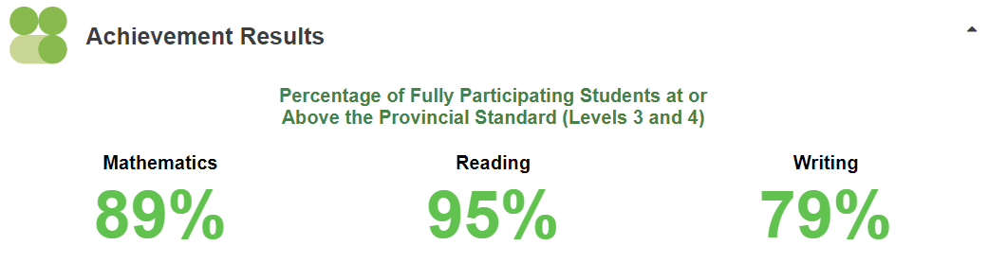
Grade 6:
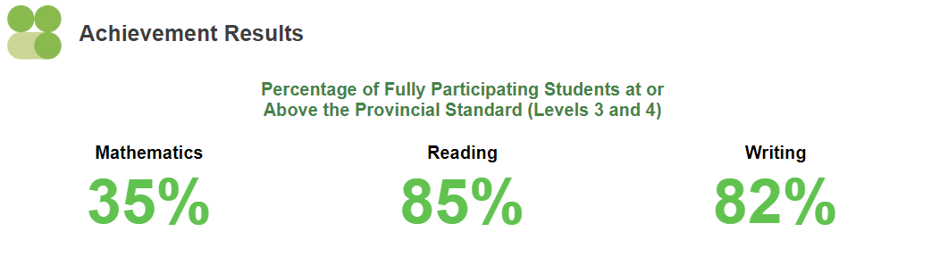
Staff are working in their grade teams to determine areas for improvement and are developing specific strategies and teacher moves to improve student achievement in the areas determined. Primary teachers are continuing a deep focus on reading improvement using the science of reading strategies and focusing on specific phonemic blends and sounds, Junior teachers are planning with a focus on developing students’ ability to confidently express ideas and opinions with evidence and Intermediate teachers are also working with students on building ideas and expressing their thinking when responding to questions.
Cost of Transportation for School Trips: As teachers are planning for school trips they are noticing an increase in bus costs which is substantially increasing the cost of the trip for students. Support from council for transportation costs would be greatly appreciated and would decrease trip costs for students/families allowing for them to enjoy experiences with their class.

5. Teacher Report
Junior: Volleyball, chess club, art club, and basketball will soon be starting. The kindness club and dance club are starting in the next two weeks as well.

Primary: Pinball intramurals will begin next week. Ms. Nollert will be leading the students with some intermediate volunteers.

Intermediate: Intramural Volleyball wrapped up in December with a tournament at JD Hogarth for the girls team and Elora for the boys team.
Intermediate Wrestling begins Monday at 7:15 am with Dave Ritter (CW’s Wrestling coach) coming down to lead practices and this popular intramural. Drama club continues to meet and is blocking for their upcoming play performance in the Spring. Rock Band/Music Club meets weekly and is preparing a song for CBC music competition

Blue Spruce Forest of reading Our Blue Spruce reading program is currently beginning and is being offered to our primary classes. We will have some guest readers (many of the staff at John Black PS), who will join the students in the learning commons and present the selection of books for the year.
Silver Birch/Silver Birch Express/ Red Maple Silver Birch Express books are aimed at Grades 3-5, Silver Birch for Grades 4-6, and Red Maple roughly grades 6-8. These books are read by many of our students who then connect with a staff member who have read the book and debrief with the students.

Grade 1-8 Guelph Grotto will be at our school for Grade 1-8 students the week of January 30th. Guelph Grotto will be presenting student age appropriate programs on climbing walls and ropes courses which will be set up in our Gym. This program is for Grade 1-8 students and will be approximately 100 minutes long (covering two class periods). The program is a great opportunity for our students to be shared a chance to participate with trained coaches on climbing walls and rope activities.

Through these exciting activities, students will be able to participate in teamwork activities which promote inclusion, communication and group and personal safety. Student permission forms/consent forms will be sent home for your review and are required to be signed and returned. Please connect with your child’s homeroom if you have any questions. We look forward to welcoming the Guelph Grotto at John Black Public School and providing the students with this exciting opportunity

6. Financial Report
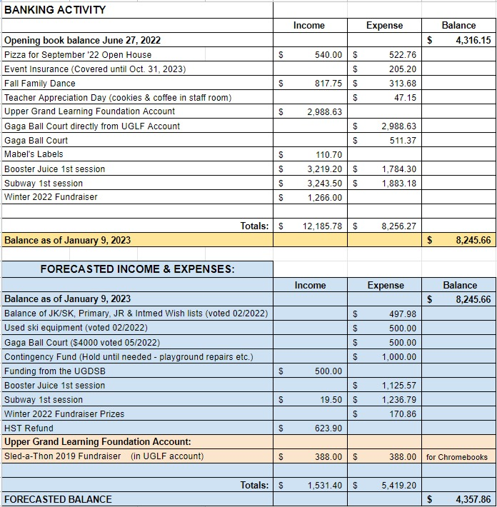

7. New Business:

Teachers can start putting together their wish lists for their classrooms.

Motion put forth to give $500.00 to each division and $250.00 to kindergarten for fieldtrip expenses. Total being $1750.00 The cost of bussing for fields trips has nearly doubled and this money will help with a reduction in field trips costs to parents.
Motion: Carrie-Ann Nind Seconded: Jessica McClennan All agree: Passed
8. Next Meeting: February 9th in person 6:30pm-7:30pm
9. Meeting Adjourned: 8:03pm

