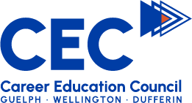
Career Education Council
Events for Partner Newsletters

Event: | Your Future/Your Choice
Date: | Wednesday,
Type: | One stop education, career, and community resource fair.
CEC Website link | http://www.careereducationcouncil.ca/yfyc
Exhibitor/employer registration link: | https://YFYC-2022.eventbrite.ca
Is there a fee for exhibitors? | Yes
Attendee/job-seeker registration link: | https://YFYC-2022-Reg.eventbrite.ca
Is there a fee for attendees? | No
Contact information: | William Gardiner  Career Education Council  williamg@careeeducationcouncil.ca | Ashley Isenberg  Career Education Council  ashleyi@careeeducationcouncil.ca | Kelly Schafer  Career Education Council  kellys@careereducationcouncil.ca
Description/  Blurb | Your Future Your Choice is a one-stop career, education, and community resource fair.  Grade 8-12 students, along with their parents/guardians are invited to stop by Centennial CVI from 6-8 pm on November 16th and interact with all our fantastic exhibitors!  Exhibitors include post-secondary schools, High-School programs, charitable organizations, community involvement, and employment opportunities.  YFYC is an amazing opportunity to discover the diverse resources and opportunities available to youth. Don't miss out!

