January 2020 Newsletter

From the Principal’s Desk
January 2020

Hello Jean Little families and welcome back! I hope you had a wonderful holiday break. I am your new principal, Chris Popofski. I am very happy to be joining the Jean Little Public School community. I have heard many positive comments about Jean Little, and am thrilled to have the opportunity to work with staff, parents and students to continue the amazing work that is happening at school. This is a familiar area as I have lived in Guelph all of my life. My wife Cheri and I have two children, our son Cohen is in Senior Kindergarten and Charli, our daughter is in her last year of daycare.

I have had the pleasure to visit Jean Little a few times over the past month. In the next short while, I look forward to building positive relationships throughout the school. If you would like to drop in to say hello, I would be very happy to see you, whether it’s on the yard, halls or in the office.

I am looking forward to meeting all of you and working alongside you to continue to provide a welcoming and inspiring learning environment for our students.

Sincerely,
Mr. Chris Popofski

Parent Council
Our next Parent Council meeting is Monday, January 27, 2019 at 6:15pm in the Library Learning Commons. All are parents welcome! Search for Jean Little Public School Parent Council on Facebook. It is a closed group so you will be asked a security question before being granted access.

Job Action
For the most up-to-date information in regard to job action, please visit the UGDSB website at the following links - https://www.ugdsb.ca/ & https://www.ugdsb.ca/board/labour-relations/

Twitter
Jean Little has its very own Twitter account! Please follow us at @JeanLittlePS.
Inclement Weather Procedures
For information regarding Inclement Weather and how to find out about cancellations, please visit: https://www.ugdsb.ca/schools/inclement-weather-procedures/ Also, please review the poster below.

Jean Little On-line Calendar
Please visit the Jean Little online calendar for upcoming events and important dates. Visit:
https://www.ugdsb.ca/JeanLittle/

School Cash Online
Please note that we will be putting all necessary purchases for events, class trips, and activities on School Cash Online. Families will be able to pay online. The option to pay cash will also continue to be available. If you are new to School Cash Online, visit http://schoolcashonline.com to sign up. Please contact the office if you have further questions.

PD Day
Friday, January 31 is a PD Day. There is no school for students.

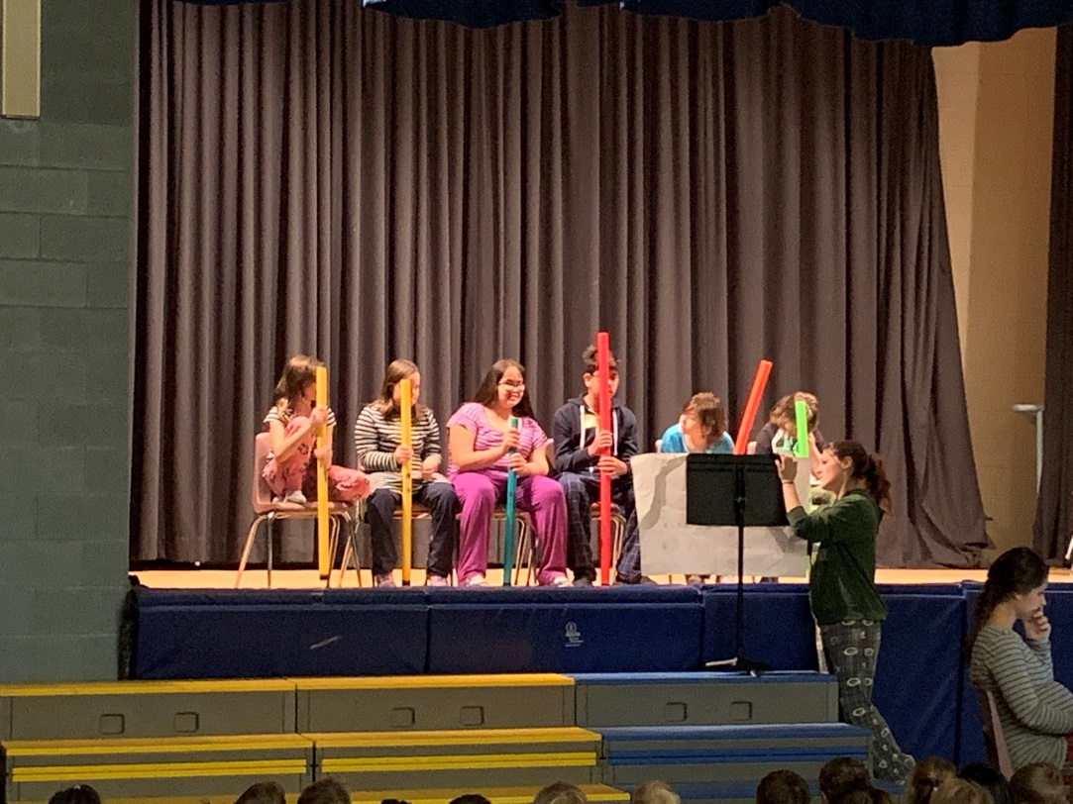

Mrs. Nelson’s Class performing with Mrs. Lucchesse

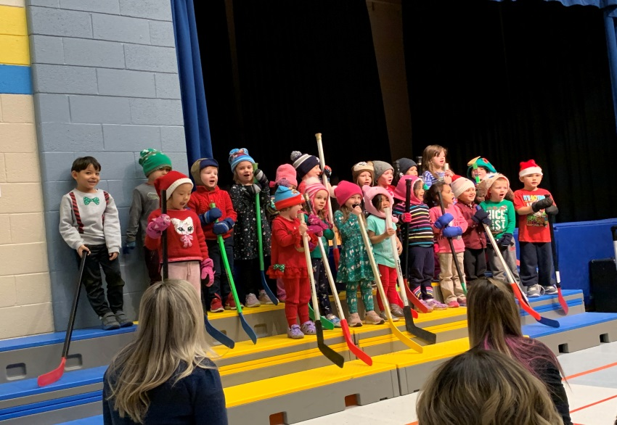
Lots of Wonderful Student Holiday Performances!

Our CAA Safety Patrols enjoying Pizza Lunch with Officer Kevin

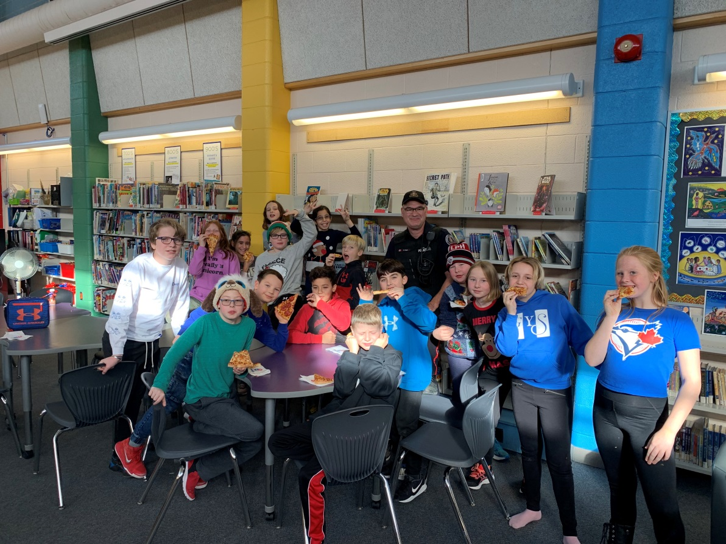

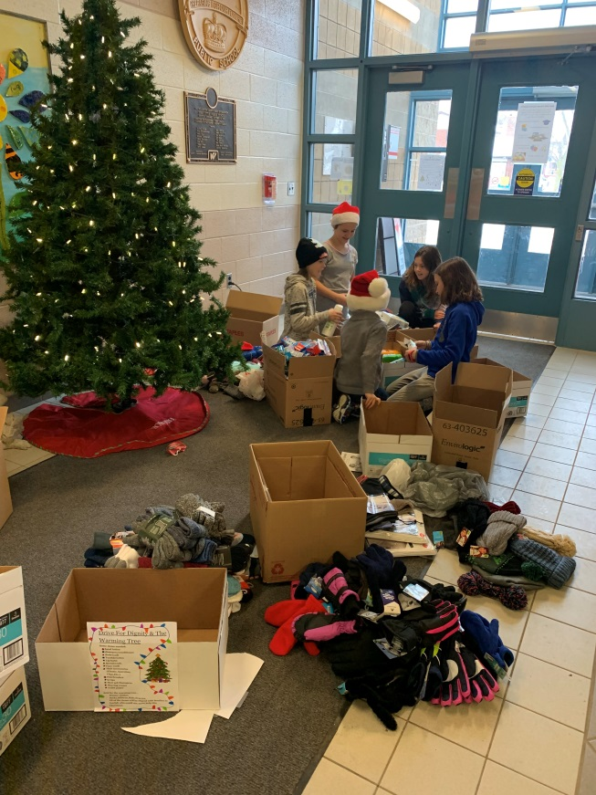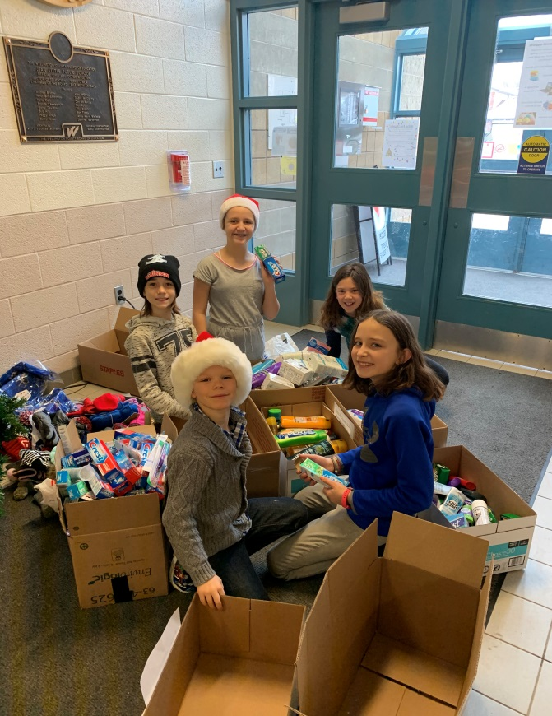
Thanks to all for the donations to our Drive for Dignity Campaign.
We collected 461 items!
Below Mrs. Nelson’s and Mrs. Kent’s Classes enjoy a tea party!
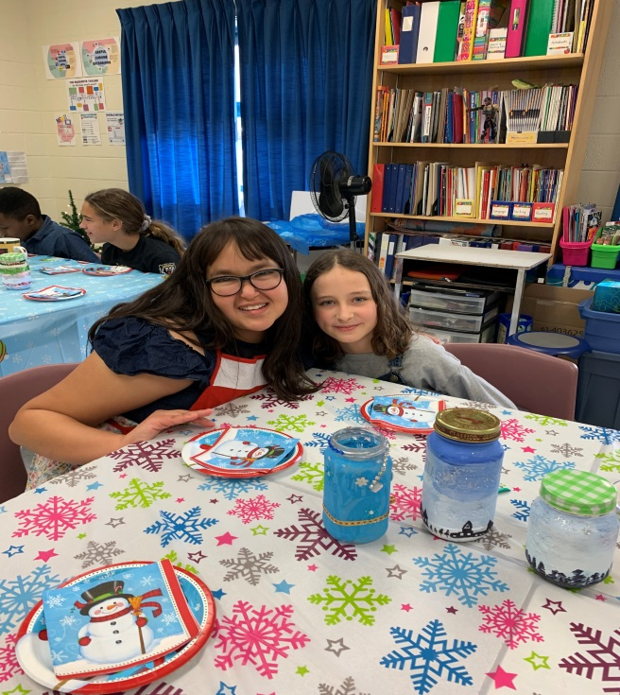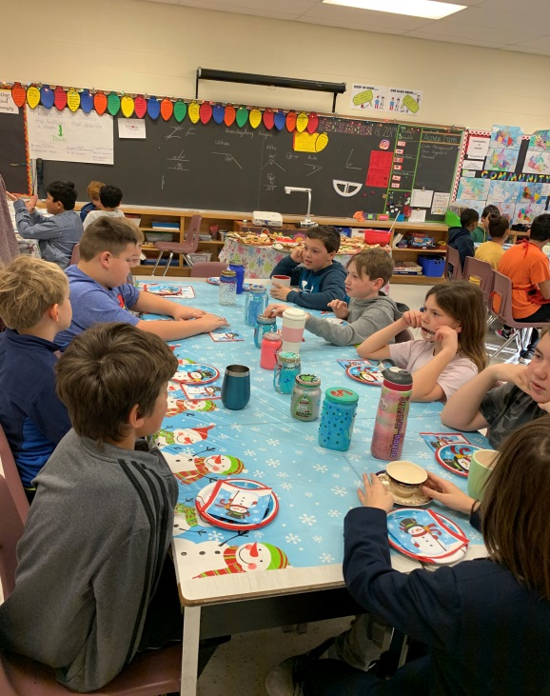

Monthly environmental activities to help celebrate our planet

JANUARY is the time to carry out your Eco Resolutions!

“There will be more waste plastic in the sea than fish by 2050” Dame Ellen MacArthur

It’s a brand new year and the perfect time for positive change. For example, let’s end plastic pollution.
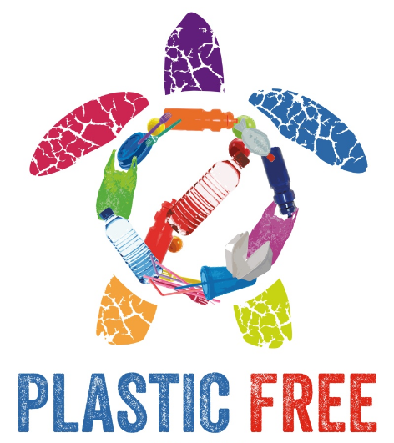
Based on the daily news, it’s never been more critical to increase your environmental efforts. The Earth Day Network is calling to end plastic pollution. Imagine a future free from harmful plastic garbage! Single-use plastics are especially wasteful and many plastics are also not properly recycled and take up precious landfill space or pollute our oceans, killing marine life and washing up on pristine beaches. Plastic garbage ‘islands’ are appearing in seas and oceans all over the world.
www.wuft.org
https://www.nationalgeographic.org/encyclopedia/great-pacific-garbage-patch/

Tips on how to reduce single-use plastics:

- Extend your use of cloth shopping bags beyond the grocery store. Use them at all other retail stores too.
- Avoid buying over-packaged food. The choice is yours. Do you need to buy the carrots that are shrink wrapped on a Styrofoam tray?
- Let the restaurants you frequent know that you would them to join the growing movement to ban the use of straws. Many have implemented a 'serve-straws-upon-request' policy.
- Tap water is best. Bottled water can deplete our precious groundwater resources and produce unnecessary green house gas emissions through the production and transport of plastic bottles. Carry a reusable water bottle instead.
- Lug a travel mug to your local coffee shop. (The plastic lining makes coffee cups unrecyclable, and they all end up in the garbage and in our overflowing landfills.)
- Write letters to the government asking them to fix a problem that you are concerned about such as: mandating the reduction of plastic packaging, banning Styrofoam, or promoting research for recyclable coffee cups or coffee pods, etc.

Starting the Year Mindfully
Starting a new year, coming off of a two week school break, new resolutions and on-going challenges are a few of the things we have on our plates in January. There is a lot of research that has shown the power of mindfulness in reducing stress and anxiety, increasing mental well-being, helping with sleep patterns, and also overall emotional regulation.

WHAT IS MINDFULNESS?
Mindfulness is a way to turn off auto-pilot and bring awareness to the present. It may seem easy but in a world full of schedules, appointments, deadlines and other daily stressors it can be a challenge to disconnect ourselves from auto pilot. Daniel J. Siegel defines mindfulness:
“Mindfulness in its most general sense is about waking up from a life on automatic, and being sensitive to novelty in our everyday experiences…Instead of being on automatic and mindless, mindfulness helps us to awaken, and by reflecting on the mind we are enabled to make choices an thus change becomes possible”
Mindfulness is not only turning off auto pilot and staying aware but doing so non-judgementally – of yourself, of others, of your experience. In that age of social media likes, followers, and commentaries this non-judgmental stance is something we could all benefit from doing. Jon Katat-Zinn writes:
“Mindfulness means paying attention in a particular way: on purpose, in the present moment, and nonjudgmentally”

WHAT ARE THE BENEFITS?
Research in the area of mindfulness shows benefits in the following areas:
- Improved working memory
- Lowered anxiety levels
- Reduced emotional reactivity
- Reduced stress
- Regulating emotions
- Less distractable
- Enhancing sleep

SO WHAT CAN YOU DO?
There are many ways to bring mindfulness into your life from a regular time every day to finding opportunities for mindfulness skills in daily life.

- Bring mindfulness to a walk by focusing on what you see, hear, feel. Listen to the sound of your steps, notice the feeling of you legs, notice what you smell.
- Try listening to someone mindfully by not crafting what you are going to respond and thinking ahead but rather listen fully to what the other person is saying – sounds easy but you will be surprised!
- When you or your child are having a difficult time take a moment and focus just on breathing, in and out. Notice what your body feels like. Notice thoughts that pop into your head – AND LET THEM GO. Just “be” for even 2 minutes. It can be very powerful to take even just one or two minutes! And a great example to set for your children.

So perhaps you can find some time in your day, your week, your month to turn off auto pilot and practice a little mindfulness!

Jenny Marino, Mental Health Lead, Upper Grand District School Board

