Parent Letter re: Jan. 15, 2020, one-day OSSTF strike

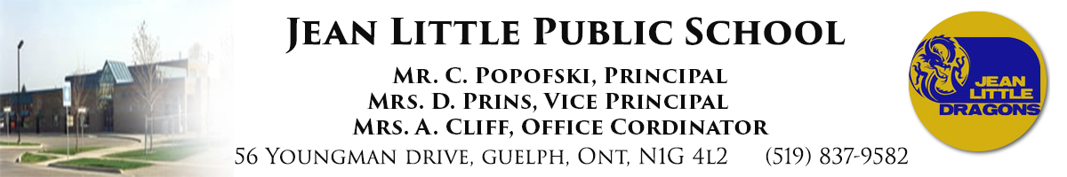

Tuesday, January 14, 2020

Dear Parents and Guardians,

On January 10, the Ontario Secondary School Teachers’ Federation (OSSTF) announced that its teachers and education workers will take part in a one-day, full withdrawal of services in select locations across Ontario on January 15, 2020. The Upper Grand District School Board is listed as one of the school boards that will be included in the Jan. 15 job action.

In the UGDSB, OSSTF represents five distinct groups of employees:
- Secondary Teachers and Secondary Occasional Teachers (secondary schools and Continuing Education)
- Educational Assistants (elementary and secondary schools)
- Early Childhood Educators (elementary schools)
- Office Clerical Technical Staff (elementary, secondary, and board sites)
- Professional Student Support Personnel, such as Child and Youth Workers, Social Workers, Speech Language Pathologists and Psychologists (elementary and secondary schools)

This withdrawal of services causes significant impact to all UGDSB schools, including our capacity for effective supervision and ability to ensure student safety. As a result, if a deal is not reached and the one-day strike occurs, all schools in the UGDSB (elementary, secondary and Continuing Education) will be closed to students on Wednesday Jan. 15.

Parents/guardians are strongly encouraged to begin making alternate arrangements for your children prior to the one-day strike.

Community Use of Schools and third-party operated child care centres will remain open during this labour action. Some Before and/or After School Programs may be operating and each operator will communicate directly with families.​

For further information please:
- Visit our Labour website to receive updates
- Follow the UGDSB on Twitter for updates
- For additional details from OSSTF, please visit the OSSTF website: https://www.osstf.on.ca/news/mr-jan-10-2020.aspx

We will continue to provide updates as information becomes available.

Thank you,

Mr. Popofski & Mrs. Prins

