TOONIES for TEENS
Gift Drive
In Support of
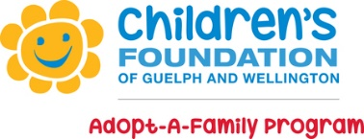
Our school community is giving back this holiday season.
Join us in making spirits bright!

If you would like to participate then please bring a TOONIE any day from
November 26th to December 3rd
OR
You can donate a New Unwrapped Gift by bringing it in prior to December 3rd.

All donations will be collected throughout the week and donated on December 6th.
If you would like additional information on how or what can be donated please see the
Ken Danby Website for further details.

TOONIES for TEENS
Gift Drive
In Support of
Our school community is giving back this holiday season.
Join us in making spirits bright!

If you would like to participate then please bring a TOONIE any day from
November 26th to December 3rd
OR
You can donate a New Unwrapped Gift by bringing it in prior to December 3rd.

All donations will be collected throughout the week and donated on December 6th.
If you would like additional information on how or what can be donated please see the
Ken Danby Website for further details.

