Laurelwoods Elementary School
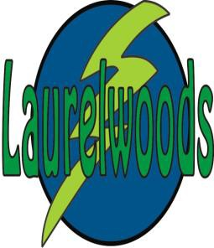

Newsletter

April 2024

PRINCIPAL NEWS
As I am writing this month’s Principal address with the sunshine streaming in my window it feels like spring has arrived! We welcome the milder spring temperatures, as the ground thaws and we experience spring showers the yard becomes muddy, please consider packing an extra pair of pants and socks in your child’s school bag. We also encourage boots to be worn at recess.
The last few months of school are going to be very busy. Please carefully make note of all school events and return permission slips promptly.
As I have been reviewing student data with staff and setting goals for the last quarter of the school year our conversations continually come back to the importance of reading practice. As partners in your child’s education, I cannot urge you strongly enough to set home routines that allow your child to read independently, with you or to hear you read to them (depending on their age) for a minimum of 15 minutes daily. I recently came across this article from the Markham Public Library that I thought seemed worthy of sharing with you.
1. Reading Exercises the Brain
While reading, we have to remember different characters and settings that belong to a given story. Even if you enjoy reading a book in one sitting, you have to remember the details throughout the time you take to read the book. Therefore, reading is a workout for your brain that improves memory function.
2. Reading is a Form of (free) Entertainment
Did you know that most of the popular TV shows and movies are based on books? So why not indulge in the original form of entertainment by immersing yourself in reading. Most importantly, it is free with the use of our school library.
3. Reading Improves Concentration and the Ability to Focus
We can all agree that reading cannot happen without focus and in order to fully understand the story, we have to concentrate on each page that we read. Reading requires your undivided attention, therefore, improving your ability to concentrate.
4. Reading Improves Literacy
Have you ever read a book where you came across an unfamiliar word? Books have the power to improve your vocabulary by introducing you to new words. The more you read, the more your vocabulary grows, along with your ability to effectively communicate. Additionally, reading improves writing skills by helping the reader understand and learn different writing styles.
5. Reading Improves Sleep
By creating a bedtime routine that includes reading, you can signal to your body that it is time to sleep. Now, more than ever, we rely on increased screen time to get through the day. Therefore, by setting your phone aside and picking up a book, you are telling your brain that it is time to quiet down. Moreover, since reading helps you de-stress, doing so right before bed helps calm your mind and anxiety and improve the quality of sleep.
6. Reading Increases General Knowledge
Books are always filled with fun and interesting facts. Whether you read fiction or non-fictions, books have the ability to provide us with information we would’ve otherwise not known. Reading a variety of topics can make you a more knowledgeable person, in turn improving your conversation skills.

7. Reading is Motivational
By reading books about protagonists who have overcome challenges, we are oftentimes encouraged to do the same. The right book can motivate you to never give up and stay positive.
8. Reading Reduces Stress
Reading has the power to transport you to another world. By doing so, reading can decrease stress, lower heart rate, and reduce blood pressure.
9. Reading Sets a Positive Example
Reading is a key component of early literacy development, and you can set an example of just how crucial this is by modeling the behaviour yourself. Children are excellent at mimicking the adults around them which means that if you regularly set aside some "me time" for reading, your children will learn to do the same.
10. Reading Teaches Empathy
Books allow us to experience realities outside of our lives. They teach us to relate to others by often putting us in the shoes of the narrator. This simple technique is called empathy. Empathy is defined as the ability to understand and share the feelings of another. Reading builds on empathy by constantly presenting us with thoughts and scenarios outside of our perspective.
The Ten Benefits of Reading for All Ages
by MPLKarenAugust 6, 2020

My hope is that excellent reading habits established now will carry over into the summer months. I hope that you enjoy the sunshine and the longer spring days.

Lori Shilvock
Principal

Staffing Update
We are thrilled to announce that Ms. Gaudette will be returning to Laurelwoods on Monday April 8th, 2024. We want to thank Ms. Yuen for doing such an amazing job of filling in for Mrs. Gaudette in her absence.

Child Abuse Program
Yearly, teachers are to deliver the Child Abuse Prevention Programs. This program is delivered to Grades 1, 3, 5, and 7 students. Your child’s teacher will be delivering this program during the month of May. The following personal safety programs that will be taught are: Be Safe (Grades 1 and 3), Kids in the Know (Grade 5) and It Is Not Your Fault (Grade 7). A letter will be sent home later in the month explaining the program that will be delivered to your child in May. If you have any questions, please do not hesitate to reach out to your child's classroom teacher.

Solar Eclipse Resources
Please see WDGPH’s website Our eclipse webpage which is now live! Public Health has also prepared this Public Health Safety for Solar Eclipse (PDF) fact sheet for sharing within the school community.

Wellness Works! UGDSB’s April theme is Gratitude
This month will focus on the benefits of gratitude and being able to notice and acknowledge what exists around us as a key component of well-being. Gratitude is:
■ The quality of being thankful
■ An acknowledgement of goodness
■ Readiness to show appreciation and return gratitude
■ Recognizing sources of goodness outside of ourselves and how they contribute to our lives

Reminder
There will be a P.D.day on Monday, April 8th, 2024. There will be no school for students.
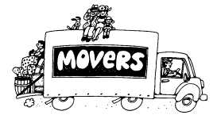

Moving
If you know you will be moving and will not be attending Laurelwoods Elementary School in the fall, please let the office know as soon as possible.

2024 – 2025 School Organization
We will soon be determining the 2024 – 2025 school organization. If you have any specific concerns or requests around class placement for next year, please put your concerns / requests in an email and send them to the school Office Coordinator: karen.gardhouse@ugdsb.on.ca

Graduation Preparations
Graduation preparations are underway. We are moving ahead with our plan to celebrate our Graduates! This year the event and will be held on Monday, June 24th, 2024. More information will follow.

Grade 7/8 Vaccinations
Nurses from the Public Health Unit will be in the school on Friday, April 19th, 2024 to administer the second round of vaccinations (Hepatitis B and Human Papillomavirus).

Eco Awareness

Celebrate Earth Day on April 22nd!
EARTHDAY.ORG is unwavering in their commitment to end plastics for the sake of human and planetary health, demanding a 60% reduction in the production of ALL plastics by 2040. The theme, Planet vs. Plastics, calls to advocate for widespread awareness on the health risk of plastics, rapidly phase out all single use plastics, urgently push for a strong UN Treaty on Plastic Pollution, and demand an end to fast fashion. Join us as we build a plastic-free planet for generations to come!

Ideas for your family to celebrate Earth Day:
- Review previous Earth Day Themes. For example, there is an ongoing focus on ending plastic pollution. Make a pledge to always carry a reusable shopping bag, use alternates to Ziploc bags, buy in bulk, refuse to buy-over packaged products and make litter-less lunches. Help End Plastic Pollution!
- Spend a day outside. In the garden with your family, plant vegetables, trees or native flowers and attract native animals and pollinators. Or join a local community event to help clean your neighbourhood by picking up discarded plastic, cans, and bottles. Or restore local plant life. Choose a good location for a compost pile – start recycling coffee grounds, eggshells etc. to decompose and to ultimately enrich your garden for the upcoming growing season.
- Help build a bird feeder. Build a bird feeder using a plastic bottle and filling it with bird seed.
- Learn more about the environment and the effects of global warming. Encourage awareness and promote the Reduce (buy less), Reuse (repurpose it) and Recycle (sort it right!) way of life.

Remember that every day is Earth Day! Do not restrict yourself to just one day a year. Make environmental actions and caring about the planet a habit - on Earth Day and every day.

School Council Update
We would like to thank the parents that came out to the Social Media Generation presentation put on by Family Transition Place on March 19th. It was an excellent and informative talk on how our children interact within social media and how to best set them up for success. A flyer covering some of the information presented was emailed out and will be available on the School Council Facebook page if you were not able to make it to the presentation.

School Council will be co-hosting a second presentation by the Family Transition Place on Monday May 6th, 6:00pm - 7:30pm at Grand Valley & District Public School. This presentation will cover how to identify, address, and help our kids deal with bullying and unhealthy relationships. A flyer with more information on this discussion will be emailed out to the school and posted on the School Council Facebook page. We hope to see you there!

As a reminder, Spring Fling will be held on Thursday June 6th and planning is in full swing! We hope our final celebration of the school year will be fun for the whole family. Volunteers will be needed to help make Spring Fling a success so keep an eye on your email in May for a chance to sign up and help with the festival.

Our next parent council meeting will be on April 4th at 6:30pm in the Laurelwoods school library. If you are not able to make it to the meeting in person, an online option will be available.
As always, thank you for your continued support of the Laurelwoods School Council!

Dates to Remember

April 2nd Skills Canada Trip
April 4th National GOOS paper day
April 4th School Council Meeting – 6:30 pm
April 8th PD day – no school for students
April 9th Swim to Survive – Grades 3 & 7
April 10th Family Transition Place Presentation – Anti Sex Trafficking
April 16th Swim to Survive – Grades 3 & 7
April 19th Public Health Grade 7 Vaccine Boosters
April 23rd Swim to Survive – Grades 3 & 7
April 26th Book Fair Begins
May 2nd Empowerment Day Trip

Food & Friends
The Laurelwood Food & Friends program is looking for volunteers who would like to help bring healthy, free food into the school for all Laurelwood students. If you are interested in volunteering or have questions on what it entails, email Alyssa at Alyssagre@gmail.com.
The Food & Friends program is hoping to offer more free lunches for all students in the coming months. If you have ideas on what type of lunches your students would love, please reach out!

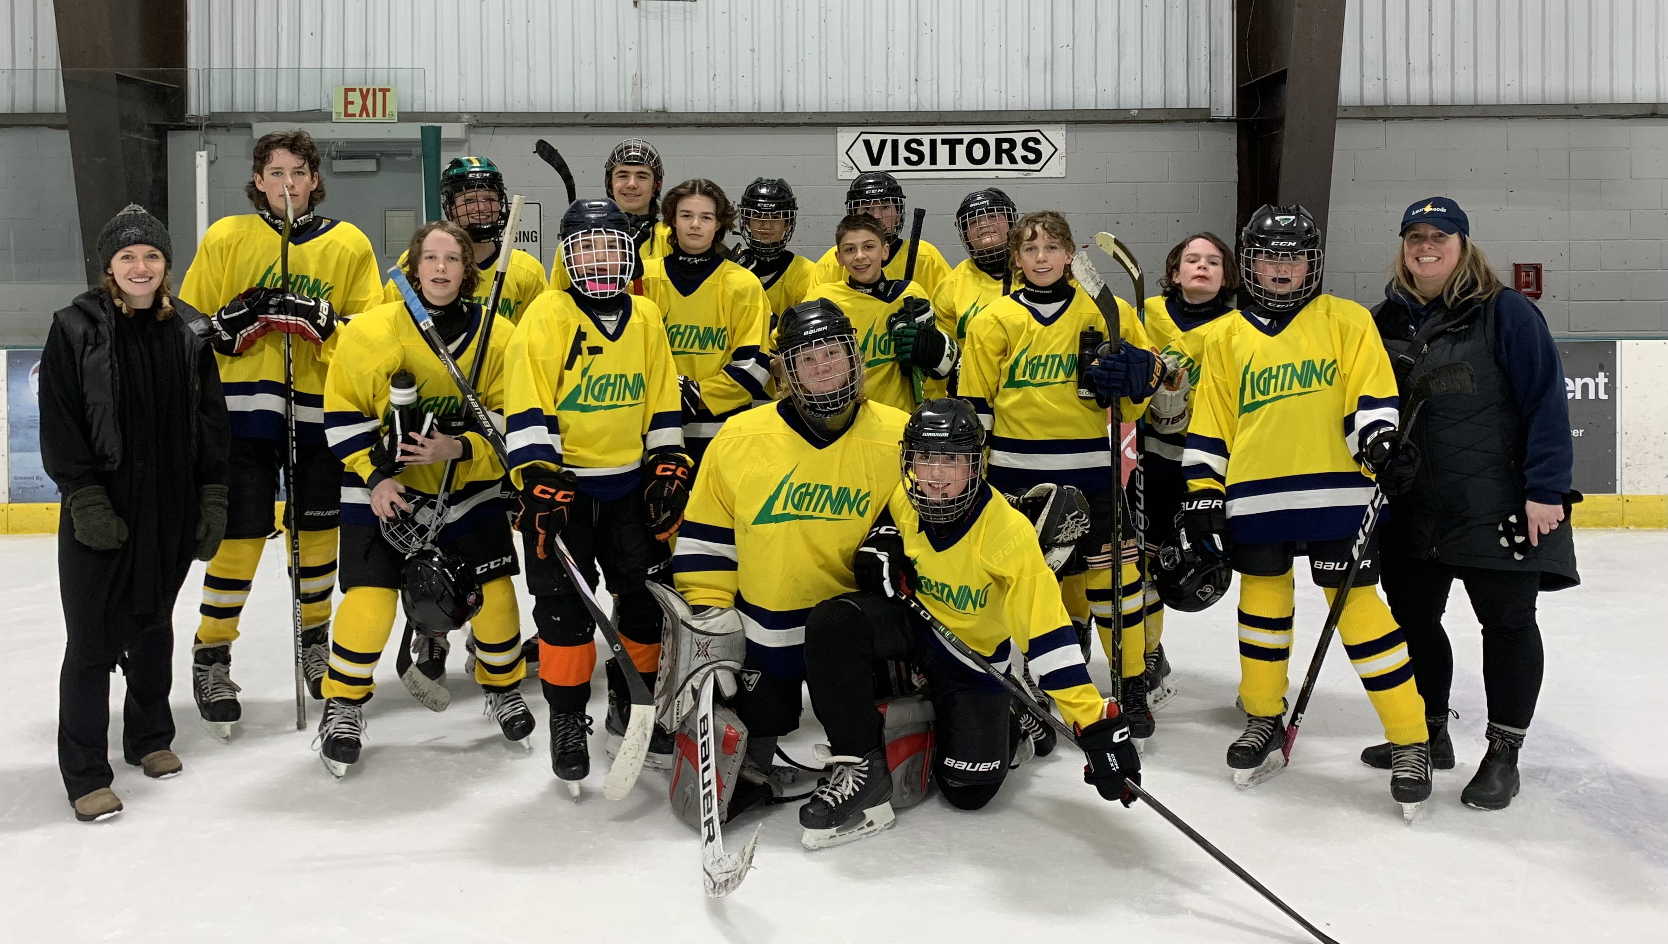

The Laurelwoods hockey had a great season this year. We finished off with our tournament against other UGDSB schools. A big thank you to Mrs. Bryan, Mrs. Bell and all the parents involved for helping to make this year a success.

Scholastic Book Fair

Our second Scholastic Book Fair of the 2023/24 school year will be happening this month! From April 29th to May 3rd, students can view and purchase a variety of items on sale such as books, posters, and other trinkets! There is always something for everyone at the sale, including a discount table with books as low as $3.00 for purchase!

Forest of Reading

As we wrap up the month, our Forest of Reading program wraps up too. The official school vote for students involved in the Forest of Reading program is on Tuesday, April 23rd. Thank you once again to our School Council for their monetary donation and support of this program. Students have certainly enjoyed the reading and book discussions once again!

2024 Amaranth Soccer Registration is Open
All kids ages 4 -16 years are welcome to join the Township of Amaranth’s noncompetitive soccer program! The 2024 season will run every Wednesday evening from June 5th to August 7th, 2024. Registration is $90.00 per child providing each player with a uniform for the season, along with a trophy and meal at the year-end Awards BBQ. Please bring completed registration forms and payment (cash or cheque) to the Township of Amaranth Municipal Office located at 374028 6th Line, Amaranth ON, L9W 0M6. Registration deadline is Friday, May 24th, 2024. Volunteers for coaching are needed! If you are interested in coaching please contact the office at 519-941-1007 or info@amaranth.ca Registration forms: https://www.amaranth.ca/en/resident-services/Recreation-and-Programs.aspx

Anti Sex Trafficking Policy
In response to the Policy/Program Memorandum 166 Keeping Students Safe: Policy Framework for School Board Anti-Sex Trafficking Protocols (PPM166), the Upper Grand District School Board is committed to promoting student safety by building a culture of caring and taking meaningful, culturally responsive and consistent action to prevent and respond to issues of student safety. The board will work to protect students, with specific attention and focus on vulnerable, at-risk and marginalized students, and empower school communities to play a key role in fighting sex trafficking and keeping children and youth safe from sexual exploitation. This protocol will support coordinated action by all community partners to prevent, identify and recognize sex trafficking, and develop responses to facilitate early and appropriate intervention.
As required in the Policy, we will be teaching age-appropriate information to help our students identify human trafficking and protect themselves. The goal is to provide children with the tools they need to keep themselves safe. The presentation covers a broad range of safety issues.
The presentation will occur Wednesday April 10th. Mrs. Bell’s class will have the Family Transition Place presentation from 8:45 AM- 10:25 AM and Mr. Johnson’s class will have the presentation from 11:10 AM -12:50 PM. We encourage you to discuss the presentation with your child at home. For further information please see the UGDSB website; Anti-Sex Trafficking Protocol (Upper Grand District School Board) (ugdsb.ca)
For more information regarding the Policy and/or Programs please contact the school at 519-925-3939.

