Monthly environmental activities to help celebrate our planet

December 10th is HUMAN RIGHTS Day!

““You cannot get through a single day without having an impact on the world around you. What you do makes a difference, and you have to decide what kind of difference you want to make.” —Jane Goodall

Celebrate Human Rights Day on December 10th!
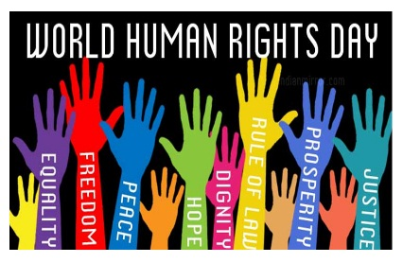
http://calendarholidays.xyz/holiday/168/human-rights-day.

Human Rights Day calls on everyone to stand up for someone's rights. It starts with each of us. Step forward and defend the rights of someone whose voice is not being heard. Recognize that human rights include the right for everyone to have access to clean water, unpolluted air and healthy food. http://www.un.org/en/events/humanrightsday/

Simple yet meaningful ways for your family to celebrate the rights and responsibilities that we all share as human beings!

- Learn about how children live in other parts of the world. Find out about their schools or traditional food and language.
- Read the book: We Are All Born Free: The Universal Declaration of Human Rights in Pictures by Amnesty International.
- Read the Ontario Environmental Bill of Rights. Decide if there is a cause your family wants to support, or an Ecojustice action you want to take on.
- Make a World Wishes Dove with your family. Cut feathers from white paper. Have everyone in the family write their wish for the world on a feather. Cut out the body of a dove and glue all the feathers on it.
- Start a tradition of doing a family service project on Human Rights Day. Find an opportunity to volunteer in your local community and make a difference.

“For the bigger picture we can (and should) do what we can to fight injustice. But on a smaller scale, in the day-to-day, practicing kindness can help knit a web of compassion to give humanity a boost of resilience” by Melissa Breyer

