Skating 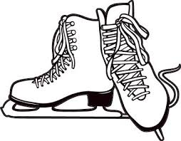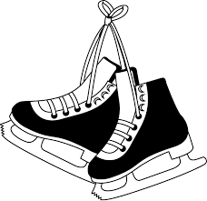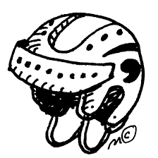

On December 19 all the classes will be rotating and going skating prior to the Christmas Holidays. Every student and adult on the ice must wear a helmet; this is not an option due to insurance. If your child does not have a helmet that is OK, the school has several they can borrow. If you have any old extra helmets at home that are no longer in use please consider donating them to the school (We will be going again in March).

If your child does not have skates please let the school know and we will try to find some they can borrow for the event. If you have any extra skates at home that you no longer use please also consider donating them to the school. Thank you!
THANK YOU to the Palmerston Dental Office - Dr. Kuhn and Dr. Thompson as they have graciously offered to pay for the buses and student cost both in December and March making this event free to all students. This is very generous and much appreciated!

