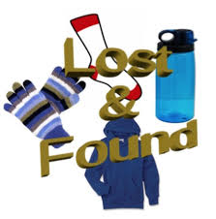Please check the “Lost and Found” before the end
of June. Any unclaimed items will be donated to a
local charity after the last day of school. Thank you!

