Arts Performance Project

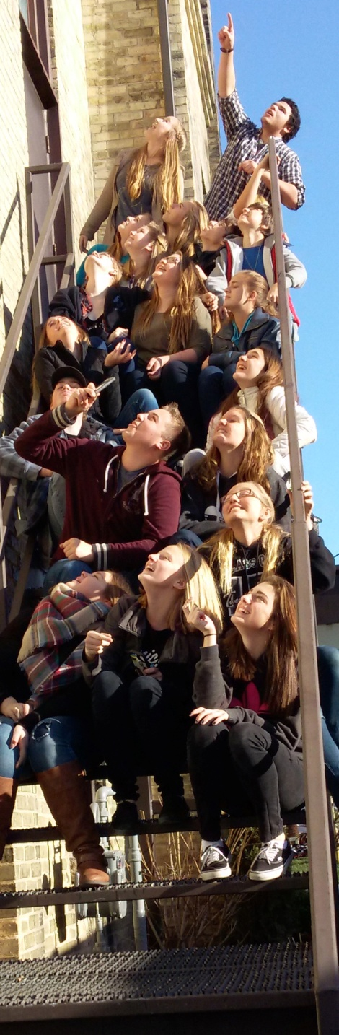

Norwell D. S. S.
Drayton Theatre
ARTS PERFORMANCE PROJECT - Teacher Reference
TO BE COMPLETED BY THE TEACHER: Please complete the referral form and return it to the student in a sealed envelope, with your signature across the seal.

Based on your experiences with this student, what skills and attributes make them a strong candidate for the Arts Performance Project?
Please check the description which best describes the student:
 | Dependability |  | Co-operation
 | very dependable |  | very co-operative, helpful
 | reliable, can be counted on |  | co-operates willingly
 | often requires prompting |  | co-operates when asked
 | requires close supervision |  | not always co-operative
 | Initiative and Independence |  | Attendance
 | self-motivated, seeks little direction |  | excellent record
 | occasionally seeks direction |  | satisfactory attendance
 | occasionally needs direction |  | frequently absent
 | often needs direction |  | high number of absences
 | Communication Skills |  | Quality of Work
 | effective and accurate |  | very thorough, few errors
 | usually effective |  | usually thorough
 | acceptable skills |  | satisfactory
 | experiences some difficulty |  | some improvement needed

Concerns:

Teacher Signature: _______________________________ Date: _____________________________________
Thank you for your time and your comments!

Hello Interested Artist! Welcome to the Arts Performance Project.
Like to perform? We’ve got an APP for that!
(Arts Performance Project) - Credits: Integrated Arts (ALC10) and English (ENG1D)

APP is an innovative, off-site performance-based arts program designed for grade 9 students with a keen interest in the arts. You will have the opportunity to explore the Performing Arts in a collaborative, non-traditional environment at the Drayton Festival Theatre. In this setting, you will explore and develop your artistic talents in theatre, music, dance and visual art. As well, you will take part in a variety of workshops with industry professionals and community mentors. In this program, you will achieve required grade 9 credits in both the Arts and English, as well as develop a framework for participation in the senior APP program and the Arts and Culture Specialist High Skills Major Program offered at Norwell in grades 11 and 12.

Because of the specialized nature of this dynamic program, candidates will meet the following expectations:

▢ PREPARATION: Attend every day and maintain a positive and energetic attitude. As well, you will be expected to dress in comfortable clothes that allow you to move, and bring required materials to class.

▢ PARTICIPATION: This program is varied, exciting and full of new experiences. Students are expected to participate in every activity. We ask that you “open the door” to creative opportunities!

▢ POLITENESS: In this program, you will act as ambassadors for Norwell District Secondary School. We ask that you showcase your professionalism and courtesy to yourself and others everyday.

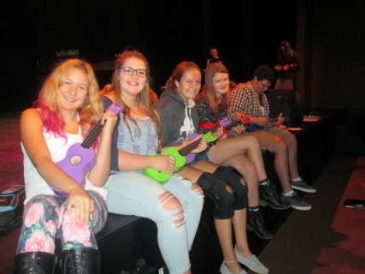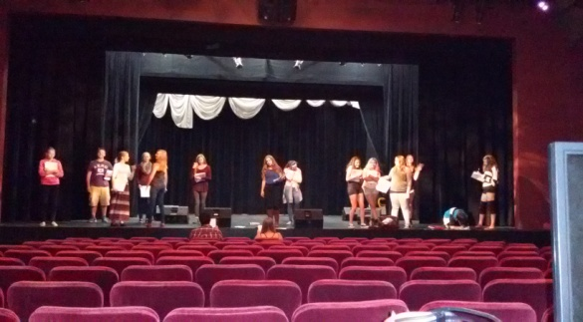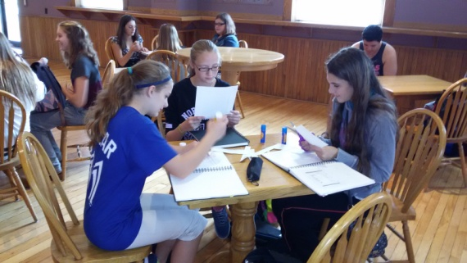

To apply to this program, please complete the following tasks:

▢ accurately and thoughtfully fill out the ARTS PERFORMANCE PROJECT Application Form

▢ ask one of your teachers to fill out the TEACHER REFERENCE FORM. They must return it to
you or N.D.S.S in a sealed envelope, with their signature over the seal.
▢ submit both the application and the sealed teacher reference to Norwell.

ARTS PERFORMANCE PROJECT – STUDENT APPLICATION FORM

First Name: ___________________________ Last Name:_________________________________

Present School: _______________________________________________ Gender:____________

Home Address:___________________________________________________________________

_________________________________________________ Postal Code: ___________________

Home Phone : _____________________ Parent/Guardian: _______________________________

Parent Email: ____________________________________________________________________

Name of Teacher Reference:________________________________________________________

Why are you a strong candidate for this program? _______________________________________
___________________________________________________________________________________________________________________________________________________________________________________________________________________________________________________________________________________________________________________________________________________________________________________________________________
Please list experiences and skills that you have in the Arts (i.e. music/dance lessons, special talents, performances, etc.)_________________________________________________________
__________________________________________________________________________________________________________________________________________________________________________________________________________________________________________________________________________________________________________________________________________________________________________________________________________________________________________________________________________________________

Please add anything else that you feel is important for us to know about you.
__________________________________________________________________________________________________________________________________________________________________________________________________________________________________________________________________________________________________________________________________________________________________________________________________________

