Primrose Elementary School
April 2024 Newsletter

Dear Parents/Guardians,
We have had a great few weeks after March Break! We welcome the milder spring temperatures, and as the ground thaws and we experience spring showers, the yard becomes muddy. Please consider packing an extra pair of pants and socks in your child’s school bag. We also encourage boots to be worn at recess.
Wellness Works! UGDSB’s April theme is Gratitude. This month will focus on the benefits of gratitude and being able to notice and acknowledge what exists around us as a key component of well-being. Gratitude is:
- The quality of being thankful
- An acknowledgement of goodness
- Readiness to show appreciation and return gratitude
- Recognizing sources of goodness outside of ourselves and how they contribute to our lives
We are grateful for your ongoing support! The last few months of school are going to be very busy. Please carefully make note of all school events and return permission slips promptly.
Enjoy the longer days and sunshine!
REMINDER
There will be a P.D. day on Monday, April 8th, 2024 and there will be a Solar Eclipse. There will be no school for students.
Solar Eclipse Resources
Please see WDGPH’s website. Our eclipse webpage is now live! Public Health has also prepared this Public Health Safety for Solar Eclipse (PDF) fact sheet in advance of April 8th.
THANK YOU
- for all the donations to help kids live free from hunger and helping to support our snack/breakfast program at the school.
- to the School Council for organizing and running a fun family movie night. It was great to see so many Primrose families in attendance.
- to the School Council for supporting Family Transition Place (FTP) for Grades 5-8, Scientists in the School for Grades K-8 and running our pizza and Boston Pizza days.
SCHOOL COUNCIL
The next School Council meeting is Wednesday, April 10, 2024 at 6:00 pm. A meeting link will be sent out and made available on the school website that day. If you would like to come in-person to the school we will be meeting in the Learning Commons (Library). There will be free babysitting if needed. If you would like to look at past agendas and minutes, they are posted on the school website under the School Council tab.
FAMILY MOVIE NIGHT
Hello Primrose Families! Did you have fun at watching Sonic the Hedgehog? Well, get ready because here comes the sequel, Sonic the Hedgehog 2!!

Invite your family and friends and join us for our next screening, Sonic The Hedgehog 2, Thursday, April 18th 2024 from 5:30-8pm.

After settling in Green Hills, Sonic is ready for more freedom, and Tom and Maddie agree to leave him home while they go on vacation. But, no sooner are they gone, when Dr. Robotnik comes back, this time with a new partner, Knuckles, in search for an emerald that has the power to both build and destroy civilizations. Sonic teams up with his own sidekick, Tails, and together they embark on a journey to find the emerald before it falls into the wrong hands.

This movie is rated PG and is 2hr 2 minutes long. There is a $2 entry fee per person with proceeds from SchoolCashOnline and the concession stand supporting student needs at Primrose. Thank you so much for your continued support. Our concession stand will offer popcorn, chips, candy, Bubly drinks and juice boxes - please bring cash to this event to purchase all concession stand items! Tickets and all other food items such as pizza and fresh veggies, will be available on SchoolCashOnline. The doors open at 5:30, and this movie will be screened in our gymnasium, seated picnic style, so bring your picnic blankets, pillows and stuffies and snuggle in for an amusing and Sonic filled Primrose night at the movies! We cannot wait to see you there!
Please pre-order your tickets and food items here: ( https://www.schoolcashonline.com/)

We are still looking for a few parent volunteers for the evening. If you are interested in helping, please contact Shannon Wright by email at shannonewright@yahoo.com

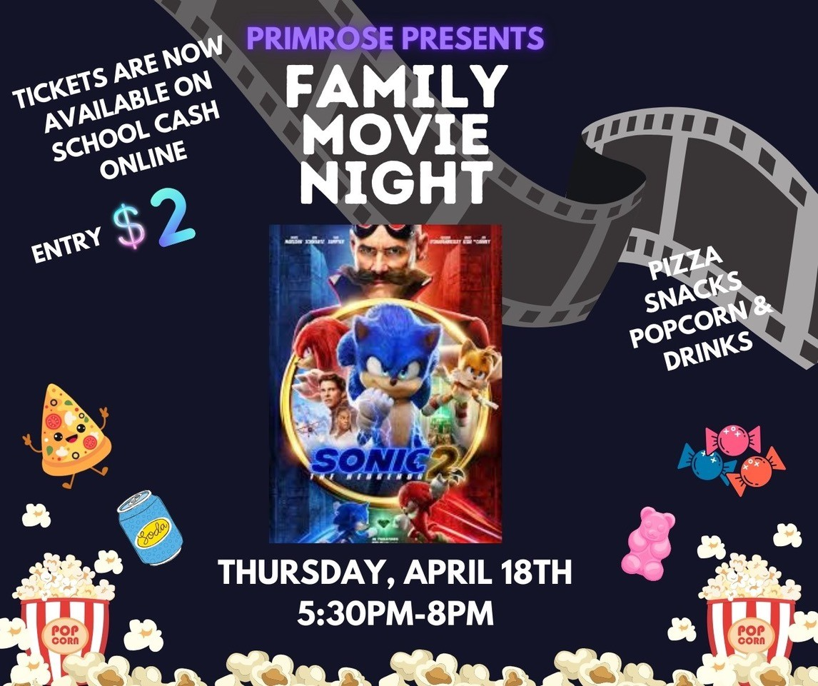

PRIMROSE FAMILY NIGHT

Primrose School Council is thrilled to be hosting an amazing event for families . It is to bring families together for a fun filled and informative event that promotes family wellness and strengthens community connections. With plenty of resources and tools available you will hopefully leave feeling empowered to take charge of your family’s health and well-being. We have 150 people coming on Thursday April 4 from 6 - 8:30 pm. You would have had to reserve your spot by March 26th in order for the School Council to prepare for numbers and food.
6-7 pm - Dinner is served in the gym
7:00 - 8:30 pm Family wellness workshops & activities
Local wellness resource vendors will be on display throughout the event
Please bring a cup, plate, bowl and cutlery for each family member registered and a bag to take home your dishes to support our eco-initiative

JUNIOR & SENIOR KINDERGARTEN REGISTRATION for September 2024
If you have not already registered your child for full day every day Junior Kindergarten in September 2024, please complete the registration online (www.ugdsb.ca/kindergaten) and call into the office so a meeting can be scheduled to complete the registration. Eligible students for the JK program must be four years of age on or before December 31st, 2024.
SCIENTISTS IN SCHOOLS

We are excited to announce that the kindergarten classes will be participating in a Scientists in Schools workshop called, Take a Nature Trek. This workshop will take place over the course of 2 days to accommodate our 4 classes. Our School Council has offered to pay for this workshop for all 4 classes! This means it will cost nothing for families. A consent form will be coming home for you to sign in order for your child to participate. Please sign and return the form as soon as possible. If you are interested in volunteering for this workshop, please contact us. We’re looking for 5 to 6 volunteers per class. Remember, a vulnerable sector check will need to be completed before you can volunteer.
Here is a little blurb about the workshop...
Go exploring with a hungry bear and investigate different habitats. Is it a bee or a wasp? Discover the answer using preserved specimens. Make a leaf rubbing to help identify a tree. Conduct an experiment to learn about fresh and saltwater. Just a few of the things we will do, while taking a nature trek right inside your classroom!

Tuesday, April 16, 2024 (Day 2)
9:15 am-10:45 am (Mrs. C-P/Ms. Hunter)
11:45am-1:15 pm (Mrs. Jones/Ms. Van Alstine)

Wednesday, April 17, 2024 (Day 3)
9:15 am-10:45 am (Ms. Stevenson/Ms. Dickson)
11:45 am-1:15 pm (Mrs. Bax & Mrs. Duern)

MOVING
If you know you will be moving and will not be attending Primrose Elementary School in the Fall, please let the office know as soon as possible.
ATTENDANCE
Just a reminder to guardians when their children are away to call into the office in the morning to let us know. Due to safety protocol, we call each family to check in when a student is away. Guardians calling in ahead of time speeds this process up and allows us to know all our students are safe. If your child is going on vacation please let the office know so they can be excused and not taken off the Primrose roster.
Also, if you receive an attendance letter, it is because your child has missed over 25 per cent of the school year. Being on time for school and attending school regularly plays a critical role in any child’s academic and social success at school.
GRADE 8 & KINDERGARTEN GRAD PHOTO RETAKES
For any absentees or those wanting retakes, we will have a photographer setting up first thing in the morning of April 22 at Centennial Hylands school.

Please fill out the appointment email below if you did not have the opportunity for photos or wish retakes. Families will simply need to reserve a morning time slot so not everyone arrives at the same time.
If for any reason you cannot make this date, we can arrange a date for you to
go to the Waterloo studio.

Appointment email
Pegasusstudio194@gmail.com

Shelley McBride
Account Manager
Pegasus
www.pegasus-si.com
localstudio@pegasus-si.com
Parent Inquiries: 800-461-6575

GRADE 7 & 8 VACCINATION PROGRAM
Nurses from the Public Health Unit will be in the school on Thursday, April 18th , 2024 to administer the second round of vaccinations (Hepatitis B and Human Papillomavirus).
Public Health is also returning to complete the Gr. 7 vaccine program. Students who missed or did not return a consent can start their series when Public Health is back on April 18th, 2024. Please advise inquiring parents to complete a consent on the online portal at www.wdgpublichealth.ca/gr7consent. If you have questions, concerns, or require assistance completing the consent, you can call the client and community support line at 1-800-265-7293, X 7006.

CHILD ABUSE PROGRAM

Yearly, teachers are to deliver the Child Abuse Prevention Programs. This program is delivered to Grades 1, 3, 5, and 7 students. Your child’s teacher will be delivering this program during the month of April. The following personal safety programs that will be taught are: Be Safe (Grades 1 and 3), Kids in the Know (Grade 5) and It Is Not Your Fault (Grade 7). A letter went home last week explaining the program. If you have any questions please do not hesitate to reach out to your child's classroom teacher.

ECO AWARENESS
Celebrate Earth Day on April 22nd!
EARTHDAY.ORG is unwavering in their commitment to end plastics for the sake of human and planetary health, demanding a 60% reduction in the production of ALL plastics by 2040. The theme, Planet vs. Plastics, calls to advocate for widespread awareness on the health risk of plastics, rapidly phase out all single use plastics, urgently push for a strong UN Treaty on Plastic Pollution, and demand an end to fast fashion. Join us as we build a plastic-free planet for generations to come!
Ideas for your family to celebrate Earth Day:
• Review previous Earth Day Themes. For example, there is an ongoing focus on ending plastic pollution. Make a pledge to always carry a reusable shopping bag, use alternates to Ziploc bags, buy in bulk, refuse to buy-over packaged products and make litter-less lunches. Download your Plastic Pollution Primer to learn more about this problem. Help End Plastic Pollution!
• Spend a day outside. In the garden with your family, plant vegetables, trees or native flowers and attract native animals and pollinators. Or join a local community event to help clean your neighbourhood by picking up discarded plastic, cans, and bottles. Or restore local plant life. Choose a good location for a compost pile – start recycling coffee grounds, eggshells etc. to decompose and to ultimately enrich your garden for the upcoming growing season.
• Help build a bird feeder. Build a bird feeder using a plastic bottle and filling it with bird seed.
• Make commitments to cut down on your energy usage as well as waste. Turn lights off, power down electrical devices, turn down your thermostat and only do full loads of laundry and dishes.
• Learn more about the environment and the effects of global warming. Encourage awareness and promote the Reduce (buy less), Reuse (repurpose it) and Recycle (sort it right!) way of life.
Remember that every day is Earth Day! Don't restrict yourself to just one day a year. Make environmental actions and caring about the planet a habit - on Earth Day and every day.
ECO UPDATE
We are continuing to work towards various Eco initiatives at Primrose. Our compost and recycling program are in full effect and our older Eco leaders are continuing to support our younger students with this. In the next few months, students will be participating in a school wide waste audit, different environmental-based activities for Earth Day in April and water awareness activities through the months of May and June. In addition, our K students will be growing sprouts and learning about how they can create and maintain sustainable gardens! We will continue to share our exciting eco initiatives as they happen!

YOU’RE THE CHEF PROGRAM

Our Healthy Schools Club is excited to be participating once again in the “You’re the Chef” program. “You’re the Chef” is a six-week cooking program that builds the skills and confidence of youth to prepare healthy and tasty recipes emphasizing vegetables and fruit. Our group of eight intermediate students will be cooking, baking and learning how to build meals on a budget. This fun hands-on cooking program is an incentive from UGDSB to promote experiential learning focusing on cooking. We are so happy to have the opportunity to offer it again this year!
Healthy Schools Leads–Mrs. CP and Mrs. Jones

PRIMROSE PRIMARY CHOIR and NEWSIES JR. UPDATES
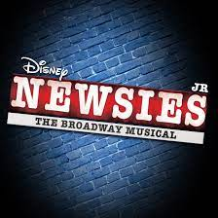
The Primrose Primary Singers have been busy rehearsing and are getting ready to participate in the Orangeville and District Music Festival during the Week of April 29 - May 1. These 65 students in grades 1 - 3 will have the opportunity to hear other elementary school choirs sing and to receive a formal adjudication on their performances.
Part of the Newsies Jr. cast will also be participating in the ODMF, showcasing two of their Newsies Jr. songs and receiving feedback too. Rehearsals are still underway, costumes are coming in, headshots have been taken, and props and sets are being created. We are excited to share the hard work and talents of our performers!

NEWSIES JR. TICKET SALES

Tickets for Newsies Jr. will be going on sale starting April 15, 2024! They will be available for purchase on School Cash Online. Availability is limited and seats will be assigned on a first come first served basis. Once your purchase has been processed, tickets will be sent home with students. The window for ticket sales will close the day before each performance or earlier if the show sells out so please be sure to purchase your tickets in advance as we won't likely be able to accommodate walk-ins. Keep an eye on the morning announcements for more information. For questions, please contact Michelle Pasmore (michelle.pasmore@ugdsb.on.ca) or the office for more information.

SCHOOL SPIRIT WEAR

Looking to add some purple and gold to your child’s wardrobe? Primrose school spirit wear is available for purchase through a link on our school website, under the School Council tab, or click HERE to reach the site. Shirts can even be personalized on the sleeve. Makes a great gift!

COMMUNICATIONS NEWSLETTER - UGDSB
The UGDSB Communications team has a monthly newsletter to give students, staff and parents/guardians a glance at the month ahead. Keep an eye out the last week of each month for your latest edition of UGDSB Together.
The April Communications Newsletter is out!.

In this month's issue we have information about:
- Every Day Counts! Student attendance
- Student career fairs
- Mental health literacy for students
- And more!
Here is the link to the website with all the newsletters from September to April.
https://www.ugdsb.ca/community/communications/communications-newsletter/

UPCOMING EVENTS
Click HERE to access the Primrose school calendar to see upcoming events.
April 1 - Easter Monday (no school)
April 2 - Rainbow Colours Day (World Autism Day)
April 2 - Skills Competition Team at Guelph University 9 am
April 2 - Boston Pizza Day
April 4 - Custodian Appreciation Day
April 4 - Smoothie Day
April 4 - Family Night 6-8:30 pm
April 5 - Pizza Day
April 8 - PA Day (no school)
April 9 - Boston Pizza Day
April 9 - Intermediate (Boys & Girls) Basketball Team Semi Finals @ Westside
April 9 - Wear Purple and Gold for Ramadan
April 10 - International Day of Pink - Anti-Bullying & Anti-Homophobia
April 10 - School Council Meeting 6 to 7:30 pm
April 11 - Intermediate (Boys & Girls) Basketball Team Finals @ Westside
April 11 - Smoothie Day
April 12 - Pizza Day
April 12 - Hat Day
April 15 - Spring Colours Day
April 15 - Pita Day
April 15 - Newsie Tickets on School Cash Online
April 16 - Boston Pizza Day
April 16 - Kindergarten Scientists in the School (Carson-Pedri/Hunter & Jones/Van Alstine)
April 17 - Kindergarten Scientists in the School ( Stevenson/Dickson & Bax/Duern)
April 18 - Smoothie Day
April 18 - Family Movie Night 5:30 to 8:00 pm
April 18 - Grade 7 Vaccinations
April 19 - Pizza Day
April 22 - Pita Day
April 22 - Wear Blue and Green for Earth Day
April 22 - Grad Photo Retakes at Centennial Hylands (email for appointment)
April 23 - Boston Pizza Day
April 24 - 2nd fluoride varnish application for JK/SK
April 24 - OC and AOA Office Day (Tricia, Amanda and Tina in the office)
April 25 - Smoothie Day
April 26 - Pizza Day
April 26 - School Colours Day
April 29 - Pita Day
April 29 & 30 & May 1 - Primary Choir and some Newsies Jr. Cast to Orangeville and District Music Festival (Exact Day TBD)
April 30 - Salad Bar Day

May 2 - Smoothie Day
May 2 - Grade 4 trip to Annie Jr.
May 3 - Newsies Jr. Dress Rehearsal (kindergarten to grade 2 student audience only)
May 3 - Pizza Day
May 3 - Red, White, Green Day (Cinco de Mayo)
May 6 - 10 Education & Mental Health Week
May 6 - Pita Day
May 7 - Boston Pizza Day
May 7 - Newsies Jr. Dress Rehearsal (grades 3-8 student audience only)
May 7 - Newsies Jr. Evening Performance 7pm
May 8 - Chess Team to Orangeville
May 8 - Newsies Jr. Evening Performance 7pm
May 9 - Smoothie Day
May 9 - Newsies Jr. Matinee (11:45am) & Evening (7pm) Performance
May 8 - June 12 EQAO
May 10 - Pizza Day
May 10 - Character Day (from movie, book, tv etc.)
May 10 - Newsies Cast Party and Clean Up
May 13 - Pita Day
May 14 - Boston Pizza Day
May 16 - Smoothie Day
May 16 - EA & CYC Appreciation Day
May 17 - International Day Against homophobia, transphobia and biphobia rainbow colours
May 17 - Pizza Day
May 20 - Victoria Day (no school)
May 21 - Flag Football Tournament 4 pm
May 21 - Boston Pizza Day
May 23 - Smoothie Day
May 24 - Comfy Clothes Day
May 24 - Pizza Day
May 24 - Jump Rope for Heart
May 27 - 31 Rock Climbing in the Gym
May 27 - Pita Day
May 28 - Boston Pizza Day
May 28 - Ultimate Frisbee Tournament
May 30 - Smoothie Day
May 31 - Pizza Day
May 31 - Grade 7 Teen Ranch Trip

June 3 - Junior Kindergarten Orientation 5-6 pm
June 3 - Pita Day
June 4 - Salad Day
June 4 - Grade 8 Toronto Trip
June 5 - 1500 m Meet @ ODSS
June 6 - Hat Day
June 6 - Smoothie Day
June 7 - PA Day (no school)
Please remember to check the UGDSB website, follow us on Twitter, visit our school website, go into your child’s Google classroom to see announcements and all the wonderful work they are doing, and read the emails for important information from our school.

If you have any questions or concerns please feel free to call or email us at
Marianne Millsap Principal 519-925-3939 ext 223 marianne.millsap@ugdsb.on.ca
Ashley Hopkins Vice Principal 519-925-3939 ext 224 ashley.hopkins@ugdsb.on.ca

Marianne Millsap
Principal

