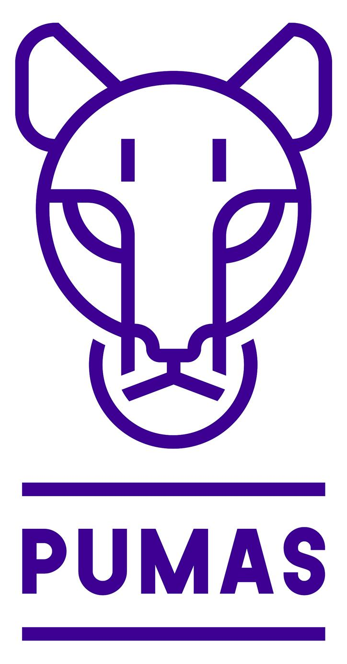
Primrose Elementary School
May 2024 Newsletter

Dear Parents/Guardians,
After a great deal of rain on the weekend we are looking forward to seeing some May flowers! Please make sure that your child is coming to school dressed for the variable spring temps; layers are best. Our yard can be muddy. Outdoor shoes are necessary to ensure we are not tracking mud throughout the school. An extra change of clothes tucked in the backpack can come in handy in the event that your child has a slip and fall at recess.

May and June are very busy months. We have lots of events planned. Please take some time to read the school newsletter and classroom memos carefully to ensure you are aware of events and endeavor to make any necessary payments on or before the listed deadlines.

WELLNESS WORKS!
UGDSB’s May theme is Empathy.
Empathy is “feeling with people” Doctor Brene Brown
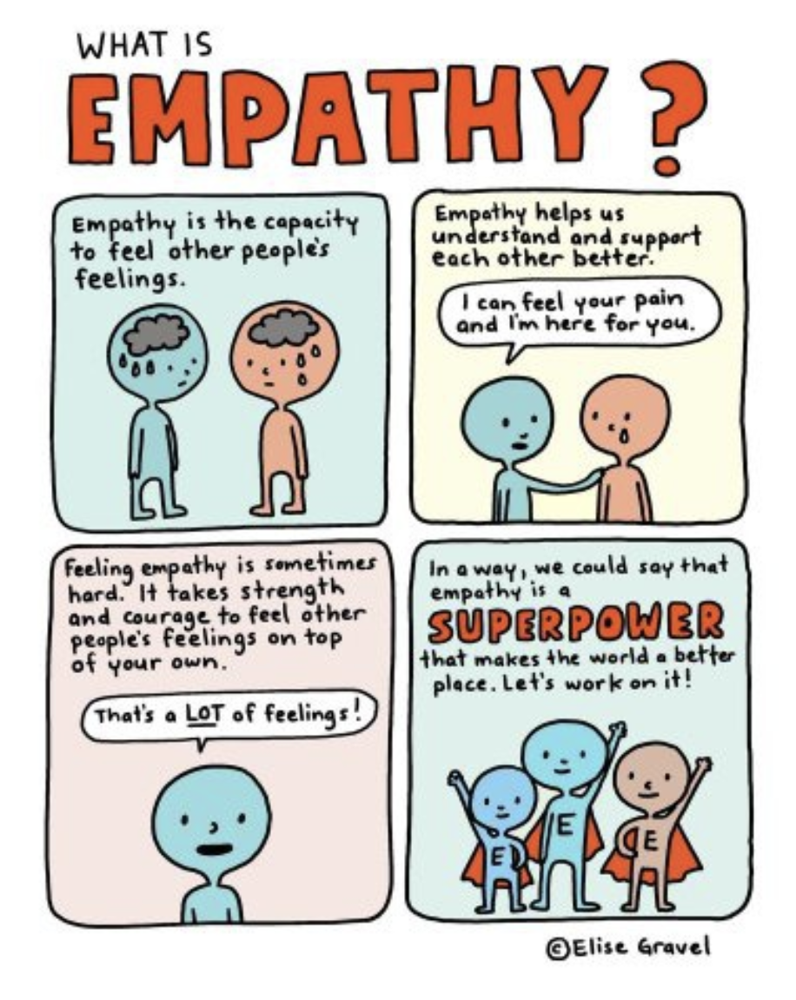

SCHOOL SAFETY DRILLS
As a reminder, each year our school must conduct drills to ensure staff and students are prepared in the event of a real emergency. The week of May 13 and May 17 we will be conducting the last of our drills. We will also be sounding the alarm bell so students know what it sounds like and to test our various pull stations in the school. We will be reassuring students that there are no concerns and that it is a drill. You may want to let your children know, particularly if your child gets anxious with drills.
For the school year:
- Three (3) fire drills in the fall and three (3) fire drills in the spring
- Two (2) lockdown drills
- One (1) tornado drill
- One (1) bomb threat drill
All drills are conducted in a manner that is sensitive to the needs of our students. If you have any questions, please do not hesitate to contact the school office.

REMINDER

A reminder there will be no school on May 20 as it is Victoria Day. Also, June 7th is a PD Day. Teachers will be continuing work on class placements for the 24/25 school year and working on assessment and evaluation for term two report cards as well.
EDUCATION AND MENTAL HEALTH WEEK MAY 6 - 10, 2024

At UGDSB we are, as always, recognizing Mental Health and Education Week collectively. We are excited to announce UGDSBs 2023-2024 Mental Health and Education Week Theme: 5 Days of Wellness - Celebrating Mental Health & Education Week at UGDSB. This year’s theme is, ‘Five Days of Wellness.
Each day this week will have a different focus. Monday is What is Wellness?, Tuesday is The Language of Wellness, Wednesday is The Science of Wellness, Thursday is The Connection to Nature and Friday is The Practice of Wellness. Classes and divisions will be doing daily activities to highlight the daily theme. Please take a look at our school announcements on your child’s classroom with more details. We hope that your children enjoy the week.
TICK INFORMATION

Here is some Tick information to share with families who may be inquiring this time of year. The memo below and links from Public Health may be helpful if you are looking for information.
Blacklegged Tick and Lyme Disease
https://wdgpublichealth.ca/your-community/ticks-lyme-disease

EQAO MAY 8 to JUNE 12
EQAO students in grades three and six will work with their teachers on the provincial Education Quality Assurance Office’s (EQAO) annual standardized assessment of mathematics and language skills. Testing will occur during the morning & middle blocks. Please avoid scheduling appointments to allow students the opportunity to participate in this assessment. The schedules are listed below.
Mr. Bannon Tuesday May 21 - Friday May 24
Ms. Mesesnel Monday June 3- Thursday June 6th
Ms. Little May 28 - May 30
Ms. Williamson May 28 - May 30
Mr. Parsons May 17 AM - Practice, May 21, May 22

NEWSIES JR. UPDATE

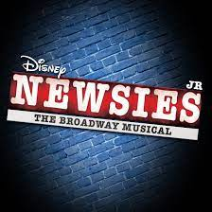
Now is the time to “seize the day”! Our grade 4-8 school musical production is finally here, with shows for our Primrose students during the school day on May 6 and 7, and public performances on May 7, 8 and 9. Evening tickets sold out quickly, but some tickets are still available through School Cash Online for our May 9th matinée. A reminder that we will be collecting donations of NON-PERISHABLE FOOD ITEMS for our local food bank, The Shepherd’s Cupboard, at the door. As well as the shows, some of our Newsies cast traveled to the Dufferin Oaks Long Term Care Home to perform for the residents there. We will also have a group represent our cast at the Orangeville and District Music Festival, showcasing our musical by performing two songs from the play. Another community connection is scheduled for Saturday, May 4th, when some of our cast will be performing as part of the “Spirit Touches Art Touches Spirit” event in Shelburne, celebrating diversity in the arts in our community. Our Newsies Jr. artistic team has been thrilled with the enthusiasm, commitment and support of our students, staff and families throughout this fantastic arts experience!

PRIMARY CHOIR UPDATE

Students in Grades 1, 2 and 3 have been enthusiastically participating in choir during one or two recesses a week since January. All of their hard work and effort will be paid off this week when they perform at the Orangeville District Music Festival on May 1st and again at the “Spirit Touches Art Touches Spirit” community event celebrating diversity in the arts at Trinity United Church on Saturday May 4. The students have been working hard on dynamics, pitch matching, two-part harmony and sharing a message through song. They are all enthusiastic about music and have continued to learn and grow and make their choir directors proud! Congratulations to these young singers on their musical journey this year!

GROTTO CLIMBING WALL

We are so excited to host the Guelph Grotto Climbing Wall from May 27 - 31! All classes JK-8 will get to have two experiences organized by the Grotto Staff. Permission slips will be sent home in the next few weeks. Please make sure your child’s permission slips have been returned to the school before the event. This will be a free event due to an outdoor education grant and money raised from our popcorn sales.

JUMP ROPE FOR HEART

Primrose will be hosting our annual Jump Rope for Heart event on Friday May 24th (Rain date: Thursday June 6th). Students will be jumping rope outside (Primary 11:45am-12:15, Junior 12:30-1pm and Intermediates 2-3pm) to promote a healthy and active lifestyle. Jumping rope builds healthy habits, boosts school spirit, and teaches social responsibility as we fundraise for life-saving heart and stroke research. Families can choose to donate to the Heart and Stroke Foundation using the following link: Donate Here
Our school goal is to raise $2,000. All students in the school will receive an extra 20 minute recess if we reach our goal! As our heartfelt thank you for your support, students can earn one of five Thank You Prizes, an online gift card from Toys “R” Us, Indigo, Amazon or Walmart – based on their fundraising levels. For more information you can watch the following video: Jump Rope for Heart Video
Please ensure that you are checking the weather and bringing appropriate attire (athletic wear, running shoes, extra clothing), and lots of water on Jump Rope Event Day!. Thank you for your support! For questions, please contact Brent Stiles (Grade 5 teacher) at bstiles@ugcloud.ca
NEWS FROM LLC

Our Blue Spruce, Silver Birch, and Red Maple readers have cast their votes for their favourite books in the Ontario Library Association's Forest of Reading program for 2024. We now wait until the middle of May to learn the winners in each category. We celebrated the Blue Spruce books with our "Blue Spruce Juice" - a special recipe that I create each year for our amazing readers. Our Maker Space is looking bare now that the props have left the "Prop Shop" and have made their way on stage to set the scene for the Newsies Jr. Production. SO many hands were involved in creating items for the show . . . we are grateful for the excitement and community spirit.

HEALTHY SCHOOLS - YOU’RE THE CHEF

Healthy Schools concluded the six week You’re the Chef cooking program, with a special guest. Thank you Mrs. French for joining us on our last day of cooking class to share some great tips. Mrs. French gave us all a lesson on how to create the perfect salad, how to roast root vegetables and how to make a delicious homemade salad dressing. Thanks to all the students who came every week to learn more about the fun art of cooking.

SCHOOL COUNCIL
The next School Council meeting is Tuesday, May 14, 2024 at 6:00 pm. A meeting link will be sent out and made available on the school website that day. If you would like to come in-person to the school we will be meeting in the Learning Commons (Library). There will be free babysitting if needed. If you would like to look at past agendas and minutes, they are posted on the school website under the School Council tab. Our last School Council meeting will be June 11, 2024 at 6:00 pm.

DUFFERIN PARENT SUPPORT NETWORK
The Dufferin Parent Support Network is a network of parents and community agencies who provide education, resources and support for parents. Dufferin Parent Support Network is hosting some amazing free parenting workshops in May for parents, grandparents and caregivers.
May 2024 - Workshops.png
These include:
• Connection Conversations: Approaching Drug Use Conversations With Your Child - May 2.
• Recognizing and Supporting Your Child’s Special Needs - May 8.
• Piggy Banks to Prosperity: Teaching Kids Smart Money Moves - May 15.
Thank you for your continued support,
Alyssa Kamphuis
Coordinator
DPSN - Dufferin Parent Support Network
519-940-8678 • www.dpsn.ca • info@dpsn.ca
MOVING?
If you know you will be moving and will not be attending Primrose Elementary School in the Fall, please let the office know as soon as possible.
ATTENDANCE
Just a reminder to guardians when their children are away to call into the office in the morning to let us know. Due to safety protocol, we call each family to check in when a student is away. Guardians calling in ahead of time speeds this process up and allows us to know all our students are safe. Also, if you receive an attendance letter it is because your child has missed over 25 per cent of the school year. Being on time for school and attending school regularly plays a critical role in any child’s academic and social success at school.
ECO UPDATE
Last week for Earth week, our school ran a variety of initiatives to recognize the importance of keeping our earth clean. Throughout the week, all classes were challenged to bring in Litterless Lunches in hopes to reduce the amount of waste we produce as a school. Thank you to our Healthy Schools Team for taking the lead on this. It was amazing to see the decrease in the amount of litter in our lunches as the week progressed. In addition we all kept our classroom lights off for an hour and learned about the importance of energy conservation and also recognized it with a Blue and Green Spirit Day.
Our Eco Representatives also lead the “Great Gulp” initiative. The purpose of this initiative was to encourage all students to reduce single use plastics and to bring a reusable water bottle to school. On Monday, April 22, we all used our reusable water bottles to take a “great gulp” of water all at the same time. It was exciting to see how many students had their reusable water bottles. Please continue to ensure that you bring these reusable water bottles every day, especially as the weather gets warmer!
As the year begins to come to a close, some of our Kindergarten students will be learning about, and growing, sprouts in their classroom to learn about the benefits of locally grown vegetables.
We are continually working towards achieving Eco School Status again this year! Thank you for your continued support!
SCHOOL SPIRIT WEAR

Looking to add some purple and gold to your child’s wardrobe? Primrose school spirit wear is available for purchase through a link on our school website, under the School Council tab, or click HERE to reach the site. Shirts can even be personalized on the sleeve. Makes a great gift!

NATIONAL ACCESSABILITY WEEK (MAY 26 - JUNE 1)
At Primrose, we’re taking action to build an even more inclusive and accessible school. We are helping to celebrate the valuable contributions of Canadians with disabilities and recognize the efforts of people who are removing barriers to accessibility and inclusion. It’s National Accessibility week.
Primrose Daily Schedule & School Bells 2024 - 2025
Below is the times for the daily schedule for 2024 - 2025
8:35 - 9:00 Supervisors on the yard (do not drop off before this time)
9:00 - 11:00 (Instructional Day 120 minutes)
11:00 - 11:40 (Nutritional Break)
11:40 - 1:20 (Instructional Day 100 minutes)
1:20 - 2:00 (Nutritional Break)
2:00 - 3:20 (Instructional Day 80 minutes)
3:20 - 3:35 End of Day Buses and Pick ups
Calendar 2024 - 2025
The Ministry of Education has a pending approved Upper Grand District School Board school year calendars for the 2024-2025 school year. Students will start the year on Sept. 4. Winter Break will be from December 23, 2024, to January 3, 2025. March Break will be from Monday March 10 to Friday March 14, 2025. The last day of school will fall on June 26 for elementary students. The approved calendars will be posted on the board website under School Year Calendars.

COMMUNICATIONS NEWSLETTER - UGDSB
The UGDSB Communications team has a monthly newsletter to give students, staff and parents/guardians a glance at the month ahead. Keep an eye out the last week of each month for your latest edition of UGDSB Together.
Here is the link to the website with all the newsletters from September to May.
https://www.ugdsb.cCommunications Newslettera/community/communications/communications-newsletter/

UPCOMING EVENTS
Click HERE to access the Primrose school calendar to see upcoming events.
May 2 - Smoothie Day
May 2 - Grade 4 trip to Annie Jr.
May 3 - Newsies Jr. Dress Rehearsal (kindergarten to grade 2 student audience only)
May 3 - Pizza Day
May 3 - Red, White, Green Day (Cinco de Mayo)
May 3 - Grade 3 Scientist in the School
May 6 - 10 Education & Mental Health Week
May 6 - Pita Day
May 7 - Newsies Jr. Dress Rehearsal (grades 3-8 student audience only)
May 7 - Newsies Jr. Evening Performance 7pm
May 8 - Chess Team to Orangeville
May 8 - Newsies Jr. Evening Performance 7pm
May 8 - June 12 EQAO
May 9 - Smoothie Day
May 9 - Newsies Jr. Matinee (11:45am) & Evening (7pm) Performance
May 10 - Pizza Day
May 10 - Character Day (from movie, book, tv etc.)
May 10 - Newsies Cast Party and Clean Up
May 13 - Pita Day
May 14 - School Council Meeting @ 6 pm
May 16 - Smoothie Day
May 16 - Ms. Cullen & Ms. McNalty Scientist in the School
May 16 - EA & CYC Appreciation Day
May 17 - International Day Against homophobia, transphobia and biphobia rainbow colours
May 17 - Pizza Day
May 20 - Victoria Day (no school)
May 21 - Flag Football Tournament 4 pm
May 23 - Smoothie Day
May 23 - Ms. Hawkins Scientist in the School
May 24 - Comfy Clothes Day
May 24 - Pizza Day
May 24 - Jump Rope for Heart
May 27 - 31 Rock Climbing in the Gym
May 27 - Pita Day
May 28 - Ultimate Frisbee Tournament
May 28 - Grade 8 at CDDHS 10:15 - 11:15
May 30 - Smoothie Day
May 31 - Pizza Day
May 31 - Grade 7 Teen Ranch Trip

June 3 - New JKs Orientation 5-6 pm
June 3 - Pita Day
June 3 - Pride Group at CDDHS 9 am - 12 pm
June 4 - Grade 8 Toronto Trip
June 4 - Grade 6 Tiffin Centre Trip
June 5 - 1500 m Meet @ ODSS
June 6 - Hat Day
June 6 - Smoothie Day
June 7 - PA Day (no school)
June 10 - Pita Day
June 11 - Salad Day
June 11 - School Council Meeting 6 pm
June 12 - Pride Club Celebration
June 13 - Grade 1 Trip to Elmvale Zoo
June 13 - Grade 3 Trip to the Dufferin Museum
June 13 - Smoothie Day
June 14 - Pizza Day
June 14 - Ms. Mesesnel’s Class to Dufferin Museum
June 14 - Grade 5 trip to the Science Centre
June 14 - Backwards Day
June 17 - Pita Day
June 17 - Senior Kindergarten Grad 5 - 6 pm
June 19 - Ms. Ingram Scientist in the School
June 20 - Track and Field (ODSS)
June 20 - Smoothie Day
June 21 - Pizza Day
June 21 - Alternate Track and Field Day
June 21 - Grade 2 Scientist in the School
June 21 - School Colours Day
June 24 - Pita Day
June 24 - Grade 8 Graduation
June 26 - Report Cards Home
June 26 - Wear Red & White for Canada Day
June 27 - Last Day of School
June 28 - PA Day
Please remember to check the UGDSB website, follow us on Twitter, visit our school website, go into your child’s Google classroom to see announcements and all the wonderful work they are doing, and read the emails for important information from our school.

If you have any questions or concerns please feel free to call or email us at
Marianne Millsap Principal 519-925-3939 ext 223 marianne.millsap@ugdsb.on.ca
Ashley Hopkins Vice Principal 519-925-3939 ext 224 ashley.hopkins@ugdsb.on.ca

Marianne Millsap
Principal

