School Newsletter Insert from Wellington-Dufferin-Guelph Public Health
September 2018

WDG Public Health is pleased to provide elementary schools with up-to-date information on health topics for their monthly newsletters and announcements to parents. Please find below an insert you can include in your school newsletter and/or announcements if you wish. If you have any questions please contact us at 1-800-265-7293 ext. 4111 or email schoolhealth@wdgpublichealth.ca
-------------------------------------------------------------------------------------------------------------------

Information from Public Health - Lunchbox Essentials!

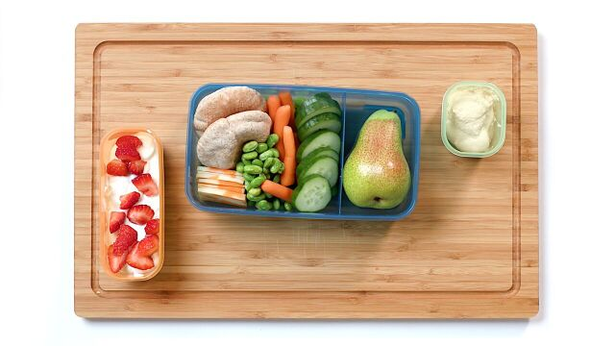
Are you getting back into the habit of packing school lunches? A balanced lunch includes a variety of foods to keep your child full and able to learn best. Try to include at least one food item from each of these 4 categories in your child’s lunch every day.
Vegetables
Fruit
Protein-rich Foods (beans, lentils, chickpeas, cheese, eggs, meat, fish, plain yogurt, plain milk)
Whole Grains & Starchy Vegetables (whole grain pasta or bread, potatoes, corn)

Top 5 Tips:
- Keep peeled and cut veggies and fruit on hand in the fridge, ready to grab and go! Try to include a fruit or veggie at every meal and snack.
- Involve your kids in planning and making school lunches. They’re more likely to eat food they helped make and they build valuable life skills in the kitchen!
- Save time and use your leftovers for school lunches.
- Include a reusable water bottle every day.
- Check out UnlockFood.ca for school lunch tips and recipes.

