Princess Elizabeth Public School
Welcome to the 2020-2021 school year!

We are looking forward to welcoming all of our new and returning students back to Princess Elizabeth Public School this September!
As you are aware, the Upper Grand District School Board has put extensive plans in place for the school year. Our school has now created plans that include both operational changes (how we manage the people and resources within the school) and health and safety changes (our response to the COVID pandemic). We hope this document will help answer your questions about the specifics about the opening day and first week of school.

Please also look through our board Parent Handbook, for more detailed information about the changes for this school year. There is also a link to the Board Website and the Parent Question and Answer (Q&A) page.

Link to Parent Handbook
Link to Board Website and Parent Q & A
Staggered Entry

We will be having a staggered entry for all students this year. This means that all students will come to school with approximately half of their classmates on alternating days for the first two weeks of school. This will allow us to carefully review and establish safety routines with fewer students in the building. Parents will soon receive a phone message identifying which class their child will be in. Students will attend school as per the charts below:

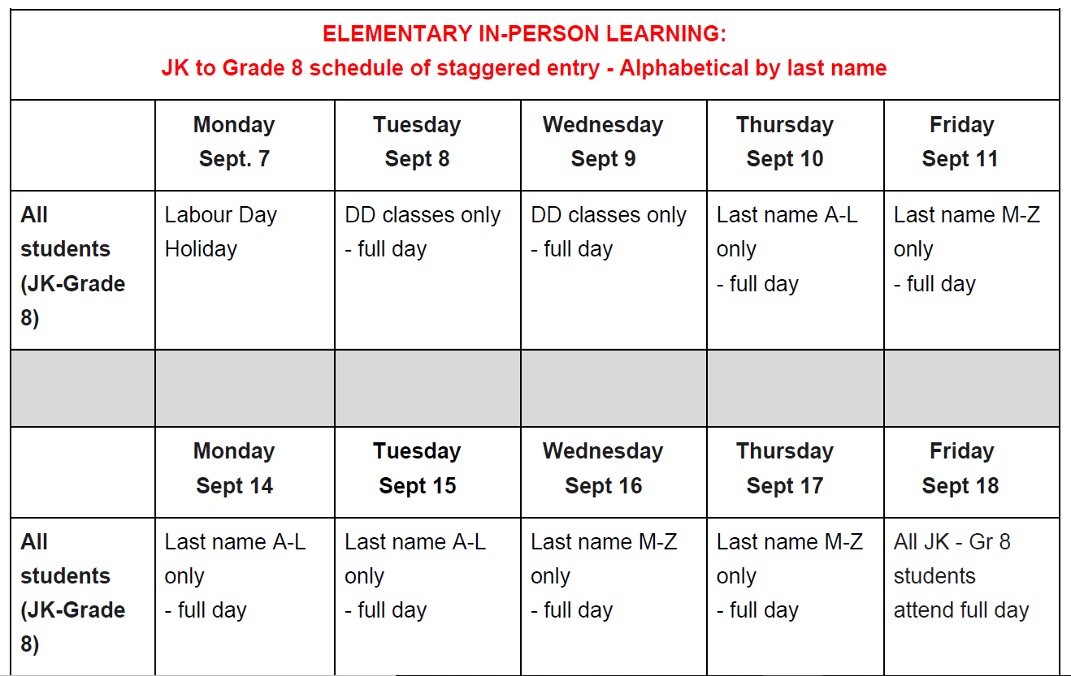

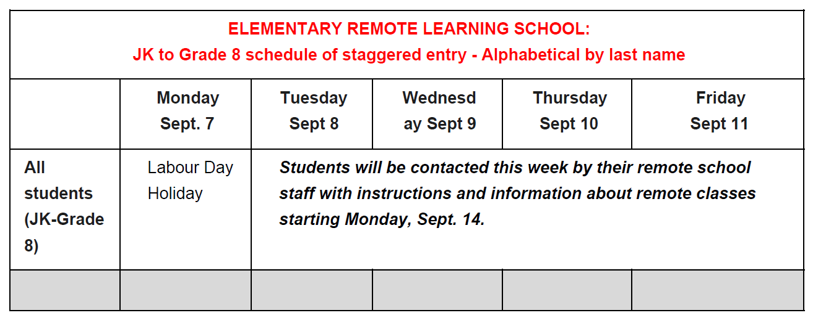
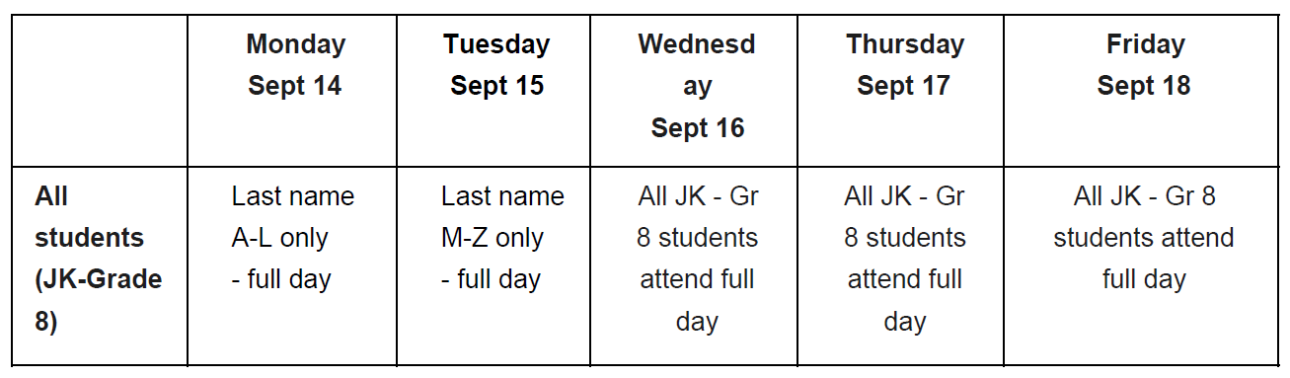

Before Coming to School

COVID-19 Screening:
- All parents must screen their children every day before leaving home for symptoms of COVID-19. If there are symptoms, children need to stay home from school. If COVID-19 is suspected, testing is recommended.
- Link to self-screening tool

What to Bring to School

Note: Cubbies, coat racks and change rooms will not be used for the 2020-2021 school year. Students will be required to keep all personal belongings with them throughout the day.

Note: Additional information will be provided to families about how the school will help students manage winter boots and coats when cold weather arrives.

Suggested School Supply List 2020-21

As you are working to get your child(ren) ready to return to school, you may be thinking of what students should bring to school to help with their safe return to school this fall. Here is a list of items that you may want to consider getting for your child(ren). These items are suggestions only. We will provide all necessary tools that students will require for school.

Primary:
-pencils - eraser
-glue stick - pencil case
-pencil crayons - box of crayons 24 (gr. 1-2)
- scissors
- at least 2 face masks (in case one gets soiled or lost)
- a baggie/container to store mask when not being worn
- earbuds/headphones (kept in their backpack)
-reusable water bottle that your child can open independently

Junior:
- pencils - eraser
- glue stick - pencil case
- pencil crayons - pencil sharpener
- clear plastic 30cm ruler - calculator
- scissors
- earbuds/headphones (kept in their backpack)
- a baggie/container to store mask when not being worn
- at least 2 face masks (in case one gets soiled or lost)
-reusable water bottle that your child can open independently

Intermediate:
- 1 large binder - calculator
- dividers (10) - glue stick
- lined paper (punched) - markers (thin)
- pencil case - pencil sharpener
- pencils - pens
- eraser
- at least 2 face masks (in case one gets soiled or lost)
- - a baggie/container to store mask when not being worn
- earbuds/headphones (kept in their backpack)
- reusable water bottle
Students may bring their own devices, but they must be wiped by the student upon entry and before leaving at the end of the day.

How Will I Know What Class My Child is In?

On September 8th, you will receive a phone call from the school. At that time we will let you know who your child’s teacher is. Please attend the school on your child’s correct entry date. Teachers will ask a few questions and offer reassurance and support for a wonderful year. Please understand that this placement cannot be changed at this time.

First Day Procedures

Morning Drop Off:
- All Kindergarten students will meet in the K playground area spread between the “outdoor classroom”, tarmac, and the playground. Parents are asked to drop their child off with their teacher, wish them well, and leave school property immediately. While on school property, you are reminded that all physical distancing requirements are in place. Parents will not be permitted into the school.
- Kindergarten bus students will be directed by an ECE to meet their educator team.
- All students in English will be directed to go to the Primary/Intermediate (West side of the school) play yard and field before the bell. Your child’s teacher will be behind a pylon with a sign indicating their name. Parents are asked to drop their child off with their teacher, wish them well, and leave school property immediately. While on school property, you are reminded that all physical distancing requirements are in place. Parents will not be permitted into the school and are asked to leave school property after you have dropped your child(ren) off with their teacher.
- All students in French Immersion will be directed to go to the 3-4-5 (East side of the school) play yard and field before the bell. Your child’s teacher will be behind a pylon with a sign indicating their name. Parents are asked to drop their child off with their teacher, wish them well, and leave school property immediately. While on school property, you are reminded that all physical distancing requirements are in place. Parents will not be permitted into the school and are asked to leave school property after you have dropped your child(ren) off with their teacher.
- If you have medication, please call the office and arrangements will be made to meet you at the front doors for a drop off. 519-941-0220
- Bus students will be directed to the appropriate yard and will be met and greeted by a staff member. The staff member will direct your child to their teacher’s line.
- This is just a reminder that in the Kiss ‘N Ride area there is no parking. Students should be dropped off and head to their designated yard to meet their teacher.
Designated Entry Doors:

To facilitate speedy entry in the morning and to limit unnecessary travel through the building, each grade/class will be assigned an entry/exit door. This will be the only door that students will use for entering the building, for accessing outdoor activities (and recess) and departing at the end of the school day.
School Greeters:

A “Greeter” will meet each student at their assigned points of entry first thing in the morning. Students will be reminded to put on a mask and to physically distance as they enter the building and they may assist with hand sanitizer. The Greeter will also meet students who arrive late (after 8:45 a.m.) to ensure they are physically distanced, write down their name, and direct them to their classroom to meet their class.
Late Arrival:

Students who arrive late are asked to wait at the front of the school by the doors. Parents/Guardians are asked to call the school and a staff member will meet you there for student pick-up. The morning bell rings at 8:30 am.
Entering the Building:

When the bell rings, teachers will direct students to line up while maintaining a physical distance (2 metres) behind their teacher and will be brought into their class single file with the furthest class from the door entering the building first. Teachers will ensure that masks are on before students come into the building. Hand sanitizer will be in the classroom for hand hygiene upon entry.

Recess Information:

A supervision schedule has been created to allow for alternating eating and outdoor play times. Some classes will be outdoors during the first 20 minutes while the other half are eating inside. The opposite scenario applies for the second half of recess. Students will not be in the same designated yards as they have been in the past so we are able to maintain physical distancing protocols throughout the recess time. Masks will not be worn outside during recess or during the eating time of nutrition break.
Classes remain with their class cohorts at all times during outdoor play.
Lunch Procedures:

Students will eat in their classrooms at their assigned seats. Teachers will review lunchroom expectations with classes the first weeks of school. The sharing of food is not permitted. Masks will be left on student’s desks when they go out for recess. Students are asked to bring containers/bottles they can open independently.
Grade 7 and 8 students are permitted to leave school property during the second break only- with parent permission. Forms will come home from Intermediate teachers on the first days of school.
If you are picking your child up for lunch, please call the school. Your child will be sent out once eye contact has been made with the parent/guardian. We will sign your child out. Students will have to sign back in upon entry.

End of Day Procedures:

- Students must be physically distanced and wearing a face covering at the school and sanitize hands before leaving the classroom.
- No unstructured play in the school yard after school.
- No parents in the building to pick up students.
- Parents should be physically distanced on school property: no congregating.
- Students must leave school and school property at the bell.

- Walking students will be dismissed at the end of the day ( mask must be worn until they are outside) maintaining physical distancing protocols. Students cannot congregate on the yard and will be asked to leave school property immediately at the end of the day. Staff will make eye contact with caregivers/parents before releasing students.
- Bus students will be dismissed to the gym (1-8) to their bus lines and wait in physically distanced lines with face covering on as they will need them for the bus.
- Students who are driven will leave the school with the walkers and exit the gate to the meeting spot for pick up. Face coverings may come off once outside. Teachers need to make eye contact with the caregivers/parents before releasing the student.
- Child care students will leave with the walking students and meet the after school program at the agreed upon location on the hardtop. Face coverings may come off once outside the school.

Classes will be dismissed in the opposite order that they entered. ie. closest to the door.

Communication with the School

Inquiries can be sent to PrincessElizabeth.ps@ugdsb.on.ca or by calling the school (519 941 0220 x 100). Our staff will do our very best to respond in a timely manner, and we ask for your patience and understanding.

We will be sending home our regular package of information on the first day of school. Please complete the forms, and return them to your child’s teacher as soon as you can.

- Safe Arrival ~ During the school day, your child’s safety is of utmost importance to us. Please call the school if your child is going to be absent or late to school. For your convenience, we have voice-mail which allows you to contact the school at any time during the night or over the weekend. When you call please note your child’s name, teacher and reason for absence

- Attendance will be done digitally this year. If you know your child will be away or has an appointment please call the school (519-941-0220 x100).

*When you call please note your child’s name, teacher and reason for absence.

- If you need to pick up your child, call the office and we will bring them out to you!

- Additional information regarding changes and additional reminders will be communicated as more information is gathered.

Access to the School

Only essential visitors are permitted inside the school (e.g., maintenance personnel and board staff.).

All parents and visitors will not be permitted inside schools during the pandemic, except in case of emergency. At entry and dismissal times, parents are to remain outside the school and adhere to physical distancing protocols.

Hand Hygiene

- Washing hands with soap and water is the preferred method of hand hygiene
- Hand sanitizer will be provided at locations without a sink (e.g. classrooms without sinks, portables)

Students must perform hand hygiene:
- Arriving at school and before they go home
- Before and after any transitions within the school (e.g. recess to classroom)
- Before eating and drinking (or handling food)
- After using the washroom
- After sneezing or coughing
- Before and after play/use of equipment

Physical Distancing

Hallways
- Pass on opposite sides while maintaining physical distance or wait until hall is clear
- No contact with other students (e.g., acceptable: ‘air high fives’, waves, thumbs up)
- Signage, decals and floor markings will be posted at entrances throughout the school to inform/remind of self-screening, hand hygiene, physical distancing requirements and traffic flow directions, as applicable

Classrooms
- Desks facing forward in individual rows rather than in circles or groupings to promote physical distancing
- Tables may be used, with fewer students seated, allowing for physical distancing
- 2 metres teaching space around teacher desk/front of classroom
- Backpacks put on back of chairs

Washrooms
- Every other stall available for use
- Limit students to maintain physical distancing

Doors
- Where possible, classroom and office doors will be left open during the day to limit need to touch common surfaces

Library and Gymnasium
- Closed until further notice
- Books can be requested and delivered to the students’ class
- Returned books will sit for 7 days upon return

