**Ensuring Equity**

**Goal: To ensure all students will be inspired to reach their full potential, with access to rich learning experiences.**

**SEF Indicators**

* [The teaching and learning environment is inclusive, promotes the intellectual engagement of all students and reflects individual student strengths, needs, learning preferences and cultural perspectives. (3.1)](http://www.edu.gov.on.ca/eng/literacynumeracy/sef2013.pdf" \l "page=26)

**Actions:**

**Implement Learning For All document by enhancing the inclusivity of students with special education needs K-12. Working collaboratively to implement *Student Centered Intervention Tool K-8.***

**Embedding First Nation, Metis, and Inuit resources across the curriculum and using the expertise of the local Indigenous community, to see an increase in understanding of Indigenous cultures and strengthen community ties. (Knowledge Keeper visits to 7/8 classes. Orange shirt day.)**

**\*Complete an equity walk-through with Equity Rep (move 2 partially implemented look-fors to fully implemented)**

**\* Incorporating/ implementing diverse resources in our LLC and classrooms focused on gender awareness and FNMI**

**\*Cultural tradition instruction/activities**

**\*Francophone reading support**

**\*Fundraising to off-set the cost of trips/activities/equipment (gym uniforms)**

**\*Awareness of Mother’s/Father’s Day- know your students and being open-minded about family dynamics**

**Students with an Individual Education Plans (IEP) will have individualized transition plans that reflect the support required for them to be successful in the school and classroom environment**

**Monitoring:**

**Principal/Vice Principal/Staff will ensure that teachers will develop and implement effective IEPs for student success**

**Principals/Vice Principal/Staff will ensure the implementation of the goals of the Special Education Plan**

**Promoting Well-Being**

**Goal: To develop children and students who have strong relationships and a positive sense of self and to support the whole child – (cognitive, emotional, social and physical well being).**

**SEF Indicator**

* [Staff, students, parents and school community promote and sustain student well-being and positive student behaviour in a safe, accepting, inclusive and healthy learning environment. (2.5)](http://www.edu.gov.on.ca/eng/literacynumeracy/sef2013.pdf" \l "page=24)

**Actions:**

 **Focus on creating a safe space for all students in our schools**

**- CONTINUE to build an awareness and understanding of issues relating to equity through in-class teaching, then we will promote a more accepting school culture:**

**- School-wide play**

**- Breakfast program Monday-Friday, Fresh snack program**

**- Use of My BluePrint with Grade 7 & 8 students (support from 7/8 Guidance counsellor)**

**- Anti-Bullying presentations –FTP: Self-Esteem, Healthy Relationships for grades 7/8**

**- Use of NO, Go, TELL and Rock, paper, scissors strategies**

**-School Teams/clubs**

**-Food drive/mitten tree/staff-student hockey game**

**- HUB room can be accessed by all students, self-directed body breaks posted in hallway**

**Outdoor Learning, Learning buddies between grades**

**- FOCUS on implementing the Zones of Regulation in our classes, then we will see an improvement in students' abilities to problem solve conflicts.**

**Incorporating Environmental issues in cross curricular units of study**

**- STRIVE to meet all pillars of the EcoSchool program, then we will achieve EcoSchool gold certification and foster an increased environment awareness in our school community:**

**- Promote whole-school environmental initiatives throughout the year to foster student learning and engagement ( Walk to School Day, Take Me Outside Day)**

**- Support our EcoTeam to champion initiatives and communicate successes**

**Monitoring: Staff/Students/Administration agrees to incorporate/evaluate and monitor progess of the Goals through observations/conversations and products.**

[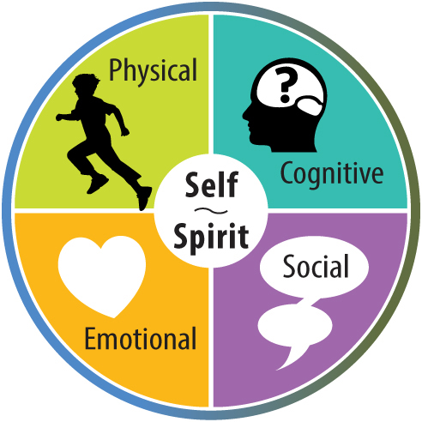](http://www.edu.gov.on.ca/eng/about/wellbeing.html) **[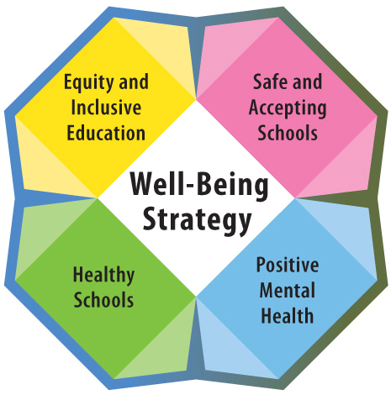](http://www.edu.gov.on.ca/eng/about/WBDiscussionDocument.pdf)**

**Achieving Excellence**

**Goal: Children and students of all ages will achieve high levels of academic performance, acquire valuable skills and demonstrate good citizenship. Educators will be supported in learning continuously to support students’ achievement and well-being**

**SEF Indicators**

* [A culture of high expectations supports the belief that all students can learn, progress and achieve. (4.1)](http://www.edu.gov.on.ca/eng/literacynumeracy/sef2013.pdf" \l "page=30)
* [A clear emphasis on high levels of achievement in literacy and numeracy is evident throughout the school. (4.2)](http://www.edu.gov.on.ca/eng/literacynumeracy/sef2013.pdf" \l "page=31)
* [A variety of relevant and meaningful assessment data is used by students and educators to continuously monitor learning, to inform instruction and to determine next steps. (1.2)](http://www.edu.gov.on.ca/eng/literacynumeracy/sef2013.pdf#page=14)
* [Collaborative instructional leadership builds capacity to strengthen and enhance teaching and learning. (2.1)](http://www.edu.gov.on.ca/eng/literacynumeracy/sef2013.pdf" \l "page=20)
* [Opportunities for authentic learning experiences and experiential learning exist in all classrooms and programs. (5.2)](http://www.edu.gov.on.ca/eng/literacynumeracy/sef2013.pdf" \l "page=39)

**Actions:**

**BIPSA**

*Creating the environment for a permanent change of teaching behaviour and mathematical thinking in our staff by putting everyone in the learner's seat to explore content knowledge for teaching, as it relates to their own practice (via collaborative inquiry and self-directed PD) and board wide goals as determined through triangulated evidence

*Supporting teacher professional learning that aligns with the BIPSA and SIPSA and facilitates capacity building, collaborative inquiry/planning and teaching in all subject areas, within and between schools through the 5-year cycle of support

*Providing opportunities for problem solving and student inquiry, supported by guided, balanced and explicit instruction in literacy and numeracy

**SEF Indicator 4.1, 4.2**

**District Review Summary Report Recommendations:**

1. ***Challenge assumptions and push staff to look at and implement changes to the school narrative, teaching methods and  practices.  As a Direction team member said, “We have amazing things happening here.  I want to see what my colleagues are doing because I thought I already knew.  Bluntly put, I didn’t.”***

***2. As part of your planning, consider what all staff members might identify need to know, do, and monitor connected to:***

* 1. ***Ontario Curriculum Expectations (Overall and Specific) and Growing Success and Rich triangulated Assessment (observations, conversations and products)***
  2. ***Learning Goals and Intentionality in instruction***
  3. ***Teacher/Student Co-created Success Criteria***
  4. ***Questioning for Higher Order Thinking***
  5. ***Teaching mathematics for conceptual understanding ( concrete, representational, abstract)***

**ISLN/ If…Then…**

**: Students struggle to communicate effectively in math: If we provide effective models of communication (if/then) to explain our thinking, then students will be better able to communicate their understanding. *Primary A***

**: Students struggle to communicate:** If we ask inquiry based and open questions then students will communicate their thinking (observations, conversations, products) to meet the learning goals and curriculum expectations.**. *Planning Time***

**: Students struggle to communicate their thinking in math: If we use targeted instruction based on data gathered, we can affect student understanding, and see improvements in students’ ability to communicate their thinking. *Junior***

**: Students struggle to communicate their thinking in math: If we co-construct success criteria with students using student examples, then they will be better able to communicate effectively in math. *Primary C***

**: Students struggle to communicate their thinking- If we ask rich open questions then students will communicate their thinking in a meaningful way. *Kindergarten***

**: Students struggle to***************: If we use more concrete tools and meet students where they are, then we will have greater success leaning basic number sense and applying them.- “Teach good, learn gooder”**

**SEF Indicator 2.1**

**District Review Summary Report Recommendations:**

1. ***Princess Elizabeth P.S. has students who are eager to engage in their learning and teachers have significant structures in place to ensure that behavioural issues are manageable.  Build on the academic strengths of your population and push their thinking through reflective strong practices.***

**SEF Indicator 5.2**

**District Review Summary Report Recommendations:**

1. ***As the school team suggested, close analysis of the thinking tasks given to students, followed by analysis of the resulting student work, will help to move the school deeper into the difficult work of addressing student thinking needs.  Questions suggested by the DSV team connected to  analysis of tasks would include:*** 
   1. ***Do our tasks allow students to address the ‘big ideas’ in our Curriculum Documents?***
   2. ***Do our students understand why they are learning what they are learning?***
   3. ***Can we help students to articulate how their learning connects to other learning with which they are engaged in?  The why need not always be in service of the future job market.***
   4. ***How can the tasks in which all students are engaged, serve their community and the wider world?  What does the staff at PEPS need to learn from and with each other about Global Competencies and Global learning to engage students in developing a global perspective?***

**ISLN/ If…Then…**

**If** we differentiate (ie. small group, guided group, use of technology, building basic skills and developing problem-solving “tool kit”) **then** students will demonstrate improved understanding of mathematical concepts***Intermediate***

**Monitoring: Through the Collaborative inquiry process, staff agrees to monitor progress through observations, conversations and products related to the SEF indicators, ISLNs, and IF…Then statements**