Continuing Education
Orangeville Winter 2023
Programs
BEGINNER GUITAR LESSONS - AGES 8-10
This beginner guitar course is geared towards kids and will teach them all the basics from strings to chords to songs. If you have a guitar sitting in the house getting dusty, it is time to learn to put it to good use. By the end of this course, you will have a basic understanding of how to play guitar.
PLEASE NOTE: There is no class on March 15th (March Break).
Wed Feb 8 – Apr 5 6:30pm - 7:30pm 8 Classes $45.00
Orangeville DSS – Rm 313 Stephanie Edwards PR-7064
BEGINNER GUITAR LESSONS - AGES 11-15
This beginner guitar course is geared towards kids and will teach them all the basics from strings to chords to songs. If you have a guitar sitting in the house getting dusty, it is time to learn to put it to good use. By the end of this course, you will have a basic understanding of how to play guitar.
PLEASE NOTE: There is no class on March 15th (March Break).
Thur Feb 9 – Apr 6 6:30pm - 7:30pm 8 classes $45.00
Orangeville DSS – Rm 607 Stephanie Edwards PR-7066
To register, visit www.learning4you.ca
OR call Continuing Education at 519-941-2661
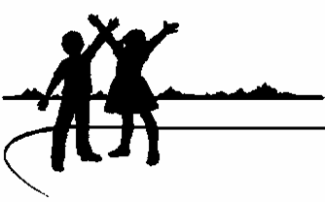
We also offer Adult Programs – Volleyball, Yoga, Nordic Walking, Dance, Writer’s Circle & The ins and outs of the Cricut world!
The Upper Grand District School Board

Home Alone and Babysitting Bootcamp with return in Spring!

