**Ross R. MacKay**

Public School

35 Trafalgar Road, R.R.# 2

Hillsburgh, ON qwON N0B 1Z0

Phone: (519) 855-4957

Website: http://www.ugdsb.on.ca/rossrmackay Fax: (519) 855-6901

**Principal:** *Ms. T. Armstrong*

**Office Coordinator:** *Mrs. C. Eberhardt* End of June, 2019

**Principal’s Message**

Well, June just flew by so we must have been having fun! There are so many special activities and celebrations including end-of-the-year trips, School Council Play-day, Grade Six Graduation, the Kindergarten Picnic, Student Helper Party and our final assembly tomorrow at 11:30 (everyone is invited☺)

Report Cards were sent home today with all students. We would sincerely appreciate the Parent/Guardian portion being returned tomorrow as they are inserted into your child’s Ontario Student Record along with a copy of the report.

September will bring the following staff changes to RRM

* Mme. Bonney will be completing her Long-term Occasional teaching position, filling in for Mme. Pearce and will be returning to the Occasional Teacher List. We are unsure at this point if Mme. Pearce will be returning in September.
* Mrs. Chambers will be completing her Long-term Occasional teaching position, filling in for Mrs. Donovan, and will be returning to the Occasional Teacher or Long-term Occasional List. Joining us in Kindergarten in the Fall will be Miss Breanne Hart-Ruhl.
* Ms Krista Gilchrist will be completing her Long-term Occasional Educational Assistant position, filling in for Mrs. Paul, and will be returning to the Occasional E. A. list. We hope Mrs. Paul will be returning in Sept.
* Mrs. Pandullo will be completing her Long-term Occasional teaching position, filling in for Mrs. Smith, and will be enjoying time at home awaiting her new arrival. Mrs. Smith will not be back from her maternity leave until March so this position has been posted.

On behalf of the Ross R. MacKay staff, I send best wishes to all of our families for a fun, relaxing and safe summer break.

As always, we encourage you to visit our RRM School Website regularly for information and upcoming events at <http://www.ugdsb.ca/rossrmackay/>,

to add the **School Messenger App** to your phone and to follow us on our Twitter Account @RossRMacKayPS . Our School Council invites you to follow their Facebook Page [Ross R. MacKay Public School - by School Council](https://www.facebook.com/RossRMacKayPS/?hc_ref=SEARCH&fref=nf)

As parents/guardians, you are our partners in ensuring the success and happiness of your children. Please feel free to email, call or set up a meeting if you have any questions/concerns.

Yours in education,

Ms. Tracy Armstrong

[tracy.armstrong@ugdsb.on.ca](mailto:tracy.armstrong@ugdsb.on.ca)

**Class Placements and First Day:**

Students should arrive to school at the regular time on Tuesday, September 3th. All students will gather in the gym when the entry bell rings at 8:55. We will then let students know their tentative class placement/teacher.

At this time, this is our school organization for 2019/2020. Please remember that there is always a chance we may have to reorganize in September if our enrollment changes.

1. Junior/Senior Kindergarten
2. Grade One/Two
3. Grade Three/Four
4. Grade Five/Six

If you are moving away from the RRM community during the summer and have not yet informed our office, please do so as soon as possible. Also, if you notice new families moving into the area, please ask them to email Ms. Armstrong and we will set up a time during the last week of August to welcome the family, register the children and receive a tour of the school.

MC900383940[1]**Student Medication & Life Threatening Allergies:**

We ask all parents/guardians to please pick up any medication, inhalers and/or Epi-pens at the end of the day on Thursday or anytime on Friday, June 30th.

Students with life-threatening allergies have been sent a letter indicating we require updated paperwork to be returned to the school by the end of August so that we are prepared for September Start-up.

**Student Agendas & Supplies:**

In an effort to maintain regular communication between home & school, Agendas have again been ordered for students in Grade 1 – 6. We will be requesting $7.00 per student to cover the cost for these agendas.

Otherwise, most school supplies are provided for students. However, we know that some of the back to school excitement relates to buying backpacks, lunch bags and classroom supplies. We do suggest that EVERYthing is clearly labelled to avoid landing in the ‘Lost & Seldom Found’ Box.

**Transportation Reminder:**

If your child rides a bus, please check the Transportation website ([www.stwdsts.ca](http://www.stwdsts.ca)) at the end of August to determine your bus number, route, pick-up and drop-off times..

**Would you be willing to volunteer?**

We have a small group of dedicated volunteers who support our school in a variety of ways. However, we are ALWAYS looking for additional volunteers to either support students or to teach them something new. If you have any time to give our school, please connect with Ms. Armstrong and she will help facilitate the process

**THANK YOU for helping to make our Heart & Stroke**

**Jump Rope for Heart event a success!**

Post-Event School Newsletter by Mrs. Lake

This year, approximately 84 students at Ross R. MacKay participated in Heart & Stroke Jump Rope for Heart. Together, we raised **$677.60** for the Heart and Stroke Foundation – thanks to your support!

Supporting kids' health for more than 35 years, the Heart and Stroke Foundation encourages kids to get active while they collect pledges for heart disease and stroke research, education and advocacy initiatives. Jump Rope for Heart is meant to be a fun and inclusive way to promote healthy choices and getting active.

By participating in Jump Rope for Heart, students at Ross R. MacKay learn about heart health and the benefits of living a healthy lifestyle. They also learn about social responsibility by helping raise vital funds for life-giving heart disease and stroke research. Every dollar raised helps families like yours live longer, healthier lives. Our event on Friday, May 19th was great fun for all and we will be looking forward to continuing with our healthy journey throughout the rest of the school year.

Plus, thanks to your generous efforts in fundraising, our school also earned valuable resources through the Heart and Stroke Foundation’s HeartSmartTM Points Program. Points earned for each participating student and each dollar raised will allow us to purchase new equipment for our school to further promote healthy choices and physical activity.

We hope that your child’s experience with the JUMP program will help them on their way to embracing a lifetime of healthy living as well as the importance of helping others. We thank you again for your generosity for those that were able to fundraise and to everyone for helping to foster these values of health in your own homes, within your own families.

**Together, we can help protect hearts and keep all kids healthy.**

***Special note:***

* Prizes were distributed through homeroom teachers. If your child received a bonus online fundraising gift card, you should have received an email notification (please check your SPAM or Junk Mail if you have not received it).



Our board has a wonderful resource for all of our students that can be accessed 24/7

from school or from home. It’s called UG2GO and includes Learn360 (educational video

streaming), Student Link (a site children use at school that gives them access to web

sites that are kid friendly and relate directly to their current units of study), Tumblebooks

(a site that has hundreds of books children can click on and have read to them),

Overdrive (eBooks and audiobooks) and much more. When students are at home they can go to this URL:

**https://www.ugdsb.on.ca/ug2go**

They will be prompted to enter the same Windows username and password that they

use at school to get onto the school network. Once they enter their Windows

username/password they will enter the site and they can then click on any of the

resources and be taken directly to the individual resource without the need for any

additional passwords. Please take a few minutes to explore the site with your child. It is an important tool that will aid them in their education, and may make your life easier when it comes to homework and projects. We are excited that students will be able to access information from anywhere and at any time in this information age!

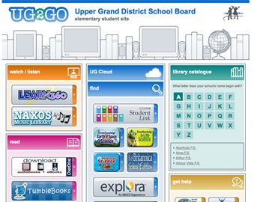

**Summer Fun & Learning**

Check out this list of ideas that might inspire your family to try some new activities as a family. Enjoy!

* Visit the Local Library
* Visit a museum
* Read a book and then watch the movie version – compare
* Try a new food, recipe or restaurant
* Grow something
* Try a new sport or activity
* Start collecting
* Learn a new board or card game
* Goggle topics of interest
* Use the Internet to help plan a Day Trip or even an Overnight Trip
* Create- arts and crafts
* Visit a local Farmers’ Market
* Attend one of the many summer festivals in our Province
* Listen to a new musical artist
* Send a letter or postcard to someone you love
* Build something
* Volunteer

**Save for Ross R. Mackay**

We are always looking for donation for our MakerSpace area. Why not start a box by your door and fill it up over the summer so you can donate in September.

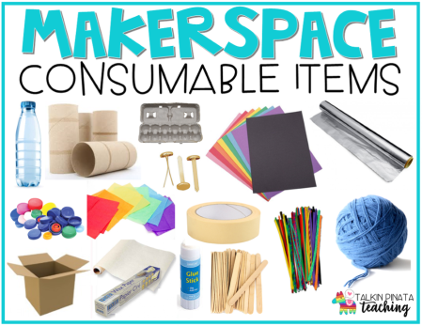Items we are in need of are found as an attachment to this newsletter. We encourage you to print off a copy and stick it on your fridge.

**Coming Soon - Wellington County Ways to Make Sure Your Family (and You) Get your Dose of VITAMIN ‘N’ this Summer!**

**The benefits are clear. Now, more than ever, we can feel good about getting our family and ourselves outdoors and into Nature. It reduces stress levels, improves mood, boosts our immune system and helps us to increase our physical activity!**

1. **Put nature on the calendar.**If you plan the family’s sports commitments and vacations in advance, do the same for time spent in nature.
2. **Don’t tear down the tree, build up the kid.**International play expert Joe Frost says the number one reason kids get hurt climbing trees is because they don’t have the upper body strength to hold onto the branch. Think of manageable risk as an opportunity to build strength and resilience in your kids.

**Children’s Outdoor Charter:** www.childrensoutdoorcharter.ca/

**In Ontario, every child should have the opportunity to:**

* *Follow a trail*
* *Explore a park*
* *Harvest something to eat*
* *Swim in a lake*
* *Paddle a canoe*
* *Play in the snow*
* *Build an outdoor fort*
* *Visit a farm*
* *Camp under the stars*
* *Go fishing*
* *Observe plants and wildlife*
* *…Or create an outdoor adventure*

1. **Take a city hike.**In urban neighbourhoods, take your day packs, water and digital cameras and go look for nature.
2. **Moon walk.** Walk by balmy summer moons with katydids singing and lightning bugs flashing - there is much magic in the natural world and most of it is free!
3. **Go backyard camping.** Buy the kids a tent or help them make a canvas tepee, and leave it up all summer.
4. **Plant a backyard, community or high-rise vegetable garden.**If your children are little, choose seeds large enough for them to handle and that mature quickly, including vegetables.
5. **Go Native.**Replace part of your lawn with native plants. Create a backyard butterfly pollinator garden.
6. **Go Wildsnapping.** Nature photography is a great way to experience the great outdoors.
7. **Enroll in a nature camp or other outdoor-based organization.**
8. **Start or join a family nature club.**
9. **Visit a park.** [Parks Canada](https://www.pc.gc.ca/en/index) now offers free admission to youth under 17 years. [Ontario Parks](https://www.ontarioparks.com/en) has over 330 parks and each hosts many different activities. Check out their websites and be sure to visit a park this summer!
10. ****Be mindful and create balance.** For every dollar invested in the virtual, put at least another dollar in the natural. Limit access to texting, computers, and TV part of the day or week. Schedule Saturday as a “Smartphone and iPad-Free Outdoor Play Day” for kids and parents.

*Adapted from: http://www.childrenandnature.org/*

**Also, check out the….**

**Library presents the 201****9**

**TD Summer Reading Club**

The Wellington County Library is busy with its move to the new location so there are not a lot of activities to promote during the month of June. However…we do have one to promote that is coming up this summer.

Wellington County Library is proud to participate in the national TD Summer Reading Club. Through books, programs, and conversations, participants will dive into areas that fascinate them, dabble in others for new inspiration, and discover that their passions have the potential to transform them, their friends, and their world.

Studies have shown that school-aged children lose much of their reading ability over the summer months if they do not continue to read. As we approach the end of the school year, we would appreciate your support in promoting our summer programs, which are designed to help children maintain and enhance their reading level for the next school year.

The TD Summer Reading Club information as well as information about many other awesome opportunities is available on their website at [www.wellington.ca/Library](http://www.wellington.ca/Library)

**More Summer Reading**

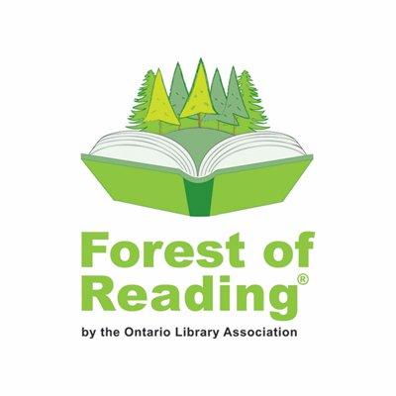

Forest Kid COMMITTEE!

**THE 2019 LIST**

The Ontario Library Association is excited to announce the 2019 Kid Committee Summer Reading List

in the Forest of Reading program!

These are the books that your children should be reading over the

summer - as recommended by seventeen avid readers!

http://bit.ly/ForestKidList2019

