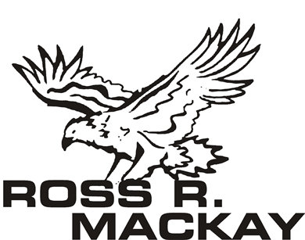MINUTES
Ross R Mackay Public School
Date | time 10/11/2022 6:00 PM | Meeting called to order by Shawn Henderson
IN ATTENDANCE

Shawn Henderson, Tiffany Hanyk, Jennifer Forrest, Amanda Sharpe, Alexandra Hart (teacher rep)

APPROVAL OF MINUTES

September Minutes approved 10/11/2022 by those in attendance.

POSITIONAL VOTE
Chair/Co-Chair – Tiffany Hanyk
Treasurer – Renee Arsenault
Secretary – Jennifer Forrest

ACTION ITEMS
- Council insurance – information provided by OC (Bonnie Gerrits) $167.40 cost for school year, and provides coverage for any after school hours events where principle (Shawn Henderson) is not present. Can be removed next meeting.
- Upper Grand Learning Foundation
  - How to access a top up and how much Ross R. McKay could apply for
- Determine the % towards – TBA Reviewing Treasury report and awaiting teacher wish list
  - School Resources/ Teachers wish list – 45% and 5% to be allocated to teacher wish list max amount $1000.00
  - Playground – 25%
  - Other/General – 25%
- By-Laws, tentative copy, to be reviewed and voted on

PRINCIPLES REPORT
See Attached

TREASURERS REPORT
Will have a report for next meeting
- To be attached

EXPENDITURES
- Snack Program - $100/month – unanimous vote to keep the program – donations welcome
- Playground Structure- need to keep 10% for repairs moving forward

FUNDRAISING
- $500 donated by Parent Involvement Committee – will need to confirm where to use.
- Suggestion for the snack program but need to confirm
- Pizza Day – in progress setting up for every week - Thursday’s
- First block October – December has been processed
- Subway Days – October – December block has been processed and running every other Monday.
- Pita Pit Days – October – December block has been processed and running every other Tuesday’s
- Thanksgiving pie, tart and fudge – set up on cash online closing September 20, 2022.
    - Pick up at the school on October 6Th between 4-6 completed
- Ross R McKay apparel – usually handled by school.
    - Looking to set up 5 t-shirts supporting awareness days with school logo.

DISCUSSION

- Equity lunches support – for the next lunch block 1 slice of pizza per student (to avoid any confusion to the students who are receiving pizza) and allowing teachers to use their discretion for any extras to be stored and handed out to students as they see fit in emergency situations ie. Forgotten / light lunches.
- Setting school year calendar events and fundraisers
  - Field Trips
  - Movie nights
  - Supplying Butterfly Kits (earth week)
- BBQ/Talent show
  - Date - TBA
- Allowing a reasonable time frame for events to be entered in Cash Online (1week) example: information provided on a Monday would be able to go live the following Monday.
- Joint council meetings, are they available.
- Dec 10th Holiday market to be held at the school. (Amanda Sharpe is heading and organizing) – awaiting insurance to go ahead with the planning process. (Hoping to have information finalized and available to the public/ school community by November 14th.)
- Removing the popcorn from pizza day and having special popcorn days ie. Fun Friday

NEXT MEETING
Date: Nov. 8, 2022 6:00 PM
School Library in person and virtual link (to be posted)

