MINUTES
Ross R Mackay Public School
Date | time 1/18/2023 6:00 PM | Meeting called to order by Shawn Henderson
IN ATTENDANCE

Shawn Henderson, Tiffany Hanyk, Jennifer Forrest, Kourtney Livingston, Reene Arsenault, Alexandra Hart

APPROVAL OF MINUTES

December Minutes approved 01/18/2023 by those in attendance.

POSITIONAL VOTE
Chair/Co-Chair – Tiffany Hanyk
Treasurer – Renee Arsenault
Secretary – Jennifer Forrest

ACTION ITEMS
- Upper Grand Learning Foundation
  - How to access a top up and how much Ross R. McKay could apply for
- Determine the % towards
  - School Resources/ Teachers wish list – 45% and 5% to be allocated to teacher wish list max amount $1000.00
  - Playground – 25%
  - Other/General – 25%
- Adding the before and after school survey to council Facebook page
- Whole school field trip setup – looking into available dates and prices Tree top Trekking
- Mr. Henderson looking into a contact for high school construction class to create a mud kitchen for kindergarten class
- BBQ/Talent show
  - Date – June 1st reaching out to optimist club, Foodland for donations
  - Tiffany contacting foodland for donations – update
  - Optimist club confirm the date/ensure they are available
  - Determine a price point for the fundraiser.
  - Volunteer list to help run the event.

PRINCIPLES REPORT
See Attached

TREASURERS REPORT
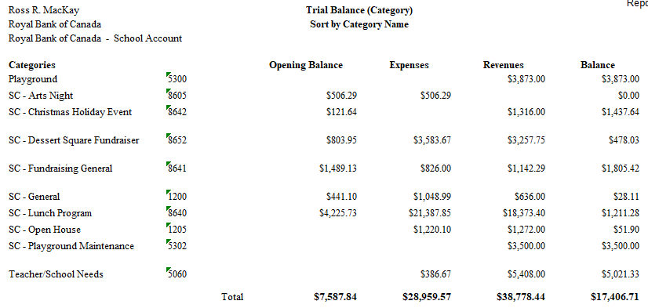

EXPENDITURES
- Snack Program - $100/month – unanimous vote to keep the program – donations welcome
- Playground Structure- need to keep 10% for repairs moving forward

FUNDRAISING
- $500 donated by Parent Involvement Committee – will need to confirm where to use.
- Lunch programs - Pizza Day/Subway/Pita – Third and last block to be posted on cash online Date TBA
- Goals – 100,000.00 green space/ playground3,400.00 raised, 8000.00 School needs/technology information 4,000.00 raised displayed information available on foyer T.V.
- I Love Chocolate fundraiser for Easter on cash online for March 1st till March 20th pick up available for April 4th -5th Flyer created and sent home with students and posted on front doors.

DISCUSSION

- Equity lunches support – for the next lunch block 1 slice of pizza per student (to avoid any confusion to the students who are receiving pizza) and allowing teachers to use their discretion for any extras to be stored and handed out to students as they see fit in emergency situations ie. Forgotten / light lunches.

- Setting school year calendar events and fundraisers
  - Field Trips – Tree top trekking awaiting approval

- BBQ/Talent show
  - Date – June 1st reaching out to optimist club, Foodland for donations
  - Tiffany contacting foodland for donations – update
  - Optimist club confirm the date/ensure they are available – Renee confirmed the date and they are available
  - Determine a price point for the fundraiser.
  - Volunteer sign up sheet to have the fundraiser run. Template started
- Allowing a reasonable time frame for events to be entered in Cash Online (1week) example: information provided on a Monday would be able to go live the following Monday.

- School logo

NEXT MEETING
Date: TBA
School Library in person and virtual link (to be posted)

