Phone: 519-766-4544 Fax: 519-766-4553

https://www.ugdsb.ca/tevans/ Twitter: @taylorevansps

January 2019

Principal’s Message
The staff wishes everyone a safe and enjoyable Winter Break. We are looking forward to working with you in 2019 as we continue making Taylor Evans Public School a wonderful learning environment for all. We hope you have time to spend as a family!

Every year we get questions on when it is too cold for the students to be outside. There is no real concrete answer. Decisions depend on the amount of wind, sunlight, length of time out, etc.

We do expect students to come dressed for the weather and to be outside. Generally, we do not send the students out if the temperature is below -20. We also provide a "warming station” inside the intermediate doors when needed.

When it is cold outside we use our judgment and be aware of weather and wind conditions, the length of time spent outside, the way children are dressed (we do have extra stuff in the storeroom), and that younger children can be more at risk of frostbite.
Hopefully, this is helpful so that we can enjoy the outdoors and our Canadian winter. Please visit the Environment Canada website at http://bit.ly/2EnHoCP for more information.

Remember to engage your child when they come home and ask “What did you learn today?”

Ken Keesmaat Alan Gouk
Principal Vice Principal

Kindergarten Registration
Kindergarten Registration for the 2019/20 school year will take place January 8-18, 2019. Students who will be four years old by Dec. 31st, 2019 are eligible to register for Junior Kindergarten and students who will be five years old by Dec. 31st, 2019 are eligible to register for Senior Kindergarten. Students who are already attending Taylor Evans Public School for the Junior Kindergarten program are not required to register again.
If you know of anyone with a child who will be four or five years old by Dec. 31st, please encourage them to register online at www.ugdsb.on.ca/kregistration and bring their paperwork into the school. People can also come in and register online in the office using our chrome book. You will need to bring the following documents:
- Proof of birth date (Birth Certificate)
- Proof of address (Hydro/telephone bill, etc.)
- Immunization record (Yellow card)

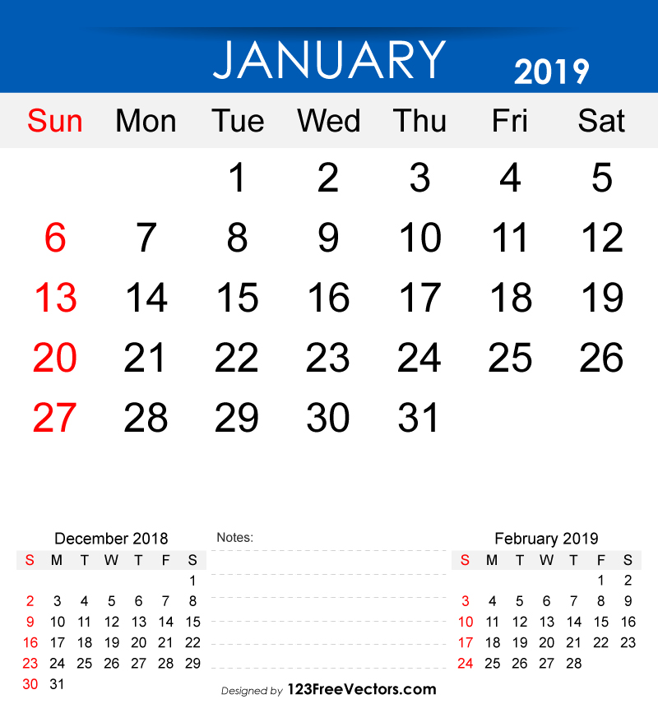
Calendar
Please see the calendar on the website for upcoming events: https://www.ugdsb.ca/tevans/calendar/monthly

- January 7th – First Day of School!
- Popcorn Fridays ($1.50) will start again at the end of January – we are raising funds to purchase new school jerseys for our teams
- January 17th – GCVI Parent Information Night at
6:30 pm at GCVI
- January 17th – School Council at 7 pm
- January 23rd – SPIRIT DAY – Dress like a twin!
- January 23rd at 10:15 am - Little Jammers Guitar begins
- January 24th – Grade 5/6 to River Run
- February 1 is a PA DAY – No School for students

Talking About Mental Health GETTING OUTDOORS
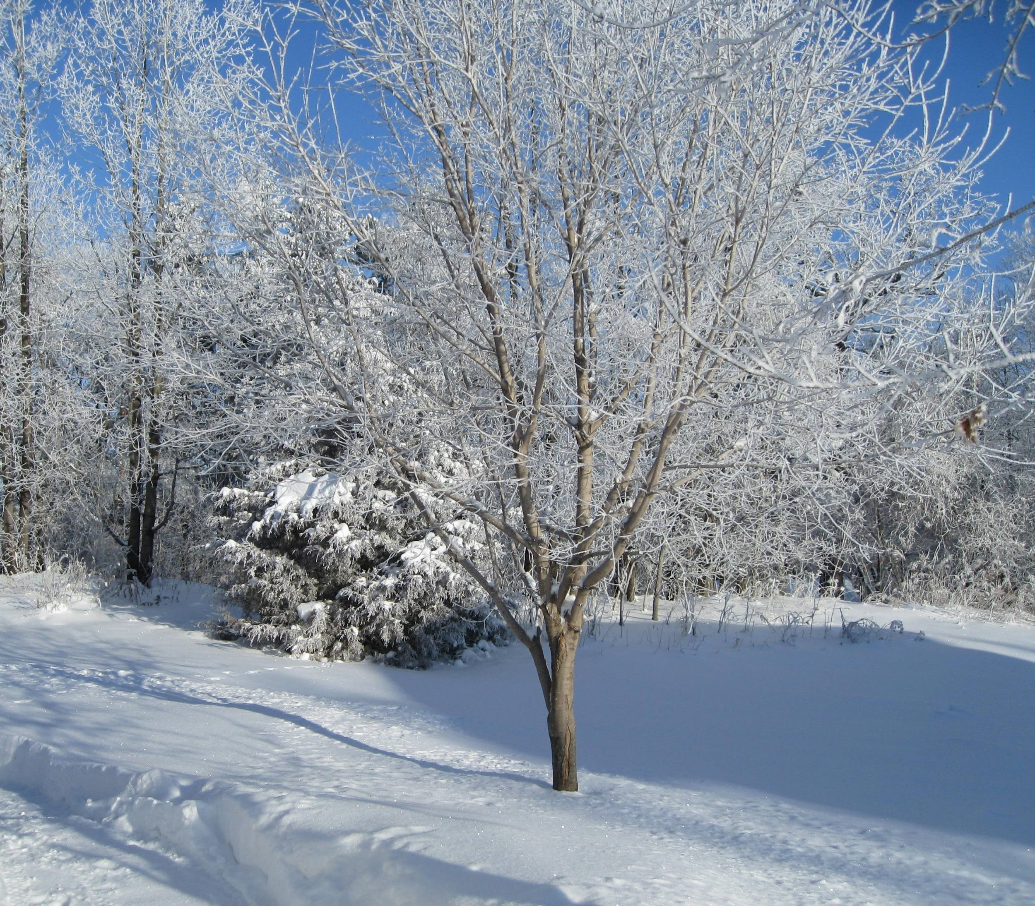
Did you know that taking a 20 minute walk can boost your memory and brain power? Getting outside reduces stress, improves sleep and creates feelings of liveliness and energy. Even in the cold weather, it is important to find time to get outdoors - even if just for brief amounts of time.

If you want your family:
To be less stressed
To be happier
To be more resilient
To feel better about themselves
To have increased attention
To have a better ability to learn

Then GO OUTSIDE! Take your kids outside! Enjoy and be a part of nature.

One study showed that even 5 minutes in nature improves our mood. 5 minutes! We all can take 5 minutes (or more if we have it) to go outside and enjoy nature.

Go for a walk or a ski or a skate or a run. Head for the woods. Go bird watching. Follow tracks in the snow. Watch the sunrise or the sunset. Watch the clouds drift by. Visit a river or lake or pond. Listen for all the sounds of nature. Take in the smells. Notice all the colours and textures. Notice the light as the days get longer.

If you are not sure where to go, check out the links below for lots of great parks in our area.
http://guelph.ca/living/recreation/parks/
http://www.wellington.ca/en/discover/trailsandforests.asp?hdnContent
https://www.grandriver.ca/en/grand-river-parks.aspx
http://headwaters.ca/experience/parks-conservation-areas/
https://www.uoguelph.ca/arboretum/

Have a mentally healthy 2019!

Jenny Marino is the Mental Health Lead for the Upper Grand District School Board.
Follow her on Instagram #ugdsb_mental_health

Monthly environmental activities to help celebrate our planet
JANUARY is the time to carry out your Eco Resolutions!

“There will be more plastic waste in the sea than fish by 2050,” - Dame Ellen MacArthur
It’s a brand new year and the perfect time for positive change. For example, let’s end plastic pollution.
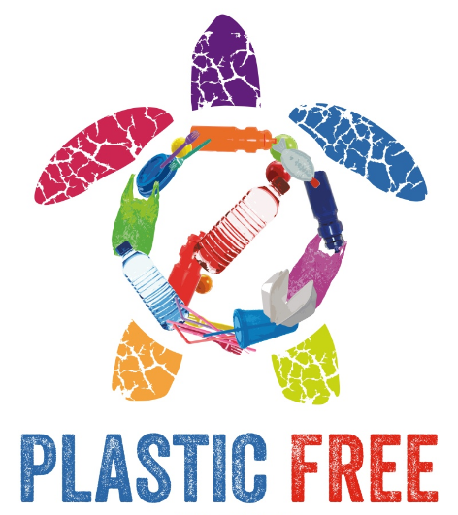

www.wuft.org

Based on the daily news, it’s never been more critical to increase your environmental efforts. The Earth Day Network is calling to end plastic pollution. Imagine a future free from harmful plastic garbage! Single-use plastics are especially wasteful and many plastics are also not properly recycled and take up precious landfill space or pollute our oceans, killing marine life and washing up on pristine beaches. Plastic garbage ‘islands’ are appearing in seas and oceans all over the world. https://www.nationalgeographic.org/encyclopedia/great-pacific-garbage-patch/
Tips on how to reduce single-use plastics:

- Extend your use of cloth shopping bags beyond the grocery store. Use them at all other retail stores too.
- Avoid buying over-packaged food. The choice is yours. Do you need to buy the carrots that are shrink-wrapped on a Styrofoam tray?
- Let the restaurants you frequent know that you would them to join the growing movement to ban the use of straws. Many have implemented a 'serve-straws-upon-request' policy.
- Tap water is best. Bottled water can deplete our precious groundwater resources and produce unnecessary greenhouse gas emissions through the production and transport of plastic bottles. Carry a reusable water bottle instead.
- Lug a travel mug to your local coffee shop. (The plastic lining makes coffee cups unrecyclable, and they all end up in the garbage and in our overflowing landfills.)
- Write letters to the government asking them to fix a problem that you are concerned about such as: mandating the reduction of plastic packaging, banning Styrofoam, or promoting research for recyclable coffee cups or coffee pods, etc.

