Phone: 519-766-4544 Fax: 519-766-4553

https://www.ugdsb.ca/tevans/ Twitter: @taylorevansps

December 2018

Principal’s Message
November has been a great month of learning! Of special note, students brought home their progress reports as a significant communication of their progress. An important aspect with which you, the parents, can support is goal setting. Have a conversation with your child about what they did well and the goals they have set to improve. Thank you to all of those parents for taking the time to connect with your child’s teacher and being part of the team!

The week of November 19th was “Increase the Kindness Week.” Students made pledges to be kind and supportive to our school community. They also learned about the difference between bullying and conflict. You can read about it on My Principal’s blog: https://www.ugdsb.ca/tevans/category/principal-blog/

Ken Keesmaat Alan Gouk
Principal Vice Principal

Safety and Traffic
As you are aware, to help ensure the safety of our students and community members, we do not allow vehicle access to the parking lot at dismissal time (except those with an accessibility pass or school buses and taxis). Vehicles will also not be allowed to exit the back parking lot until 3:05. Thank you for helping to keep our families and children safe!

For added safety, we do have student safety patrols at the driveway entrance, the crosswalk in the parking lot and at the Stephanie Drive crosswalk. Please support these students by standing a safe distance behind them. Teach your child to wait until they allow you to cross. We do have the privilege of having an adult crossing guard at the crosswalk on Stephanie in the morning and after school. Please teach your child to wait until the adult guard is in the crosswalk and all traffic has stopped before crossing. Thanks for helping to keep our children safe!

Booster Juice Wednesdays
Give your child, a healthy boost of fruit and vegetables by enjoying a smoothie for the next six weeks on Wednesdays. You can order your child's Booster Juice Smoothie either on the envelope form that came home or go to the following website to order and pay online. Order forms are due on Dec 3rd. The funds raised will be put towards new sports jerseys for our Intermediate Students.
https://boosterjuice.com/boosterjuiceday/​

Cold Weather has arrived!
Cold weather has returned and with that the need to dress warmly when students are outside for recess or for outdoor learning activities! Please support your child in dressing in warm clothing including hats, mitts and outdoor shoes/boots. Layers are suggested. Extra socks and mittens in backpacks are a good idea. Please label your child’s clothing. This really helps return items to their owner.

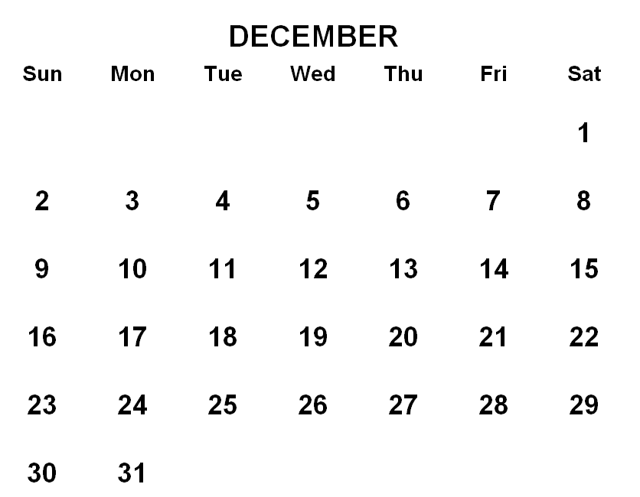
Calendar
Please see the calendar on the website for upcoming events: https://www.ugdsb.ca/tevans/calendar/monthly

1. Popcorn Fridays ($1.50) continue for the month of December – we are raising funds to purchase new school jerseys for our teams
2. Holiday Assembly - December 20th, 9 am
3. Booster Juice – orders due December 4
4. School Council meets December 20th at 7 pm

Monthly environmental activities to help celebrate our planet
December 10th is HUMAN RIGHTS Day!

“You cannot get through a single day without having an impact on the world around you. What you do makes a difference, and you have to decide what kind of difference you want to make.” —Jane Goodall

Celebrate Human Rights Day December 10th!

Human Rights Day calls on everyone to stand up for someone's rights. It starts with each of us. Step forward and defend the rights of someone whose voice is not being heard. Recognize that human rights include the right for everyone to have access to clean water, unpolluted air and healthy food. http://www.un.org/en/events/humanrightsday/

http://calendarholidays.xyz/holiday/168/human-rights-day.

Find simple yet meaningful ways for your family to celebrate the rights and responsibilities that we all share as human beings!

- Learn about how children live in other parts of the world.
Find out about their schools or traditional food and language.

- Read the book: We Are All Born Free
The Universal Declaration of Human Rights in Pictures by Amnesty International.

- Read the Ontario Environmental Bill of Rights.
Decide if there is a cause your family wants to support or an Ecojustice action you want to take on.

- Make a World Wishes Dove with your family.
Cut feathers from white paper. Have everyone in the family write their wish for the world on a feather. Cut out the body of a dove and glue all the feathers on it.

- Start a tradition of doing a family service project on Human Rights Day.
Find an opportunity to volunteer in your local community and make a difference.

“For the bigger picture we can (and should) do what we can to fight injustice. But on a smaller scale, in the day-to-day, practising kindness can help knit a web of compassion to give humanity a boost of resilience.” by Melissa Breyer

Talking About Mental Health GIVE THE GIFT OF RESILIENCY
As we head through December and towards the holidays, it is important to be aware that this can be a very exciting time of year, but for some, it is also a difficult time of year.

REMEMBER:
- eat well
- get good sleep
- don’t over schedule
- stay connected to family and friends
- keep daily routines going
- avoid over-use of technology
- get outside and enjoy the crisp, fresh air

HOLIDAY “CONNECTING & REFLECTING” IDEAS:
23 Days of Giving
Every day in December have everyone put something that they don't use or need into a basket. Later in the month you can go as a family and donate to a shelter or community centre

Reflection Wall
Have a wall in the house where everyone can add sticky notes of what they are grateful about from the year. Focus on lessons learned, new skills and strategies used throughout the year

Rose, Bud, Thorn
Have everyone identify one or two things that they feel were successes from the year (rose), something that was a struggle (thorn) and what they did to overcome the struggle, and something they are looking forward to in the new year (bud).

Signs to look for that someone is struggling
Sometimes it’s hard to tell that someone is suffering. Here are some signs that someone is struggling.
- not coming to school or work
- not engaging with friends or family
- not participating in activities that they used to enjoy
- withdrawing
- feeling hopeless
- increase use of drugs or alcohol
- changes in behaviour
- anger/irritability

December Colour House Update
Taylor Evans Public School has recently started a Colour House System. All of the students and staff at Taylor Evans P.S. have been split into 6 colour house teams: RED, YELLOW, ORANGE, GREEN, BLUE & PURPLE. Grade 8 students are the Colour House Leaders. Throughout the school year, students and staff will participate in colour house events, competitions and community building activities.

There are a few Colour House Team building activities that your child can look forward to throughout the month of December.

GIVING BACK - FOOD DRIVE COMPETITION - Each Colour House will be given a barrel at the front entrance of our school, to collect donations for the Guelph Food Bank from Dec.3 - Dec.14th. Which Colour House will collect the most non-perishable food items?

SPIRIT BUILDING - By participating in Wacky Sweater Day on December 12th, your child can earn points for their Colour House!

SPIRIT BUILDING - Students & staff are invited to WEAR THEIR COLOUR HOUSE TEAM COLOUR on December 19th, to earn points for their Colour House!

COMMUNITY BUILDING - All students & staff will participate in some fun, games and a holiday sing-along in the gym on December 21st.

Monday | Tuesday | Wednesday | Thursday | Friday
3  FOOD DRIVE | 4  FOOD DRIVE | 5  FOOD DRIVE | 6  FOOD DRIVE | 7  FOOD DRIVE
10  FOOD DRIVE | 11  FOOD DRIVE | 12  FOOD DRIVE  SPIRIT DAY  WACKY SWEATER DAY! | 13  FOOD DRIVE | 14  FOOD DRIVE
17  FOOD DRIVE POINTS TOTAL  REVEAL! | 18  9 AM GCVI BAND VISIT | 19  COLOUR DAY!  WEAR YOUR TEAM COLOUR! | 20  9 AM  HOLIDAY ASSEMBLY | 21  11 AM  COLOUR COMPETITION &  SING-ALONG

