Monthly environmental activities to help celebrate our planet

Friday November 29th is BUY NOTHING Day!

Don’t buy, give. “No one has ever become poor by giving”, Anne Frank

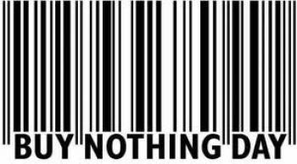
Celebrate Buy Nothing Day on November 29th!
Buy Nothing Day is an awareness day highlighting society’s habit of buying too many things. It is a day for society to examine the issue of over-consumption and is held on ‘Black Friday’, which is one of the busiest shopping days in the United States. https://en.wikipedia.org
Image from https://www.permaculture.co.uk

“We are also consuming and trashing clothing at a far higher rate than our planet can handle.
Today's trends are tomorrow's trash. The only solution is to reduce our levels of consumption.” Dr Kirsten Brodde of Greenpeace Germany- https://www.telegraph.co.uk

Repair, reduce, re-use, recycle – 4 R’s are best!
It's time for a new kind of materialism, based on an economy of better, not more... that makes things which last and can be repaired many times before being recycled, from furniture to tools, cars, fridges, clothes and food. ‘Repair, reduce, re-use, recycle’ could be the new model. https://www.theguardian.com

Some great ideas for your family on Buy Nothing Day!
• Instead of shopping, enjoy a day in the great outdoors by walking trails or going to the park.
• Recycle school supplies such as binders, workbooks, pens and pencils instead of buying new.
• Donate clothes, books, toys and games your family does not need any more.
• Think of things you can make or do for people as gifts without spending any money.

Either way, there’s no doubt that going without buying anything for an entire day is quite a challenge in the modern world, and will serve to make you think about what your life is really about! https://www.daysoftheyear.com/days/buy-nothing-day

