Environmental Activities to help celebrate our planet
OCT 7th IS INTERNATIONAL WALK TO SCHOOL DAY!
A walk outdoors is good for our hearts and minds!

Participate in International Walk to School Day on October 7th 2020!
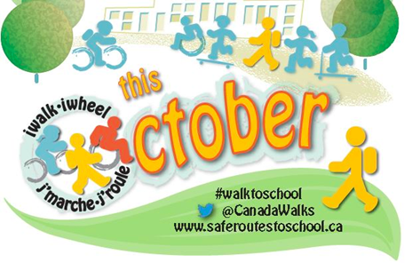
In October we celebrate “active travel” by encouraging students to walk or bike between home and school, or to actively travel as much as they can in their local environments.

“In the ParticipACTION Active Healthy Kids Canada Report Card, the overall grade for children remains at a D- for the third year in a row. Overall, only 9% of 5-17 year olds are getting the 60 minutes of heart-pumping activity they need each day. And sadly, only 24% of 5-17 year olds are walking/wheeling/rolling to school. Our tendency to constantly watch over them or keep them indoors to ensure they are safe from risk limits their opportunities for physical activity, endangering their long-term health.” http://www.saferoutestoschool.ca/

4 ways that walking, biking or rolling can benefit kids

by Katherine Martinko

- Outside activity is known to improve academic performance. Children that have had some outside time in the morning arrive brighter and more alert for their first morning class.
- Walking gives children good life experience. It’s an opportunity for them to be independent, think responsibly, and make decisions for themselves. Some children feel less anxiety about being at school when they know how to get home.
- Walking gets children outdoors – and, according to Richard Louv, who wrote about Nature Deficit Disorder, kids certainly aren’t spending enough time outside these days. Find opportunities for your child to get outside and get moving by walking, biking, skipping, or rolling too!
- Walking/biking/rolling provides daily exercise for children. Obesity rates have skyrocketed in North America, so incorporating physical activity into a child’s daily routine is a good place to start fighting it.
Encourage your children to get outside and get active!

