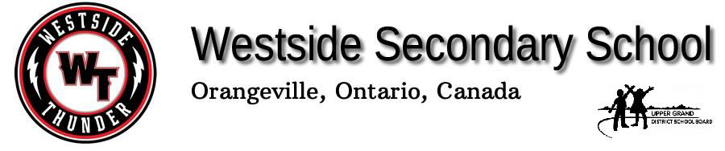
519-938-9355 Grade 11 Automotive Course Outline www.ugdsb.on.ca/westside
Course: TTJ3C Teacher: J. Brasil Program Leader: J. Wardle
Phone Extension: 507

Course Description: This course enables students to develop technical knowledge and skills as they study, test, service, and repair engine, electrical, suspension, brake, and steering systems on vehicles, aircraft, and/or watercraft. Students will develop communication and teamwork skills through practical tasks, using a variety of tools and equipment. Students will develop an awareness of environmental and societal issues related to transportation, and will learn about apprenticeship and college programs leading to careers in the transportation industry.

Big Ideas (overall learning outcomes for the course):
- Students will learn about a vehicle's brake system
- Student will learn about a vehicle’s suspension system
- Students will learn about a vehicle’ steering system
- Students will learn about a vehicle’ alignment system

Achievement Categories: Student learning is assessed and evaluated with respect to the following four categories of knowledge and skills. | Knowledge and Understanding: 25% Thinking: 25%  Communication: 25% Application: 25%

A Personalized Learning Placement Plan (PPLP) will be sent home with each student with in the first month of the semester. This will outline the course expectations specific to your student.

Instructional Strategies: Westside teaching staff will use a variety of instructional strategies to help students develop and improve skills in the following areas: character, citizenship, communication, critical thinking and problem solving, collaboration and teamwork, and creativity and imagination.

Assessment and Evaluation:
Formative assessments are used to improve student learning by providing varied opportunities to demonstrate an understanding of course expectations in preparation for summative evaluations. Summative evaluations test groups of key expectations. Failure to complete a summative evaluation may result in the expectations of the course not being met and the credit not being granted.
Late Policy:
Students are expected to complete all assigned work and submit it by the teacher's established due date. Every attempt will be made to encourage students to complete all assigned work on time so their grade represents their actual achievement. For late and missed summative assessments, please see the Westside Students’ Contract for Missing Evidence of Learning.

More details about Westside’s Assessment and Evaluation Policy is available at: http://www.ugdsb.ca/westside/wp-content/uploads/sites/74/2016/12/Westside-Assessment.pdf

 | Term Work (70%)
Unit of Study | Summative Evaluations
Safety | Test
Tools | Test
Tire system | Test/Quiz
Brake system | Test/Quiz
Suspension system | Test/Quiz
Steering system | Test/Quiz
Alignment system | Test/Quiz
 | Final Summative (30%)
Project/Presentation | 15%
Exam | 15%

Safety:
Safety glasses must be worn at all times in the shop. Safety work habits are extremely important in every work area. Basic safety rules apply in all of the Technological Labs, Shops and Classrooms. Each area may have some unique safety rules, and it is the student's’ responsibility to learn the safe operation-procedure for all the equipment before using them. Failure to follow the safety rules can result in the student being removed from the course with a loss of credit.

Attendance and Punctuality:
Tech. classes are presented in sequence. Each class consists of a set of skills that are necessary for successfully completing the course.
Each technical class emphasizes the importance of good habitats. It is important that each student learn to take responsibility for their own actions. Students are expected to BE ON TIME, courteous, and be able to follow directions.
The teacher has a right to ask the student to wait outside if the student's lateness will cause disruption to the demonstration or the lecture. It is the responsibility of the student to acquire the information that was missed during their absence.

I have read and understand the Course Outline:
Student Name (please print): ______________________________ Signature: _____________________________
Parent/Guardian Name (please print): _______________________ Signature: ______________________________

