January 2019
SUNDAY | MONDAY | TUESDAY | WEDNESDAY | THURSDAY | FRIDAY | SATURDAY
Week 1  1 2 3 4 | 7 Scott’s  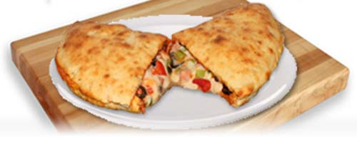  (panzerotti)  $6.00 | 8 Matteo’s Pizza  (pizza & drink)  $6.00 | 9 Scott’s (TBD) | 10 Wooden Spoon  (Variety of Sandwiches)  $6.00 | 11 Scandinavia Trip TBD | 12
13 Week 2  2 1 4 3 | 14 Scott’s  (panzerotti)  $6.00 | 15 Matteo’s Pizza  (pizza & drink)  $6.00 | 16 Scott’s (TBD) | 17 Wooden Spoon  (Variety of Sandwiches)  $6.00 | 18 Athletic Council TBD | 19
20 Week 3  3 4 1 2 | 21 Scott’s  (panzerotti)  $6.00 | 22 Matteo’s Pizza  (pizza & drink)  $6.00 | 23 Scott’s (TBD) | 24 Wooden Spoon  (Variety of Sandwiches)  $6.00 | 25 Exams | 26
27 | 28 Exams | 29 Exams | 30 Exams | 31 Exams | 1 PD Day | 2
3 Week 1  1 2 3 4 | 4 Scott’s  (panzerotti)  $6.00 | 5 Matteo’s Pizza  (pizza & drink)  $6.00 | 6 Scott’s TBD | 7 Wooden Spoon  (Variety of Sandwiches)  $6.00 | 8 Student Council TBD | 9

