November 2018
SUNDAY | MONDAY | TUESDAY | WEDNESDAY | THURSDAY | FRIDAY | SATURDAY
Week 1  1 2 3 4 | 29 Scott’s  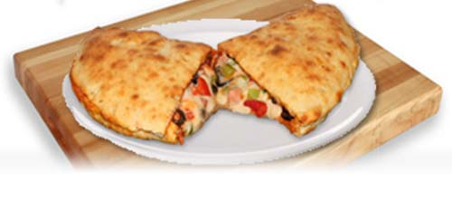  (panzerotti)  $6.00 | 30 Matteo’s Pizza  (pizza & drink)  $6.00 | 31 Griff’s Class  Bacon Potato Soup | 1 Wooden Spoon  (Variety of Sandwiches)  $6.00 | 2 Commencement  Scandinavia Trip  TBD | 3
4 Week 2  2 1 4 3 | 5 Scott’s  (panzerotti)  $6.00 | 6 Matteo’s Pizza  (pizza & drink)  $6.00 | 7 Foods Class TBD $6 | 8 Wooden Spoon  (Variety of Sandwiches)  $6.00 | 9 Prom Committee TBD | 10
11 Week 3  3 4 1 2 | 12 Scott’s  (panzerotti)  $6.00 | 13 Matteo’s Pizza  (pizza & drink)  $6.00 | 14 Foods Class TBD $6 | 15 Wooden Spoon  (Variety of Sandwiches)  $6.00 | 16 WWW Staff Chili Cook Off | 17
18 Week 4  4 3 2 1 | 19 Scott’s  (panzerotti)  $6.00 | 20 Matteo’s Pizza  (pizza & drink)  $6.00 | 21 Foods Class TBD $6 | 22 Wooden Spoon  (Variety of Sandwiches)  $6.00 | 23 WWW Taco Fiesta | 24
25 Week 1  1 2 3 4 | 26 Scott’s  (panzerotti)  $6.00 | 27 Matteo’s Pizza  (pizza & drink)  $6.00 | 28 Foods Class TBD $6 | 29 Wooden Spoon  (Variety of Sandwiches)  $6.00 | 30 PD Day | 3

