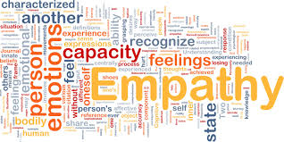

**Why do we do Empathy Week?:**

WHSS launched Empathy Week because we believe in the power of empathy to positively transform student and teacher experience. If you’ve been in a school for any length of time, you know that whether you’ve asked for it or not, you’re bound to encounter extremely vulnerable situations. For example, each day teachers and students are on the front lines of complex, deeply human questions—questions about difference and belonging, privilege and ability, acceptance and conflict. Teachers know the daily significance of modeling higher order emotional intelligence, including practicing compassion, love, and tolerance. As schools become more centered on the unique needs of each student, and as we continue to embrace the diversity of our school, we will need to continue to practice and cultivate empathy for our students and for each other. During Empathy week, our Equity club will bring you small bits of information, some activities, and most importantly, some opportunities to reflect on the greatness and the importance of ourselves and this school community we are here at Wellington Heights. We will challenge you to appreciate yourself more, and to appreciate every human here at Wellington Heights for all they have to offer, good, bad, and indifferent. We ask each of  you to approach this week with an open mind - and an open heart.