Flying the Pride flag at WHSS
For the month of June, Wellington Heights will fly the Pride flag.

What is the Pride flag?
Rainbow flags have existed in many configurations representing many peoples and experiences throughout human history.
The current Pride flag’s exact colours and dimensions have changed from the Gilbert Baker flag, which first appeared as a representation of the LGBTQ+ community in 1977. The Rainbow flag is strongly connected to the LGBTQ+ community, it also is a representation of social change cited as being a symbol of hope and peace.
LGBTQ+ refers to Lesbian, Gay, Bisexual, Transgender, and Queer or Questioning. The + refers to people who identify as Intersex, Asexual or an Ally.
There are specific flags and flag variations for many identities within the LGBTQ+ community.
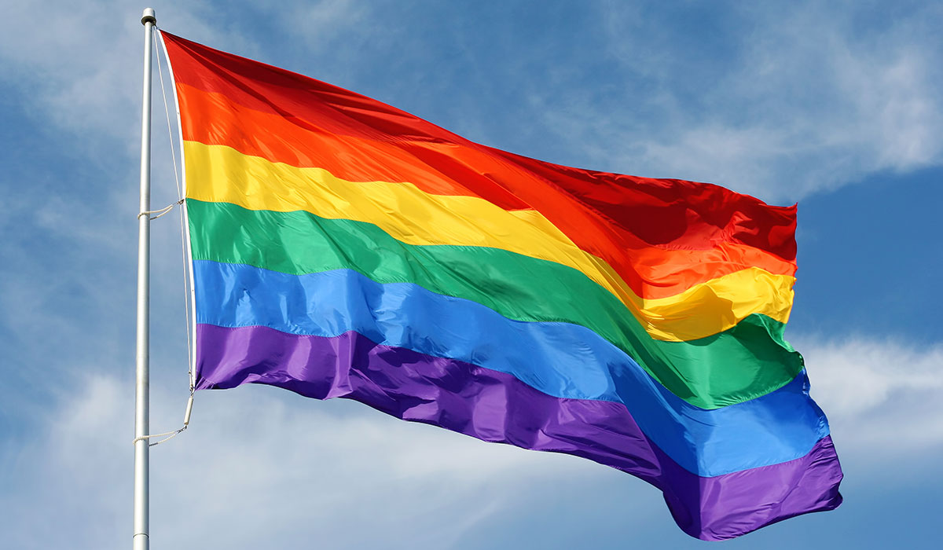

Why is WHSS flying the Pride flag?
The month of June is Pride month. Many of our students, staff, parents/guardians and community members identify as members of the Rainbow or LGBTQ+ community. Flying the Pride flag not only signals that our school is a safe space for everyone, it also aligns with our Vision Statement and Guiding Principles of inclusion and student and staff well-being and our new Equity Plan.
Our school district is showing our acceptance and celebration of the LGBTQ community during Pride month by raising the Pride flag at schools and offices across the UGDSB.
We continue to raise awareness and support inclusion and acceptance of other marginalized groups in other ways.
Some examples include our Poverty Challenge initiative aimed at increasing awareness of socio-economic disadvantage, the One Voice One Team initiative aimed at creating community for racialized students, supporting persons with disabilities by making our schools more accessible, and by acknowledging the original people of these lands. We continue to work to ensure the equity and inclusion of all our students and staff.

UGDSB Vision Statement
Students will attain individual excellence through dynamic programming provided by an effective staff and supported by a committed community. We will meet our students’ diverse needs through the provision of equitable and accessible resources. Our learning environment will be characterized by empowered administrators, effective communication and mutual compassionate respect.

Guiding Principles
We believe that:
- Student learning is our focus
- The learning process is open-ended
- Education is a community responsibility
- Embracing diversity contributes to community
- Teachers make a significant difference
- Leaders must focus on students
- Continuous professional development supports life-long learning
- A commitment to values guides activities
- A safe physical environment needs to be sustained
- A respectful learning environment fosters personal growth
- Opportunities and resources need to be equitably distributed
- Everyone should be treated with respect

What if the flying of the Pride flag is against my personal values and beliefs?
We believe that our school is a safe space for everyone. Everyone has the right to be treated with dignity and respect. Additionally, regardless of your personal values and beliefs, we all must follow the Ontario Human Rights Code that protects marginalized groups from discrimination and harassment. We are flying the Pride flag to demonstrate our commitment to our community that discrimination and harassment of any kind will not be tolerated in our board. The Board policy can be found at: https://www.ugdsb.ca/schools/safe-equitable-and-inclusive-schools/flying-the-pride-flag-in-the-ugdsb/

